X3
Description of SW Download Tool for X3
References
References are external documents (papers, files, articles, and photocopies) which are mentioned to give further information about topics in the document. Remember to write the accurate path for the reference file.
Enclosures
Enclosures are external documents (papers, files, articles, and photocopies) which are an essential part of the document itself, but which cannot be put into the word format.
Revision Information
Created: | Revision | Name | Comments
24.03.03 | 0.1 | Flemming Mikaelsen | Initial revision in PVCS
Modified

Contents
1 Introduction 1
2 Download tool for X3 1

Introduction
This document describes the SW download tool to be used for X3.

Download tool for X3
The tool to be used for downloading SW to a X3 phone is started by running an .exe file. A screen dump of the tool is shown below.
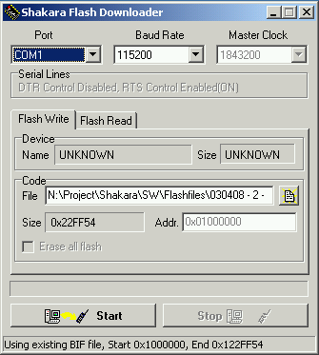

The only fields that can be changed by the service centres are Port, Baud Rate and File, the rest of the options will be locked to simplify the use.
After starting the tool by running the .exe file the Port shall be set-up to the Com port that the cable/boot box is connected to. The Baud Rate of the com port shall then be set to the speed of the selected com port (maximum 460800 bit/s).
After setting up the tool the SW to be downloaded in the X3 shall be selected, this is done by pressing the browse icon in the right side of the File line. When browsing for the SW it is important that the file type is set to .bif. After the right file has been selected the tool is ready for downloading the SW.
Connect the phone to the cable and click the Start box then press and hold the left side of the key on the X3. The key shall be pressed until the bar over the Start box have been filled completely with blue and the bottom line writes Sending Block 1 of …….
When the bottom line is showing Download Completed the cable can be removed. To download a new phone connect it to the cable and click the Start box and do the same as with the first phone.

The tool saves the settings that was made in the tool so second time the tool shall be used it shall just be started and it is ready unless the SW have to be changed.

