Mobile Software Programming

Due to this separation of common mobile software and language package, it is possible to fulfill the demands of the market requiring customization and flexibility.
As a consequence the software programming process in the LSO is divided into two different steps as followed:
Software update to latest version of signaling software
Programming of customer specific language package
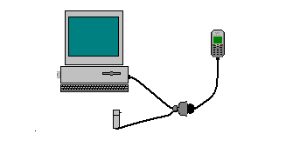
STANDARD
SIEMENS
CHARGER
SIEMENS DONGLE
PC
XELIBRI X1
SIEMENS CABLE
(BA 2000 – SLIM)
SERIAL
CABLE
RS 232
FLASH ADAPTER
SFA-110

xelibri x1 software programming setup

Mobile Software Updating

Update the latest signalling software and language package with flash programmer. The software of the Xelibri X1 is loaded from a PC directly. Hardware interconnection between the mobile and the PC is shown in the figure above.
Flashing is done to the phone via the system connector. Flashing adapter SFA-110 for Xelibri is needed.
Flashing requires that the battery of the phone is charged.

Flashing tools

Flash programmer is used for flashing. The latest software release and language package can be chosen. A Siemens dongle must be connected.
Flashing the product is done via the phone's system connector. In order to have a connection with a PC, the following equipment are needed: Siemens dongle (part no.x) adapter in PC's printer port, a Siemens connecting cable BA 2000-SLIM, a flash adapter SFA-110 (programming interface) connected with a standard RS 232 cable and a standard Siemens charger (US/China (part no.x), Euro (part no.x) or UK (part no.x).
The RS 232 cable is connected between the PC's serial port and the flashing adapter. A charger needs to be plugged to the flash adapter. Finally, the Siemens connecting cable needs to be connected between the flash adapter and the phone's system connector.
Use the flashing tools according to the instructions given in the Flash Programmer.

Language Groups

EU xx-1 (xx= software release number)

- T9-English (EN)
- T9-French (FR)
- T9-Spanish (ES)
- T9-German (DE)
- T9-Italian (IT)

China xx-21 (xx= software release number)

- T9-Chinese (Simplified) (ZS)
- T9-Chinese Traditional (ZT)
- T9-English (EN)



Latest software release can be found from communication market

Software programming process

This information is subject to change!

Contact your Service Manager for the order number of the right version of mobile software for your market.

No
Yes
Yes
No
No
Yes
Yes
No
Yes
No
Plug in the Flash Adapter to the PC and Mobile
Connect the Charger to the Flash Adapter
Power up Flash Adapter & Check Green LED
Check Charger
Faulty Charger
Faulty Flash Adapter
Power up the PC in Windows environment
Execute the Flash Programmer
Check settings and correct COM port from Flash Programmer
Update the SW according instructions
Correct settings and COM port

Test Mobile
Take note of error and repeat process again
Feedback Error to ICM CD ASC
END
Error ?
Error ?
Ok ?
Ok?
Ok?
Test with other mobile phone
No
Repair mobile phone
Yes

software programming process

Flash Programmer

Open the Flash Programmer and the following window will appear.
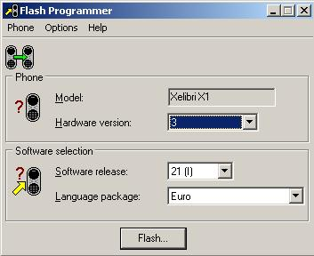
Flash

Flashing process

The flash button is disabled if the Flash Programmer options are not correctly set. (see page 37, Options)
- Select the correct hardware version from the list.
- Select the software release from the list. Latest is the biggest number of the software versions.
- Select the language package from the list. None means that no language package is selected.
- Press “Flash”. (Window shown below appears)

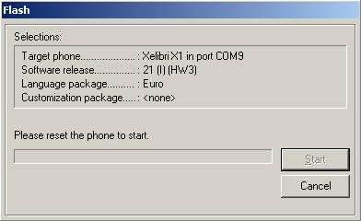
Preparing to flash
Reset the phone (turn phone off and on) and the flashing will start automatically.
The window seen below appears when flashing is done.
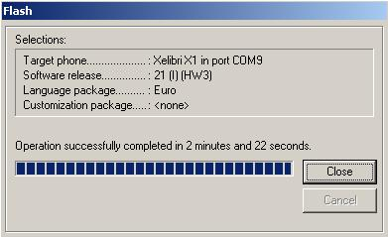
Flashing completed
Flashing is completed. Press “Close” to exit the flashing.

Recovery Flash

If flashing of the phone fails you can use Recovery Flash. Select “Recovery Flash…” from the Phone menu as seen below. After using Recovery Flash you can try to flash the phone again.
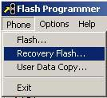
Phone Menu

The window seen below will appear.
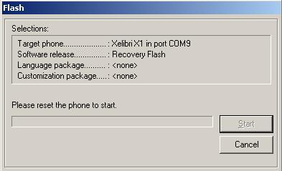
Recovery Flash
Reset the phone (turn phone off and on) and the flashing will start automatically.
The window seen below appears when flashing is done.
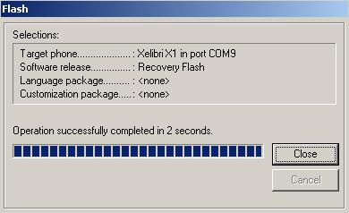
Recovery Flash complete
Flashing is completed. Press “Close” to exit the flashing.

Copy User Data
Select “User Data Copy” from the Phone menu or press the 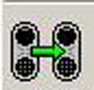 button to open the User Data Copying Wizard (see fig. below). It is used for copying all user data from one phone to another phone.
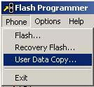
Phone Menu
Following window will appear.
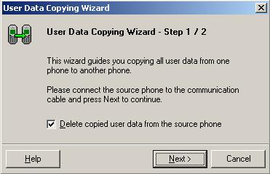
Wizard
Start wizard by pressing the “Next>” button. The “Help” button opens Help for flash programmer. “Cancel” takes you back to main menu.
If “Delete copied user data from the source phone” is selected, source phone’s data will be deleted. (to use this function SIM-card must be placed to the phone)
Connect the source phone to the communication cable and press “Next>” to continue.
The following window will appear when copying user data.
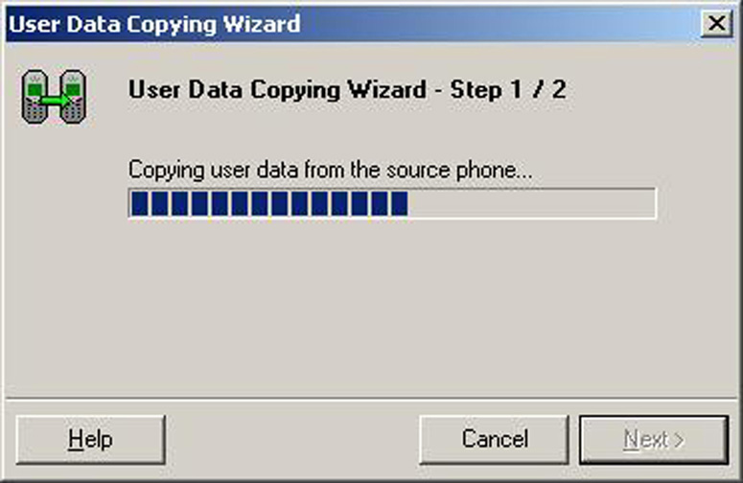
Wizard copying user data
When the user data is copied, the following window appears.
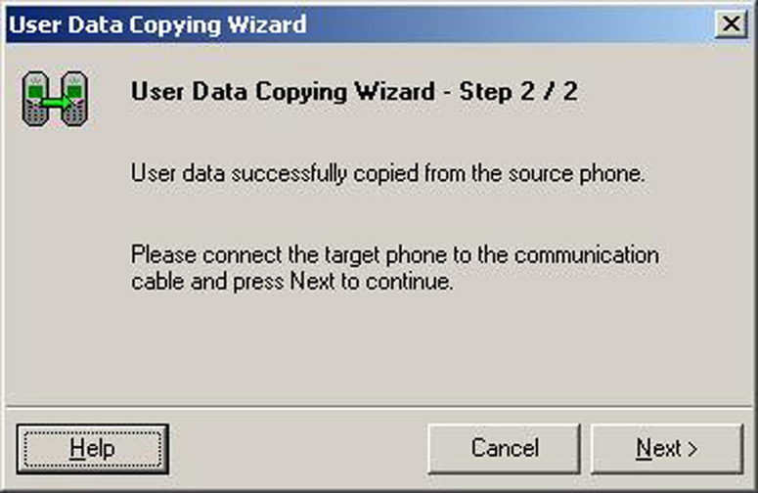
User data is copied
Connect the target phone to the communication cable and press the “Next>” button to continue.
The following window appears after copying is successfully completed.
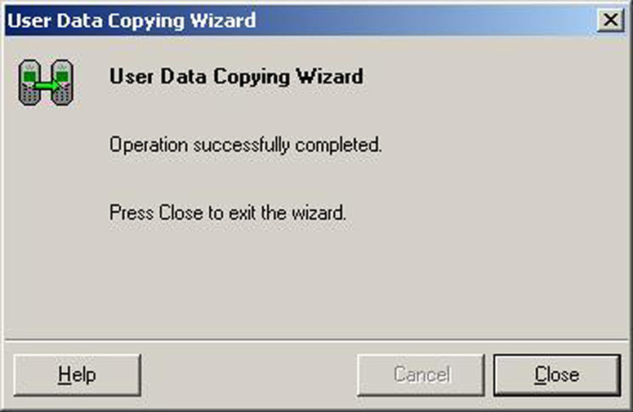
User data is copied to another phone
Press “Close” to exit.

Options

To change Flash Programmer setups, select “Settings” from the Options menu (see figure below).
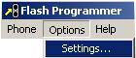
Options Menu

The following window will appear.
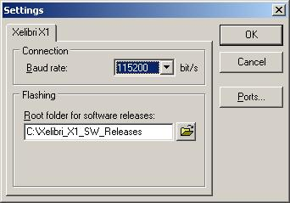
Settings
- Set baud rate to 115200 bit/s or higher depending on a serial port speed.
- Define the correct Root folder, where the software releases have been saved in, by pressing button.
The following window will appear.
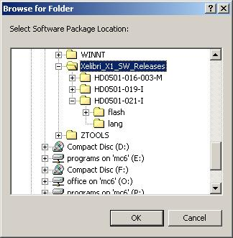
Browse for folder
- Select the correct root folder and press OK.

- Define the correct COM port(s) by selecting the “Ports” button.
The following window will appear.
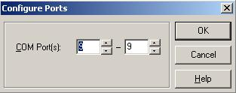
Configure Ports
- Select the correct COM port(s) and press “OK”. (Multi-flashing can be done if the computer supports it.)

