SL45/6688

Level 2.5

Repair Documentation

V 1.2

Table of Contents:

1 Introduction 3
2 Bottom Connector (Lumberg) 4
3 Display Connector 8
4 Keyboard LEDs 12
5 Keyboard Connector 15
6 Irda Diode 18
7 Antenna Connector 21
8 Resistor R384 25
9 Voltage Protection Diode V200 29

Introduction

SL45 product family, internally referred to as U35, consists of 2 different dualband handsets (GSM-900 and GSM-1800), which can easily be distinguished from the second block of the partnumber printed on the IMEI label. There is a standard type SL45 and a Chinese type called 6688.

Partnumber on IMEI label:

- SL45: S30880-S4800-#1xx

- 6688: S30880-S4800-#8xx
,while # may be any letter (A-Z) and xx may be any number from 10,20,30 ....90.

Important:

The SL45 and the 6688 use a different hardware (RF/control module). This is due to the fact that for the Chinese type there is a bigger flash memory size required for the Chinese characters.

The information in this manual applies to both types, SL45 and 6688, unless otherwise noted.

This manual is intended to help you carry out repairs on level 2.5, meaning limited component repairs. Failure highlights are documented and should be repaired in the local workshops.

It must be noted that all repairs have to be carried out in an environment set up according to the ESD (Electrostatic Discharge Sensitive Devices) regulations defined in international standards.

If you have any questions regarding the repair procedures or spare parts do not hesitate to contact our technical support team in Kamp-Lintfort, Germany:

Tel.: +49 2842 95 4666
Fax: +49 2842 95 4302
e-mail: dominik.schnoor@klf.siemens.

Bottom Connector (Lumberg)

Affected Units

Type: SL45/6688

Affected IMEIs / Date Codes: All / All

Affected SW-Versions: All

Fault Code for LSO reporting: 3LUC

Fault Description

Fault Symptoms for customers:

Charging problems.
Problems with external loudspeaker or microphone when using a car kit.
Problems with accessories connected at the bottom connector.
Problems with SW booting.

Fault Symptom on GSM-Tester:

This problem cannot be detected with a GSM-Tester.

Priority:

❐ ........ Mandatory
 ........ Repair
❐ ........ Optional
❐ ........ Not Yet Defined

Repair Documentation

Description of procedure:

Diagnosis

Visually check the bottom connector. Watch for dry joints!

Repair by component change

Use hot air blower remove defective bottom connector.
Avoid excessive heat!
Watch surrounding components!

Resolder new bottom connector afterwards.

Repair by SW-Booting

Not possible!

Test
Retest handset after repair.

List of needed material

Components

Bottom Connector SL45/6688
Part-Number: L36334-Z93-C262

Jigs and Tools

Hot Air Blower
Soldering Iron

Special Tools

None

Working materials

Desolder Wick / Braid
Solder

Drawings

Figure 1: SL45/6688 Board Bottom Connector Side
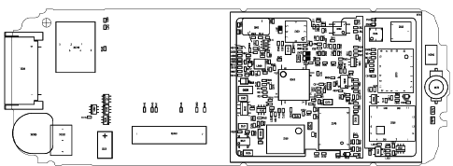

Figure 2: SL45/6688 Bottom Connector Placement (Top View)
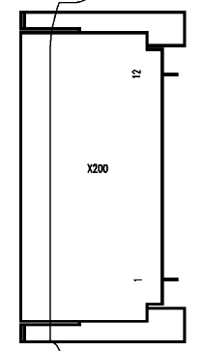
Pin 12
Pin 1

Table 1: SL45/6688 Bottom Connector Pin Description

Pin | Name | IN/OUT | Notes
1 | GND
2 | HS_LEFT | I/O | Output left channel for stereo-headset.
3 | POWER | I | Charging Current
4 | FBatt+ | O | Power supply for the accessories.
5 | TX | O | Serial interface
6 | RX | I | Serial interface
7 | ZUB_CLK | I/O | Clock line for accessory bus  Use as DTC In data operation
8 | ZUB_DATA | I/O | Data line for accessory bus.  Use as CTS in data operation
9 | GND_MIC |  | For external microphone
10 | MICP2 | I | External microphone
11 | HS_RIGHT | O | Output right channel for stereo-headset
12 | LGND |  | For external loudspeaker

Display Connector

Affected Units

Type: SL45/6688

Affected IMEIs / Date Codes: All / All

Affected SW-Versions: All

Fault Code for LSO reporting: 3DIC

Fault Description

Fault Symptoms for customers:

Display problems, like missing lines or columns on the LCD or display contrast problems.

Fault Symptom on GSM-Tester:

Display test fails.

Priority:

❐ ........ Mandatory
 ........ Repair
❐ ........ Optional
❐ ........ Not Yet Defined

Repair Documentation

Description of procedure:

Diagnosis
Visually check the status of the display connector. Watch for oxidation and dry solder joints.
Mechanically check the opening / closing mechanism.

Repair by component change

Use hot air to remove defective connector
Avoid excessive heat!
Watch surrounding components!!

Resolder new connector afterwards

Repair by SW-Booting

Not possible!

Test
Retest handset after repair.

List of needed material

Components Display connector SL45/6688:
Part-Number: L36334-Z97-C130

Jigs and Tools

Soldering Iron
Hot Air Blower

Special Tools

None

Working materials

Desolder Wick / Braid
Solder

Drawings

Figure 1: SL45/6688 board display connector side

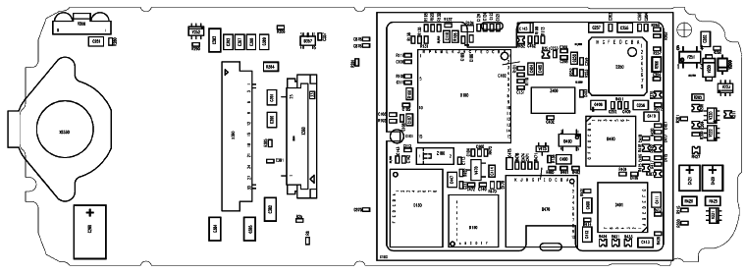

Figure 2: SL45/6688 display connector placement (Top View)

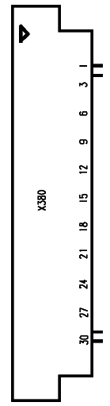

Keyboard LEDs

Affected Units

Type: SL45/6688

Affected IMEIs / Date Codes: All / All

Affected SW-Versions: All

Fault Code for LSO reporting: 3LED

Fault Description

Fault Symptoms for customers:

Keyboard Illumination does not work.

Fault Symptom on GSM-Tester:

This fault cannot be detected with a GSM-Tester

Priority:

❐ ........ Mandatory
 ........ Repair
❐ ........ Optional
❐ ........ Not Yet Defined

Repair Documentation

Description of procedure:

Diagnosis

Use the diode test function of a multimeter to check the status of the diode.
The typical voltage drop on the diode is 1.7V when testing the diode function with the multimeter.

Repair by component change

Use soldering iron to remove defective diode
Avoid excessive heat!
Watch surrounding components!

Resolder new diode afterwards.

Repair by SW-Booting

Not possible!

Test
Retest handset after repair.

List of needed material

Components

LED keyboard SL45/6688
Part-Number: L36840-L2057-D670

Jigs and Tools

Hot Air Blower
Soldering Iron

Special Tools

None

Working materials

Desolder Wick / Braid
Solder

Drawings

Figure 1: SL45/6688 board keyboard LED Side

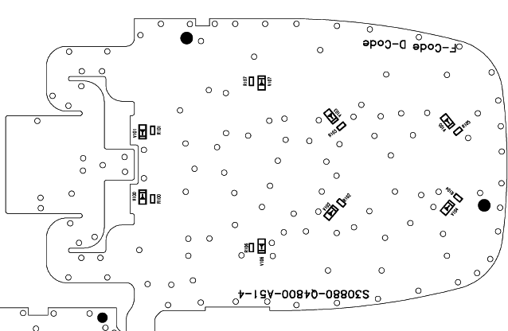

Figure 2: SL45/6688 keyboard LED placement (top view)

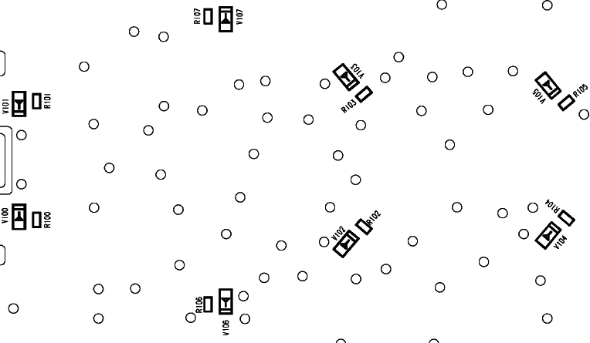

Keyboard Connector

Affected Units

Type: SL45/6688

Affected IMEIs / Date Codes: All / All

Affected SW-Versions: All

Fault Code for LSO reporting: 3KCO

Fault Description

Fault Symptoms for customers:

Keyboard does not work.
Keyboard Illumination does not work
Mobile does not switch on via keyboard.

Fault Symptom on GSM-Tester:

The keyboard test fails on the defective button
The illumination fault cannot be detected with a GSM-Tester.

Priority:

❐ ........ Mandatory
 ........ Repair
❐ ........ Optional
❐ ........ Not Yet Defined

Repair Documentation

Description of procedure:

Diagnosis

Repair by component change

Use soldering iron to remove defective connector
Avoid excessive heat!
Watch surrounding components!

Resolder new diode afterwards.

Repair by SW-Booting

Not possible!

Test
Retest handset after repair.

List of needed material

Components

Keyboard connector SL45/6688
Part-Number: L36195-Z26-C624

Jigs and Tools

Hot Air Blower
Soldering Iron

Special Tools

None

Working materials

Desolder Wick / Braid
Solder

Drawings

Figure 1: SL45/6688 board display connector Side

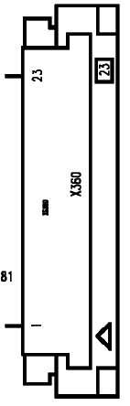Figure 2: SL45/6688 board display LED placement

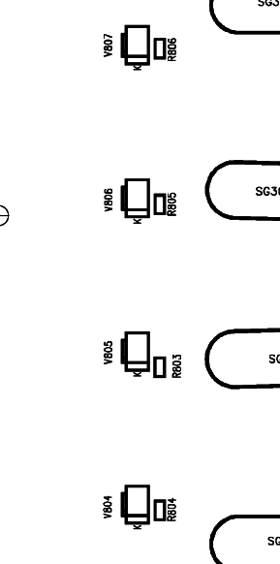
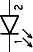

Irda Diode

Affected Units

Type: SL45/6688

Affected IMEIs / Date Codes: All / All

Affected SW-Versions: All

Fault Code for LSO reporting: 3INF

Fault Description

Fault Symptoms for customers:

No infrared connection possible.

Fault Symptom on GSM-Tester:

This fault cannot be detected with a GSM-Tester.

Priority:

❐ ........ Mandatory
 ........ Repair
❐ ........ Optional
❐ ........ Not Yet Defined

Repair Documentation

Description of procedure:

Diagnosis
Visually check the status of the IrDa module. Watch for dry solder joints.
Use a reference infrared port (eg. from a notebook) to check the IrDa function. If the notebook recognizes the S35, the infrared function is ok.

Check the status (reverse blocking) of the diode V201 with a multimeter.

Repair by component change

Use hot air to remove defective infrared module.
Avoid excessive heat!
Watch surrounding components!!

Resolder new module afterwards

Repair by SW-Booting

Not possible!

Test
Retest handset after repair

List of needed material

Components Infrared diode
Part-Number: L36810-U6030-D670

Jigs and Tools

Soldering Iron
Hot Air Blower

Special Tools

None

Working materials

Desolder Wick / Braid
Solder

Drawings

Figure 1: SL45/6688 board IRDA side

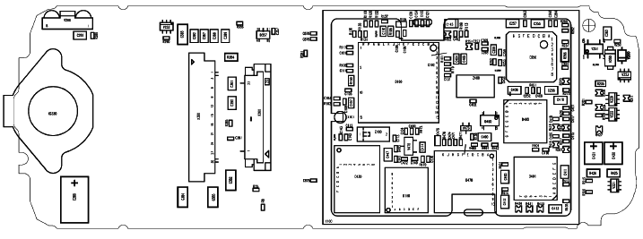
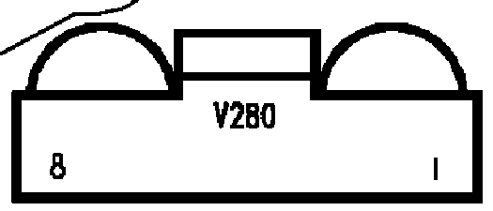

Figure 2: SL45/6688 IRDA placement (Top View)

Antenna Connector

Affected Units

Type: SL45/6688

Affected IMEIs / Date Codes: All / All

Affected SW-Versions: All

Fault Code for LSO reporting: 3ANC

Fault Description

Fault Symptoms for customers:

Network Search when using the external antenna (carkit)
No location update possible on external antenna (carkit)

Fault Symptom on GSM-Tester:

Output power problems on the external antenna.
No location update possible

Component Information

The Antenna Connector is a mechanical switch operated by the RF plug of a carkit or, for testing purposes, of an RF clip.
Normally the RF signal goes to and comes from the internal antenna. Whenever an RF plug is plugged into the antenna connector the connection to the internal antenna is opened and the connection to the external antenna socket is made. See drawing below.

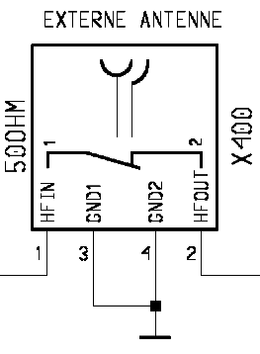
From Power Amplifier/
To Receiver

To / From Internal Antenna

Priority:

❐ ........ Mandatory
 ........ Repair
❐ ........ Optional
❐ ........ Not Yet Defined

Repair Documentation

Description of procedure:

Diagnosis
Check the output power of the handset with the LSO testprogram. Especially watch the external antenna power!

Repair by component change

Use soldering iron to remove defective capacitor.
Avoid excessive heat!
Watch surrounding components!!

Resolder new capacitor afterwards

Repair by SW-Booting

Not possible!

Test
Retest handset after repair

List of needed material

Components

SL45/6688 antenna connector

Attention: This is not the same connector as C25/S25 !!!

Part-Number: L36334-Z93-C272

Jigs and Tools

Soldering Iron
Hot Air Blower

Special Tools

None

Working materials

Desolder Wick / Braid
Solder

Drawings

Figure 1: SL45/6688 board antenna connector side

Figure 2: SL45/6688 antenna connector placement (Top View)

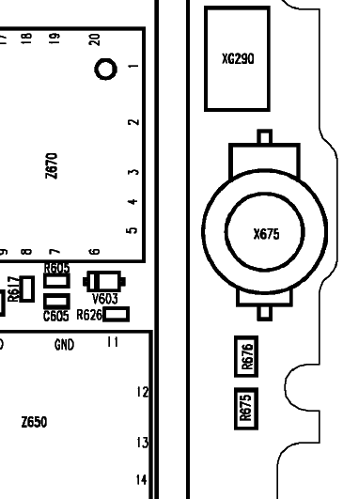

Resistor R384

Affected Units

Type: SL45/6688

Affected IMEIs / Date Codes: All / All

Affected SW-Versions: All

Fault Code for LSO reporting: 3DRE

Fault Description

Fault Symptoms for customers:

Irregular display illumination

Fault Symptom on GSM-Tester:

This fault cannot be detected with a GSM-Tester.

Priority:

❐ ........ Mandatory
 ........ Repair
❐ ........ Optional
❐ ........ Not Yet Defined

Repair Documentation

Description of procedure:

General Information
The old display type is replaced by a new one. The replacement has been done in the production in mid-February. The new display module has 4 additional resistors inside.
Also the series resistor R384 located on the mainboard has changed its value from 39Ω to 0.1Ω.
If the display needs to be exchanged the hardware status of the mainboard and the display module must be checked.

- For boards with a new HW status the resistor R384 has a value of 0.1Ω
- For boards with an old HW status the resistor R384 has a value of 39Ω

Diagnosis
Check the status of the resistor with a multimeter.

Repair by component change

Use soldering iron to remove defective capacitor.
Avoid excessive heat!
Watch surrounding components!!

Repair by SW-Booting

Not possible!

Test
Retest handset after repair

List of needed material

Components SL45/6688 Resistor R384
Part-Number: L36245-F4000-F100

Jigs and Tools

Soldering Iron
Hot Air Blower

Special Tools

None

Working materials

Desolder Wick / Braid
Solder

Drawings

Figure 1: SL45/6688 board R384 side

Figure 2: SL45/6688 R384 placement (Top View)

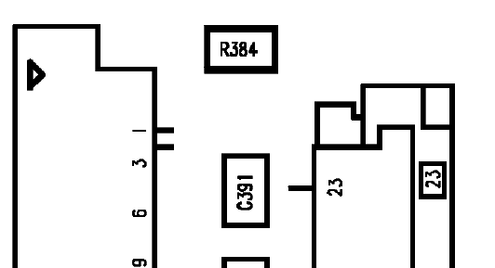

Voltage Protection Diode V200

Affected Units

Type: SL45/6688

Affected IMEIs / Date Codes: All / All

Affected SW-Versions: All

Fault Description

Fault Symptoms for customers:

External equipment which needs power via the I/O connector does not work.

Fault Symptom on GSM-Tester:

BATT+ rises too fast

Priority:

❐ ........ Mandatory
 ........ Repair
❐ ........ Optional
❐ ........ Not Yet Defined

Repair Documentation

Description of procedure:

General Information
The purpose of the diode V200 is to prevent the feedback of external connected equipment. An external voltage, connected to the I/O connector, may damage the accumulator.

Diagnosis
Check the status (reverse blocking) of the diode V200 with a multimeter.

Repair by component change

Use soldering iron to remove defective diode.
Avoid excessive heat!
Watch surrounding components!!

Resolder new diode afterwards

Repair by SW-Booting

Not possible!

Test
Retest handset after repair

List of needed material

Components

Diode V200
Part-Number: L36840-D5035-D670

Jigs and Tools

Soldering Iron
Hot Air Blower

Special Tools

None

Working materials

Desolder Wick / Braid
Solder

Drawings

Figure 1: X35 V200 side

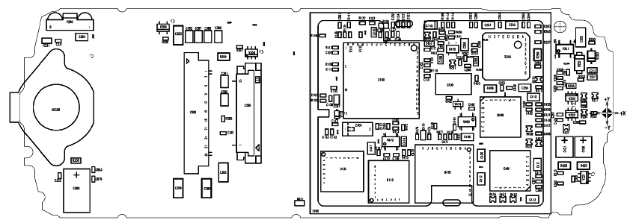

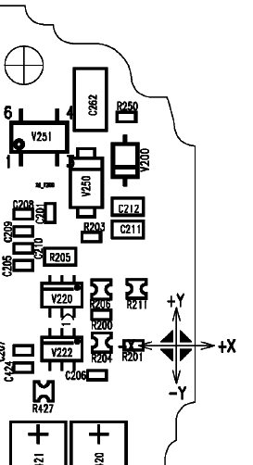
Figure 2: X35 V279 placement (Top View)

V200

