SL10
Level 2.5

Repair Documentation

V 1.3

Table of Contents:

1 Introduction 3
2 TCXO 4
3 Fuse 1A 8
4 Connector X1 - Lower MMI 12
5 Connector X2 - Upper MMI + Flexible Cable 16
6 Ringer 21
7 31µH Coil 24
8 Flexible Cable Microphone 28

Introduction

This manual is intended to help you carry out SL10 repairs on level 2.5, meaning limited component repairs. Failure highlights are documented and should be repaired in the local workshops.

It must be noted that all repairs have to be carried out in an environment set up according to the ESD (Electrostatic Discharge Sensitive Devices) regulations defined in international standards.

If you have any questions regarding the repair procedures or spare parts do not hesitate to contact our technical support team in Kamp-Lintfort, Germany:

Tel.: +49 2842 95 4666
Fax: +49 2842 95 4302
e-mail: dominik.schnoor@klf.siemens.de

TCXO

Affected Units

Type: SL10

Affected IMEIs / Date Codes: All / All

Affected SW-Versions: All

Fault Code for LSO reporting: 3TCX

Fault Description

Fault Symptoms for customers:

Network Search
Handset not logging into network

Fault Symptom on GSM-Tester:

Frequency error in synchronized mode >90 Hz
No location update possible

The TCXO (Temperature Compensated Crystal Oscillator) is responsible for generating the
13 MHz reference frequency of the handset.
If it is defective, the handset cannot synchronize to the base station anymore.

Priority:

❐ ........ Mandatory
 ........ Repair
❐ ........ Optional
❐ ........ Not Yet Defined

Repair Documentation

Description of procedure:

Diagnosis

Check the output frequency of the TCXO using the level-2 testing
program for SL10.
Set the „Simulator“ option in the S611.INI file to 0 and restart
the program. Start the test. When the program says „Check power and phase of external antenna with your GSM-Tester“, switch the CMD to „LOCAL“ mode and enter the „MODULE TEST“.
On the CMD display you can see the frequency error of the handset.
(Make sure that the CMD is on channel 124, power level 5!)

If the frequency error is higher than 2kHz, the TCXO has to be replaced.

Repair by component change

Use hot air blower to remove defective TCXO.
Avoid excessive heat!
Watch surrounding components!

Resolder new TCXO afterwards.

Repair by SW-Booting

Not possible!

Test
Retest handset after repair as described above.
The frequency error must now be < 2kHz.

List of needed material

Components

TCXO
Part-Number: L36145-G300-Y17

Jigs and Tools

Hot Air Blower
Soldering Iron

Special Tools

None

Working materials

Desolder Wick / Braid
Solder

Drawings
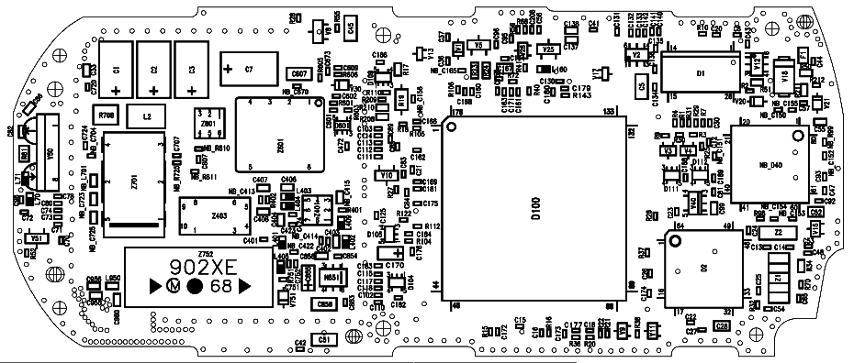

Figure 1: SL10 Board TCXO Side

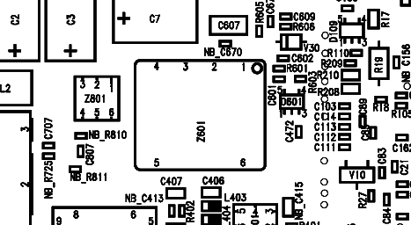

Figure 2: TCXO (Z601) Placement (Top View)

Fuse 1A

Affected Units

Type: SL10

Affected IMEIs / Date Codes: All / All

Affected SW-Versions: All

Fault Code for LSO reporting: 3FU1

Fault Description

Fault Symptoms for customers:

Battery charging not possible

Fault Symptom on GSM-Tester:

This fault cannot be detected with a GSM-Tester

Priority:

❐ ........ Mandatory
 ........ Repair
❐ ........ Optional
❐ ........ Not Yet Defined

Repair Documentation

Description of procedure:

Diagnosis

Check the status of the fuse by measuring its resistance with
a multimeter. The fuse is defective if the resistance is higher than 10 ohms.

Repair by component change

Use soldering iron to remove defective fuse.
Avoid excessive heat!
Watch surrounding components!

Resolder new fuse afterwards.

Repair by SW-Booting

Not possible!

Test
Retest handset after repair as described above.
The resistance must now be close to zero.

List of needed material

Components

Fuse
Part-Number: L36145-A820-Y7

Jigs and Tools

Soldering Iron

Special Tools

Multimeter

Working materials

Desolder Wick / Braid
Solder

Drawings

Figure 1: SL10 Board 1A Fuse Side

Figure 2: 1A Fuse (F1) Placement (Top View)

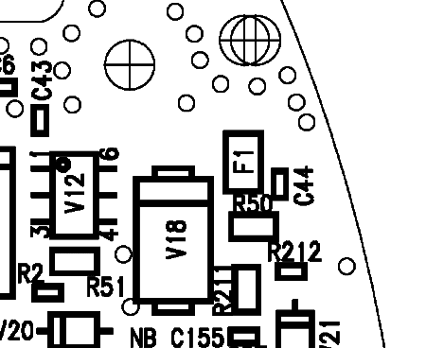

Connector X1 - Lower MMI

Affected Units

Type: SL10

Affected IMEIs / Date Codes: All / All

Affected SW-Versions: All

Fault Code for LSO reporting: 3X1C

Fault Description

Fault Symptoms for customers:

Problems with main keyboard. Either keys or the keyboard illumination not working properly.

Fault Symptom on GSM-Tester:
Handset fails test of main keyboard

Priority:

❐ ........ Mandatory
 ........ Repair
❐ ........ Optional
❐ ........ Not Yet Defined

Repair Documentation

Description of procedure:

The connector X1 is connecting the main board of the SL10 with the main
keyboard through a flexible cable.

Diagnosis

Visually check the connector. Watch for dry joints.

Repair by component change
Resolder dry soldering joints.
If the connector is physically damaged use hot air blower or wick to remove defective connector.
Avoid excessive heat!
Watch surrounding components!

Resolder new connector afterwards.

Repair by SW-Booting

Not possible!

Test
Retest handset after repair.

List of needed material

Components

Connector X1:
Part-Number: L36195-Z26-C618

Jigs and Tools

Hot Air Blower
Soldering Iron

Special Tools

None

Working materials

Desolder Wick / Braid
Solder
Flux

Drawings

Figure 1: SL10 Board X1 Connector Side

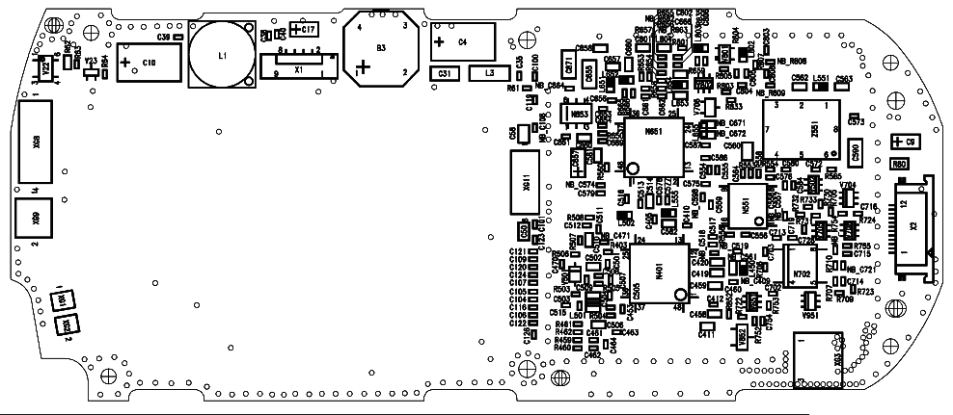

Figure 2: Connector X1 Placement (Top View)

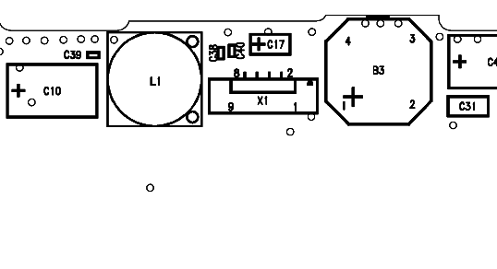

Connector X2 - Upper MMI + Flexible Cable

Affected Units

Type: SL10

Affected IMEIs / Date Codes: All / All

Affected SW-Versions: All

Fault Code for LSO reporting: Connector X2: 3X2C
Flexible Cable MMI: 3FL2

Fault Description

Fault Symptoms for customers:

Slider keypad does not work properly.
Display problems.
Display or keyboard illumination problems.

Fault Symptom on GSM-Tester:

Handset fails the keyboard, display or illumination test.

Priority:

❐ ........ Mandatory
 ........ Repair
❐ ........ Optional
❐ ........ Not Yet Defined

Repair Documentation

Description of procedure:

The connection between the main board and the upper MMI is made
through the connector X2 and a flexible cable. The signals of these
connection are:
1) Display signals.
2) Earphone (loudspeaker) signals.
3) Display / Keyboard illumination signals.

Diagnosis
Visually check the connector. Watch for dry joints.
Visually check the flexible cable coming from the upper MMI. Watch for dry joints on the MMI.

Repair by component change

Resolder dry soldering joints.
If the connector or flexible cable is physically damaged use hot air blower or wick to remove defective connector / cable.
Avoid excessive heat!
Watch surrounding components!

Resolder new connector/cable afterwards.

Repair by SW-Booting

Not possible!

Test
Retest handset after repair an verify proper function.

List of needed material

Components
Connector X2:
Part-Number: L36195-Z26-C617
Flexible Cable MMI:
Part-Number: L36880-Q1600-A4

Jigs and Tools

Soldering Iron
Hot Air Blower

Special Tools

None

Working materials

Desolder Wick / Braid
Solder

Drawings

Figure 1: SL10 Board MMI Connector (X2) Side

Figure 2: MMI Connector (X2) Placement (Top View)

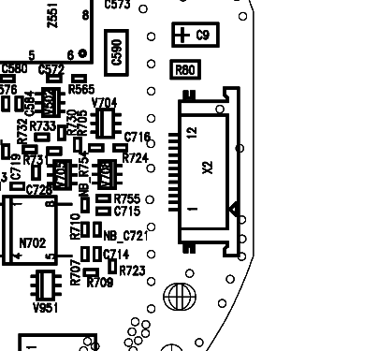

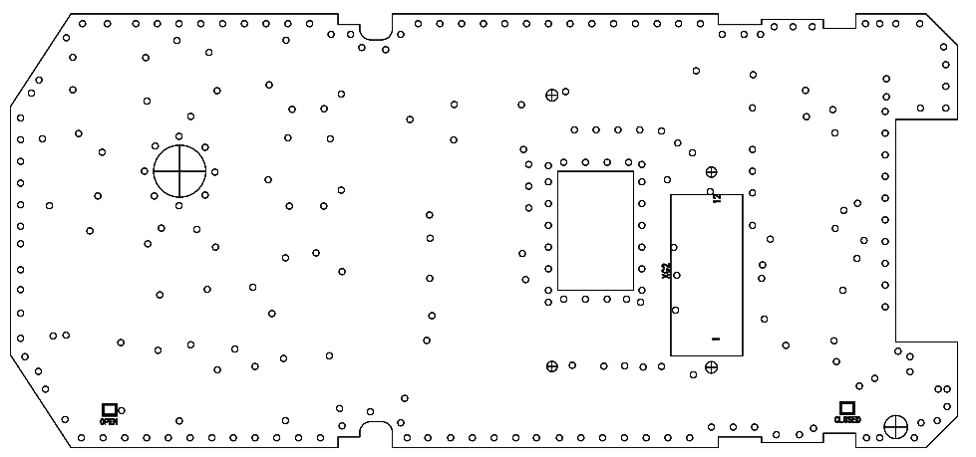

Figure 3: SL10 MMI Board Flexible Cable Side (Top View)
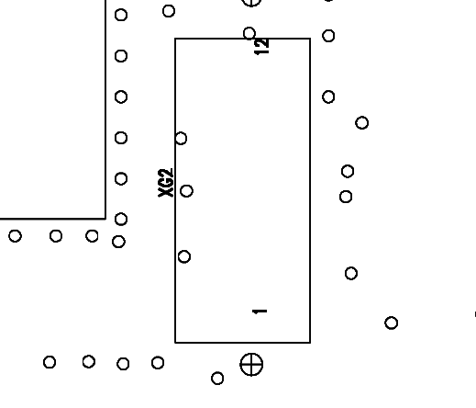

Figure 4: SL10 MMI Board Flexible Cable Soldering Pads

Ringer

Affected Units

Type: SL10

Affected IMEIs / Date Codes: All / All

Affected SW-Versions: All

Fault Code for LSO reporting: 3RIN

Fault Description

Fault Symptoms for customers:

No ringer tone audible or ringer tone distorted.

Fault Symptom on GSM-Tester:

Ringer check fails.

Priority:

❐ ........ Mandatory
 ........ Repair
❐ ........ Optional
❐ ........ Not Yet Defined

Repair Documentation

Description of procedure:

Diagnosis

Check ringer functionality either manually or with testing program.

Repair by component change

Use hot air blower remove defective ringer.
Avoid excessive heat!
Watch surrounding components!

Resolder new ringer afterwards.
Watch placement of ringer hole!

Repair by SW-Booting

Not possible!

Test
Retest handset after repair.

List of needed material

Components

Ringer
Part-Number: L36178-Z2-C15

Jigs and Tools

Hot Air Blower
Soldering Iron

Special Tools

None

Working materials

Desolder Wick / Braid
Solder

Drawings

Figure 1: SL10 Board Ringer Side

Figure 2: Ringer (B3) Placement (Top View)

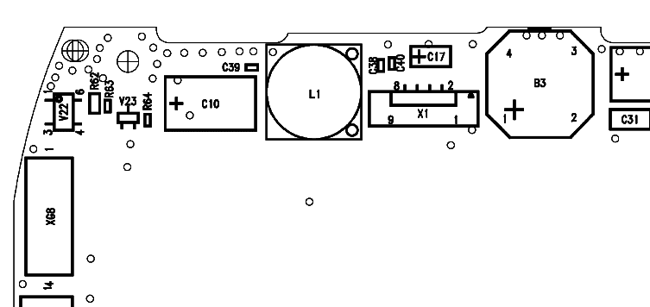

31µH Coil

Affected Units

Type: SL10

Affected IMEIs / Date Codes: All / All

Affected SW-Versions: All

Fault Code for LSO reporting: 3COI

Fault Description

Fault Symptoms for customers:

Loud humming noise in loudspeaker.

Fault Symptom on GSM-Tester:

Handset fails with loud humming noise in echo loop.

Priority:

❐ ........ Mandatory
 ........ Repair
❐ ........ Optional
❐ ........ Not Yet Defined

Repair Documentation

Description of procedure:

Diagnosis
The 31µH coil is used in the step up converter which is generating a
6.0 V supply voltage for the power amplifier out of the 2.8V battery voltage.
If the coil is mechanically damaged (broken) it produces heavy interference with the acoustical elements of the SL10 resulting in a loud humming noise in the earpiece.

A broken coil can easily be diagnosed by trying to move it with two fingers. If it moves, the core is broken and the coil has to be
replaced.

Repair by component change

Use hot air to remove defective coil.
Avoid excessive heat!
Watch surrounding components!!

Resolder new coil afterwards

Repair by SW-Booting

Not possible!

Test
Retest handset after repair by checking the audio quality with the echo loop of the testprogram.

List of needed material

Components
Part-Number: L36151-F5273-M3

Jigs and Tools

Soldering Iron
Hot Air Blower

Special Tools

None

Working materials

Desolder Wick / Braid
Solder

Drawings

Figure 1: SL10 Board 31µH Coil (L1) Side

Figure 2: 31µH Coil (L1) Placement (Top View)

Flexible Cable Microphone

Affected Units

Type: SL10

Affected IMEIs / Date Codes: All / All

Affected SW-Versions: All

Fault Code for LSO reporting: 3FL1

Fault Description

Fault Symptoms for customers:

No microphone function.
Other party cannot hear callers’s voice.

Fault Symptom on GSM-Tester:

Microphone test fails.

Priority:

❐ ........ Mandatory
 ........ Repair
❐ ........ Optional
❐ ........ Not Yet Defined

Repair Documentation

Description of procedure:

The microphone is connected to the main board through a two pin flexible cable.

Diagnosis

Check microphone functionality either manually or with testing program.

Repair by component change

Use hot air blower remove defective cable.
Avoid excessive heat!
Watch surrounding components!

Resolder new cable afterwards.

Repair by SW-Booting

Not possible!

Test
Retest handset after repair.

List of needed material

Components

Flexible Cable Microphone
Part-Number: L36880-Q1600-A5

Jigs and Tools

Hot Air Blower
Soldering Iron

Special Tools

None

Working materials

Desolder Wick / Braid
Solder

Drawings

Figure 1: SL10 Board Microphone Cable Side

Figure 2: Microphone Cable Soldering Pads (XG1;XG2)
Placement (Top View)

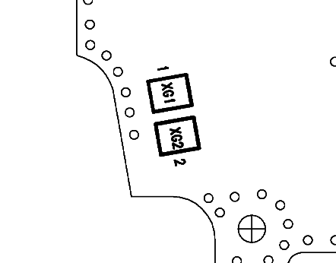

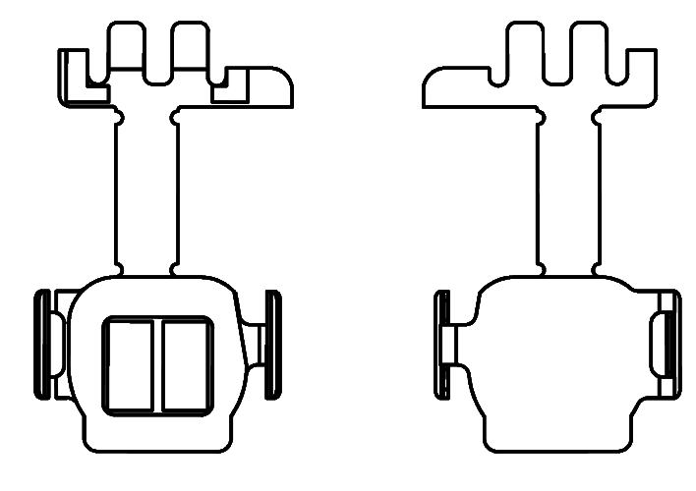

Figure 3: Flexible Cable Microphone

