S46

Level 2.5

Repair Documentation

V 1.0

Content of Training

1 Introduction 3
2 I/O Connector (Lumberg) 4
3 Keypad Connector 8
4 Antenna Connector 14
5 IrDA Interface 18
6 Keypad LEDs 21

Introduction

The S46 is a four-mode phone, able to operate in TDMA 800, TDMA 1900, GSM 1900 and
EGSM 900 mode. The EGSM 900 mode is not supported in U.S.A and so the phone will not operate in this mode outside EGSM 900 coverage.

Partnumber on IMEI label:

S46: S30880-S5450-#xxx

,while # may be any letter (A-Z) and xxx may be any number from 100, 101, 102....

This manual is intended to help you carry out repairs on level 2.5, meaning limited component repairs. Failure highlights are documented and should be repaired in the local workshops.

It must be noted that all repairs have to be carried out in an environment set up according to the ESD (Electrostatic Discharge Sensitive Devices) regulations defined in international standards.

If you have any questions regarding the repair procedures or technical questions about the spare parts do not hesitate to contact our technical support team in Kamp-Lintfort, Germany:

Tel.: +49 2842 95 4666
Fax: +49 2842 95 4302
e-mail: st-support@klf.siemens.de

I/O Connector (Lumberg)

Affected Units

Type: S46

Affected IMEIs / Date Codes: All / All

Affected SW Versions: All

Fault Description

Fault Symptoms for customers:

- Charging problems.
- Problems with external loudspeaker or microphone
when using a car kit.
- Problems with accessories connected at the I/O -
connector.
- Problems with SW booting

Fault Symptoms on GSM Tester:

This fault cannot be detected with a GSM-Tester

Priority:

◻ Mandatory
☑ Repair
◻ Optional
◻ Not Yet Defined

Repair Documentation:

Description of procedure:

Diagnosis:

Visually check the bottom connector. Watch for dry joints:

Repair by component change:

Use hot air blower remove defective I/O connector.
Avoid excessive heat!
Watch surrounding components!

Resolder new I/O connector afterwards.

Repair by Software booting:

Not possible!

Test:

Retest handset after repair.

List of needed material:

Components:

I/O Connector S46
Part-Number: L36334-Z93-C262

Jigs and Tools:

Hot Air Blower
Soldering Iron

Special tools:

None

Working materials

Desolder Wick / Braid
Solder

Drawings

Figure 1: S46 board I/O connector

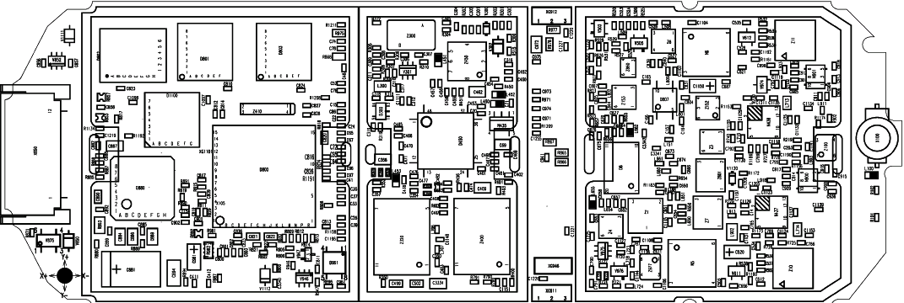

Figure 2: S46 I/O connector placement (top view)
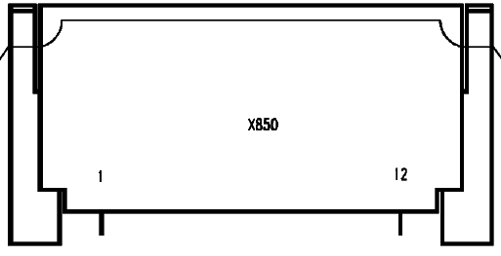

Table 1: S46 Bottom Connector Pin Description

Pin | Name | IN/OUT | Notes
1 | GND
2 | SB | I/O | Charger coding and charger control.
3 | POWER | I | Charging Current
4 | Batt+ | O | Power supply for accessories.
5 | TX0 | O | Serial interface
6 | RX_BC | I | Serial interface
7 | ZUB_CLÒCK | I/O | Clock line for accessory bus  Use as DTC In data operation
8 | ZUB_DATA | I/O | Data line for accessory bus.  Use as CTS in data operation
9 | GND_MIC |  | For external microphone
10 | HF_MICRO | I | External microphone
11 | EPP_EXT | O | External loudspeaker
12 | EPN_EXT | O | External loudspeaker

Keypad Connector

Affected Units

Type: S46

Affected IMEIs / Date Codes: All / All

Affected SW Versions: All

Fault Description

Fault Symptoms for customers:

Problems with MMI functions like:

Keyboard malfunction
Illumination problems

Fault Symptoms on GSM Tester:

The keyboard test fails.

Priority:

◻ Mandatory
☑ Repair
◻ Optional
◻ Not Yet Defined

Repair Documentation:

Description of procedure:

Diagnosis:

Visually check the status of the Keypad connector. Watch for oxidation and dry solder joints.
Mechanically check the opening / closing mechanism.

Repair by component change:

Use hot air blower remove defective Keypad connector.
Avoid excessive heat!
Watch surrounding components!

Resolder new Keypad connector afterwards.

Repair by Software booting:

Not possible!

Test:

Retest handset after repair.

List of needed material:

Components:

Keypad Connector S46
Part-Number: L36334-Z97-C129

Jigs and Tools:

Hot Air Blower
Soldering Iron

Special tools:

None

Working materials

Desolder Wick / Braid
Soldering Iron

Drawings

Figure 1: S46 board Keypad connector

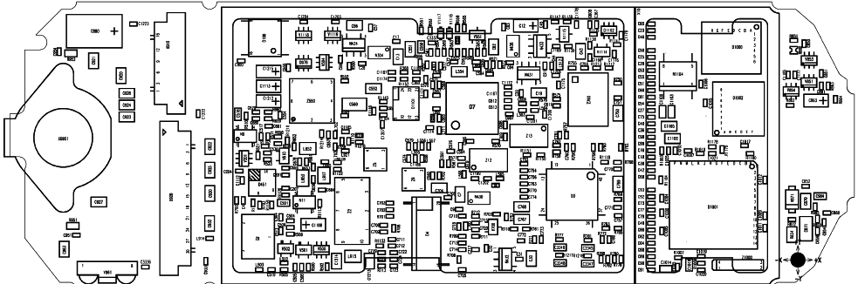

Figure 2: S46 Keypad connector placement (top view)

Display Connector

Affected Units

Type: S46

Affected IMEIs / Date Codes: All / All

Affected SW Versions: All

Fault Description

Fault Symptoms for customers:

Display problems, like missing lines or columns on the LCD or display contrast problems.

Fault Symptoms on GSM Tester:

Display tests failed.

Priority:

◻ Mandatory
☑ Repair
◻ Optional
◻ Not Yet Defined

Repair Documentation:

Description of procedure:

Diagnosis:

Visually check the status of the Display connector. Watch for oxidation and dry solder joints.
Mechanically check the opening / closing mechanism.

Repair by component change:

Use hot air blower remove defective Display connector.
Avoid excessive heat!
Watch surrounding components!

Resolder new Display connector afterwards.

Repair by Software booting:

Not possible!

Test:

Retest handset after repair.

List of needed material:

Components:

Display Connector S46
Part-Number: L36334-Z97-C130

Jigs and Tools:

Hot Air Blower
Soldering Iron

Special tools:

None

Working materials

Desolder Wick / Braid
Soldering Iron

Drawings

Figure 1: S46 board Display connector

Figure 2: S46 Display connector placement (top view)

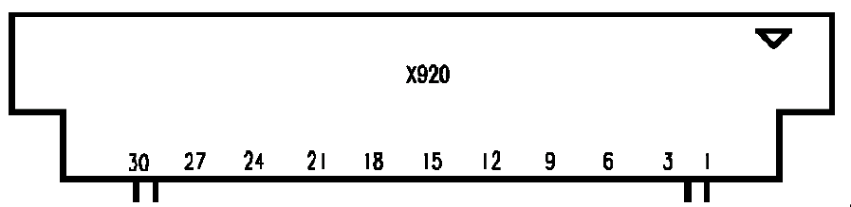

Antenna Connector

Affected Units

Type: S46

Affected IMEIs / Date Codes: All / All

Affected SW Versions: All

Fault Description

Fault Symptoms for customers:

Network Search
No location update possible

Fault Symptoms on GSM Tester:

Output power problems on the external and internal antenna
No location update possible

Component Information:
The Antenna Connector is a mechanical switch operated by the RF plug of a carkit.
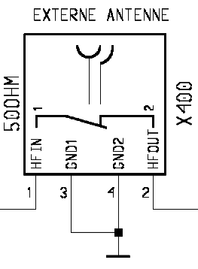
Normally the RF signal goes to and comes from the internal antenna. Whenever an RF plug is plugged into the antenna connector the connection to the internal antenna is opened and the connection to the external antenna socket is made. When the antenna connector is blocked without RF plug the connection to the internal antenna is also opened. See drawing below.

From Power Amplifier/
To Receiver
To/From Internal Antenna

Priority:

◻ Mandatory
☑ Repair
◻ Optional
◻ Not Yet Defined

Repair Documentation:

Description of procedure:

Diagnosis:

Check the output power of the handset with the LSO testprogram. Especially watch the external antenna power!

Repair by component change:

Use hot air to remove defective antenna connector.
Avoid excessive heat!
Watch surrounding components!!

Resolder new module afterwards

Repair by Software booting:

Not possible!

Test:

Retest handset after repair.

List of needed material:

Components:

Antenna Connector S46
Part-Number: L36334-Z93-C272

Jigs and Tools:

Hot Air Blower
Soldering Iron

Special tools:

None

Working materials

Desolder Wick / Braid
Soldering Iron

Drawings

Figure 1: S46 board Antenna connector

Figure 2: S46 Antenna connector placement (top view)

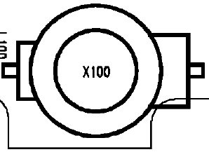

IrDA Interface

Affected Units

Type: S46

Affected IMEIs / Date Codes: All / All

Affected SW Versions: All

Fault Description

Fault Symptoms for customers:

No infrared connection possible.

Fault Symptoms on GSM Tester:

This fault cannot be detected with a GSM-Tester

Priority:

◻ Mandatory
☑ Repair
◻ Optional
◻ Not Yet Defined

Repair Documentation:

Description of procedure:

Diagnosis:

Visually check the IrDA. Watch for dry joints:

Repair by component change:

Use soldering iron to remove defective diode.
Avoid excessive heat!
Watch surrounding components!

Resolder new diode afterwards.

Repair by Software booting:

Not possible!

Test:

Retest handset after repair.

List of needed material:

Components:

IrDA S46
Part-Number: L36840-U6030-D670

Jigs and Tools:

Hot Air Blower
Soldering Iron

Special tools:

None

Working materials

Desolder Wick / Braid
Soldering Iron

Drawings

Figure 1: S46 board IrDA

Figure 2: S46 IrDA placement (top view)

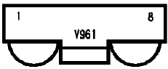

Keypad LEDs

Affected Units

Type: S46

Affected IMEIs / Date Codes: All / All

Affected SW Versions: All

Fault Description

Fault Symptoms for customers:

Keyboard Illumination does not work.

Fault Symptoms on GSM Tester:

This fault cannot be detected with a GSM-Tester

Priority:

◻ Mandatory
☑ Repair
◻ Optional
◻ Not Yet Defined

Repair Documentation:

Description of procedure:

Diagnosis:

Use the diode test function of a multimeter to check the status of the diode.The typical voltage drop on the diode is 1.7V when testing the diode function with the multimeter

Repair by component change:

Use soldering iron to remove defective diode.
Avoid excessive heat!
Watch surrounding components!!

Resolder new diode afterwards ards.

Repair by Software booting:

Not possible!

Test:

Retest handset after repair.

List of needed material:

Components:

LEDs S46
Part-Number: L36840-L2056-D670

Jigs and Tools:

Hot Air Blower
Soldering Iron

Special tools:

None

Working materials

Desolder Wick / Braid
Soldering Iron

Drawings

Figure 1: S46 S46 LEDs placement (top view)

