C35(i), M35(i), S35
Level 2.5

Repair Documentation

V 0.9

Table of Contents:

1 Introduction 3
2 Antenna Connector 4
3 Ringer 8
4 Bottom Connector (Lumberg) 11
5 Display Connector 15
6 Keyboard LEDs 19
7 Display LEDs 22
8 Infrared Diodes 26

Introduction

The C/M/S35 product family consists of 5 different dualband handsets (GSM-900 and GSM-1800), which can easily be distinguished from the second block of the partnumber printed on the IMEI label. There also exist Asian variants of C/M/S35 named 3508 / 3518 / 3568 respectively. All information below also applies to the Asian variants unless otherwise noted.

Partnumber on IMEI label:

- C35 / 3508: S30880-S4000-Xxxx

- C35i / 3508i: S30880-S4050-Xxxx
Same as C35 / 3508 but with additional WAP and fax/data capabilities

- M35 / 3518: S30880-S4200-Xxxx

- M35i / 3518i: S30880-S4250-Xxxx
Same as M35 / 3518 but with additional WAP and fax/data capabilities

- S35i / 3568i: S30880-S4100-Xxxx

This manual is intended to help you carry out repairs on level 2.5, meaning limited component repairs. Failure highlights are documented and should be repaired in the local workshops.

It must be noted that all repairs have to be carried out in an environment set up according to the ESD (Electrostatic Discharge Sensitive Devices) regulations defined in international standards.

If you have any questions regarding the repair procedures or spare parts do not hesitate to contact our technical support team in Kamp-Lintfort, Germany:

Tel.: +49 2842 95 4666
Fax: +49 2842 95 4302
e-mail: dominik.schnoor@klf.siemens.de

Antenna Connector

Affected Units

Type: C/M/S35

Affected IMEIs / Date Codes: All / All

Affected SW-Versions: All

Fault Code for LSO reporting: 3ANC

Fault Description

Fault Symptoms for customers:

Network Search when using the external antenna (carkit)
No location update possible on external antenna (carkit)

Fault Symptom on GSM-Tester:

Output power problems on the external antenna
No location update possible

Component Information
The Antenna Connector is a mechanical switch operated by the RF plug of a carkit or, for testing purposes, of an RF clip.
Normally the RF signal goes to and comes from the internal antenna. Whenever an RF plug is plugged into the antenna connector the connection to the internal antenna is opened and the connection to the external antenna socket is made. See drawing below.

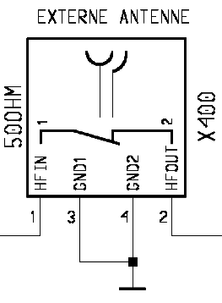
From Power Amplifier/
To Receiver

To / From Internal Antenna

Priority:

❐ ........ Mandatory
 ........ Repair
❐ ........ Optional
❐ ........ Not Yet Defined

Repair Documentation

Description of procedure:

Diagnosis

Check the output power of the handset with the LSO testprogram. Especially watch the external antenna power!

Repair by component change

Use hot air blower to remove defective connector
Avoid excessive heat!
Watch surrounding components!

Resolder new connector afterwards.

Repair by SW-Booting

Not possible!

Test
Retest handset after repair as described above.

List of needed material

Components

X35 antenna connector
Attention: This is not the same connector as C25/S25 !!!

Part-Number: L36334-Z93-C272

Jigs and Tools

Hot Air Blower
Soldering Iron

Special Tools

None

Working materials

Desolder Wick / Braid
Solder

Drawings
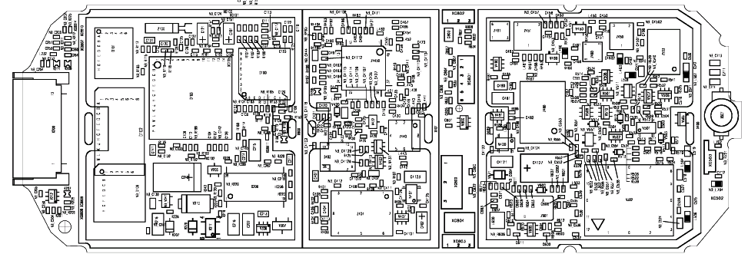

Figure 1: X35 Board Antenna Connector Side (Top View)

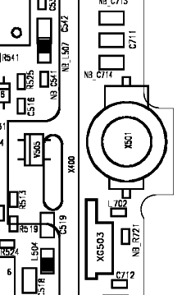

Figure 2: X35 Antenna Connector Placement (X501) (Top View)

Ringer

Affected Units

Type: C/M/S35

Affected IMEIs / Date Codes: All / All

Affected SW-Versions: All

Fault Code for LSO reporting: 3RIN

Fault Description

Fault Symptoms for customers:

Problems with the handset ringer. No ringer tone audible.

Fault Symptom on GSM-Tester:
Handset fails ringer test.

Priority:

❐ ........ Mandatory
 ........ Repair
❐ ........ Optional
❐ ........ Not Yet Defined

Repair Documentation

Description of procedure:

Diagnosis

Visually check the ringer. Watch for physical damage or dry joints.

Repair by component change
Resolder dry soldering joints.
If the ringer is physically damaged use hot air blower or wick to remove defective connector.
Avoid excessive heat!
Watch surrounding components!

Resolder new ringer afterwards.

Repair by SW-Booting

Not possible!

Test
Retest handset after repair.

List of needed material

Components

Ringer P35:
Part-Number: L36178-Z2-C26

Jigs and Tools

Hot Air Blower
Soldering Iron

Special Tools

None

Working materials

Desolder Wick / Braid
Solder
Flux

Drawings

Figure 1: X35 Board Ringer Side

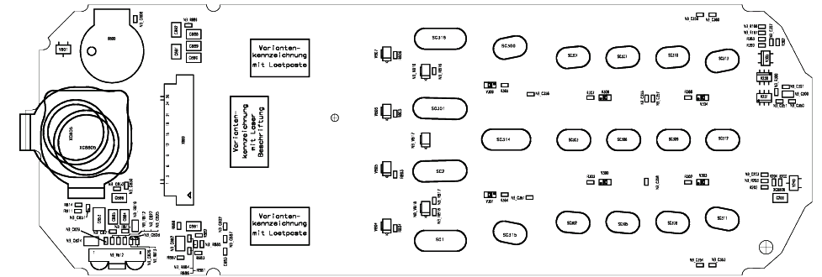
Figure 2: X35 Ringer (B800) Placement (Top View)

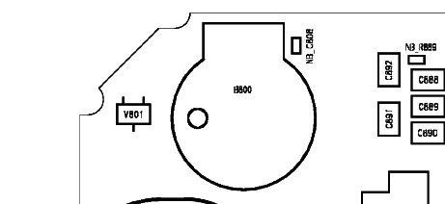

Bottom Connector (Lumberg)

Affected Units

Type: C/M/S35

Affected IMEIs / Date Codes: All / All

Affected SW-Versions: All

Fault Code for LSO reporting: 3LUC

Fault Description

Fault Symptoms for customers:

Charging problems.
Problems with external loudspeaker or microphone when using a car kit.
Problems with accessories connected at the bottom connector.
Problems with SW booting.

Fault Symptom on GSM-Tester:

This problem cannot be detected with a GSM-Tester.

Priority:

❐ ........ Mandatory
 ........ Repair
❐ ........ Optional
❐ ........ Not Yet Defined

Repair Documentation

Description of procedure:

Diagnosis

Visually check the bottom connector. Watch for dry joints!

Repair by component change

Use hot air blower remove defective bottom connector.
Avoid excessive heat!
Watch surrounding components!

Resolder new bottom connector afterwards.

Repair by SW-Booting

Not possible!

Test
Retest handset after repair.

List of needed material

Components

Bottom Connector X35
Part-Number: L36334-Z93-C262

Jigs and Tools

Hot Air Blower
Soldering Iron

Special Tools

None

Working materials

Desolder Wick / Braid
Solder

Drawings

Figure 1: X35 Board Bottom Connector Side

Figure 2: X35 Bottom Connector Placement (Top View)
Pin 12
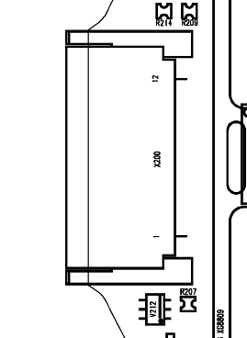
Pin 1

Table 1: X35 Bottom Connector Pin Description

Pin | Name | IN/OUT | Notes
1 | GND
2 | SB | I/O | Charger coding and charger control.
3 | POWER | I | Charging Current
4 | FBatt+ | O | Power supply for the accessories.
5 | TX | O | Serial interface
6 | RX | I | Serial interface
7 | ZUB_CLK | I/O | Clock line for accessory bus  Use as DTC In data operation
8 | ZUB_DATA | I/O | Data line for accessory bus.  Use as CTS in data operation
9 | GND_MIC |  | For external microphone
10 | HF_MIC | I | External microphone
11 | AUDO | O | Trigger for external loudspeaker
12 | GNDA |  | For external loudspeaker

Display Connector

Affected Units

Type: C/M/S 35

Affected IMEIs / Date Codes: All / All

Affected SW-Versions: All

Fault Code for LSO reporting: 3DIC

Fault Description

Fault Symptoms for customers:

Display problems, like missing lines or columns on the LCD or display contrast problems.

Fault Symptom on GSM-Tester:

Display test fails.

Priority:

❐ ........ Mandatory
 ........ Repair
❐ ........ Optional
❐ ........ Not Yet Defined

Repair Documentation

Description of procedure:

Diagnosis
Visually check the status of the display connector. Watch for oxidation and dry solder joints.
Mechanically check the opening / closing mechanism.

Repair by component change

Use hot air to remove defective connector
Avoid excessive heat!
Watch surrounding components!!

Resolder new connector afterwards

Repair by SW-Booting

Not possible!

Test
Retest handset after repair.

List of needed material

Components Display connector
Part-Number: L36195-Z26-C629

Jigs and Tools

Soldering Iron
Hot Air Blower

Special Tools

None

Working materials

Desolder Wick / Braid
Solder

Drawings

Figure 1: X35 board display connector side

Figure 2: X35 display connector placement (Top View)

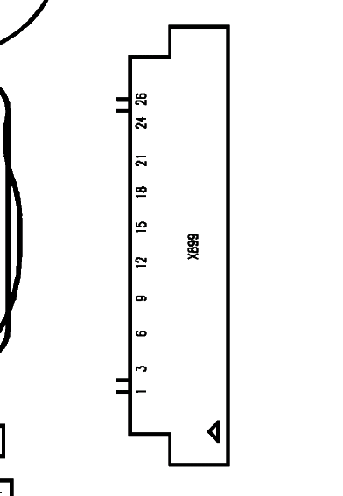

Keyboard LEDs

Affected Units

Type: C/M/S 35

Affected IMEIs / Date Codes: All / All

Affected SW-Versions: All

Fault Code for LSO reporting: 3LED

Fault Description

Fault Symptoms for customers:

Keyboard Illumination not working.

Fault Symptom on GSM-Tester:

This fault cannot be detected with a GSM-Tester

Priority:

❐ ........ Mandatory
 ........ Repair
❐ ........ Optional
❐ ........ Not Yet Defined

Repair Documentation

Description of procedure:

Diagnosis

Use the diode test function of a multimeter to check the status of the diode.
The typical voltage drop on the diode is 1.7V when testing the diode function with the multimeter.

Repair by component change

Use soldering iron to remove defective diode
Avoid excessive heat!
Watch surrounding components!

Resolder new diode afterwards.

Repair by SW-Booting

Not possible!

Test
Retest handset after repair.

List of needed material

Components

LED keyboard X35
Part-Number: L36840-L2031-D670

Jigs and Tools

Hot Air Blower
Soldering Iron

Special Tools

None

Working materials

Desolder Wick / Braid
Solder

Drawings

Figure 1: X35 board keyboard LED Side

Figure 2: X35 keyboard LED placement and polarity (top view)
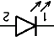
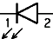
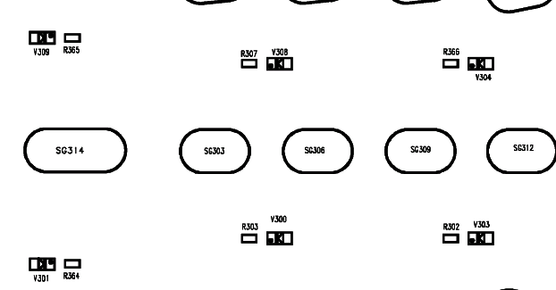

Display LEDs

Affected Units

Type: C/M/S 35

Affected IMEIs / Date Codes: All / All

Affected SW-Versions: All

Fault Code for LSO reporting: 3LED

Fault Description

Fault Symptoms for customers:

Display Illumination not working.

Fault Symptom on GSM-Tester:

This fault cannot be detected with a GSM-Tester

Priority:

❐ ........ Mandatory
 ........ Repair
❐ ........ Optional
❐ ........ Not Yet Defined

Repair Documentation

Description of procedure:

Diagnosis

Use the diode test function of a multimeter to check the status of the diode.
The typical voltage drop on the diode is 1.7V when testing the diode function with the multimeter.
Attention: There are two different types of display LEDs, one for C/M35 and one for S35! Also they use different placement location, see drawings 1 and 3.

Repair by component change

Use soldering iron to remove defective diode
Avoid excessive heat!
Watch surrounding components!

Resolder new diode afterwards.

Repair by SW-Booting

Not possible!

Test
Retest handset after repair.

List of needed material

Components

Display LED S35
Part-Number: L36840-L2048-D670
Display LED C/M35
Part-Number: L36840-L2047-D670

Jigs and Tools

Hot Air Blower
Soldering Iron

Special Tools

None

Working materials

Desolder Wick / Braid
Solder

Drawings

Figure 1: C/M35 board display LED Side

Figure 2: C/M35 board display LED placement and polarity

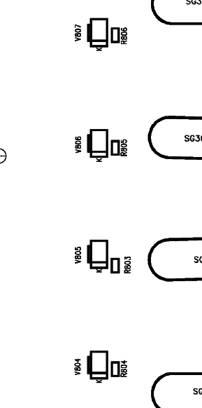
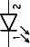

Figure 3: S35 board display LED side

Figure 4: S35 board display LED placement and polarity

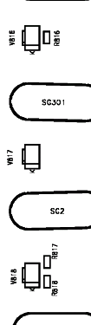

Infrared Diodes

Affected Units

Type: S 35

Affected IMEIs / Date Codes: All / All

Affected SW-Versions: All

Fault Code for LSO reporting: 3INF

Fault Description

Fault Symptoms for customers:

No infrared connection possible.

Fault Symptom on GSM-Tester:

This fault cannot be detected with a GSM-Tester.

Priority:

❐ ........ Mandatory
 ........ Repair
❐ ........ Optional
❐ ........ Not Yet Defined

Repair Documentation

Description of procedure:

Diagnosis
Visually check the status of the IrDa module. Watch for dry solder joints.
Use a reference infrared port (eg. from a notebook) to check the IrDa function. If the notebook recognizes the S35, the infrared function is ok.

Repair by component change

Use hot air to remove defective infrared module.
Avoid excessive heat!
Watch surrounding components!!

Resolder new module afterwards

Repair by SW-Booting

Not possible!

Test
Retest handset after repair.

List of needed material

Components Infrared module S35
Part-Number: L36810-U6030-D670

Jigs and Tools

Soldering Iron
Hot Air Blower

Special Tools

None

Working materials

Desolder Wick / Braid
Solder

Drawings

Figure 1: S35 board infrared module side

Figure 2: S35 infrared module placement (Top View)

