S10 / S10 MMI

S10 active / S10 active MMI

Repair Documentation

Level 2.5

V 4.4

Table of Contents:

1 Introduction 3
2 Antenna Spring 4
3 TCXO 6
4 VCO 11
5 Fuse 1A 14
6 Fuse 0.25 A 18
7 Molex Connector 22
8 Ringer 26
9 Cardreader 30
10 Volumeslider 34
11 Memoswitch 37
12 Antennaswitch 40
13 Coil 44
14 ANNEX / FLOWCHARTS 48

Introduction

The product familiy S1x consists of S10 (GSM-900), S11 (GSM-1800) and S12 (GSM-1900).
Two S10 versions exist:

- The old type with part number S30880-S1200-Xxxx and
- The new type with part number S30800-S1220-Xxxx

The partnumber can be found on the IMEI stickerof the handset.
The S10 is also available as a special outdoor version, the S10 active (S30880-S1200-Lxxx or –Fxxx). This phone has different display and RF/Control modules, even though many of the components are identical.

This manual is intended to help you carry out repairs on level 2.5, meaning limited component repairs. Failure highlights are documented and should be repaired in the local workshops.

It must be noted that all repairs have to be carried out in an environment set up according to the ESD (Electrostatic Discharge Sensitive Devices) regulations defined in international standards.

If you have any questions regarding the repair procedures or spare parts do not hesitate to contact our technical support team in Kamp-Lintfort, Germany:

Tel.: +49 2842 95 4666
Fax: +49 2842 95 4302
e-mail: dominik.schnoor@klf.siemens.de

Antenna Spring

Affected Units

Type: S10 old/new and S10 active

Affected IMEIs / Date Codes: All / All

Affected SW-Versions: All

Fault Code for LSO reporting: 3ANS

Fault Description

Fault Symptoms for customers:

Customers experience a low Rx sensitivity of the hand-
set, have problems registering to the network and making calls.

Fault Symptom on GSM-Tester:

The GSM-Tester will show a low Tx-Power only on the internal antenna (aerial coupler measurement!).

Priority:

❐ ........ Mandatory
 ........ Repair
❐ ........ Optional
❐ ........ Not Yet Defined

Repair Documentation

Description of procedure:

Diagnosis

Visually check the status of the antenna spring. Look for a bent contact or dry soldering joint.

Repair by component change

Use soldering iron to remove defective spring.

Resolder new spring afterwards.

Repair by SW-Booting

Not possible!

Test
Retest handset after repair.

List of needed material

Components

Antenna Spring
Part-Number: L36158-A11-C23

Jigs and Tools

Soldering Iron

Special Tools

None

Working materials

Desolder Wick / Braid
Solder

Drawings

Figure 1: S10 / S10 active Board Antenna Spring Side

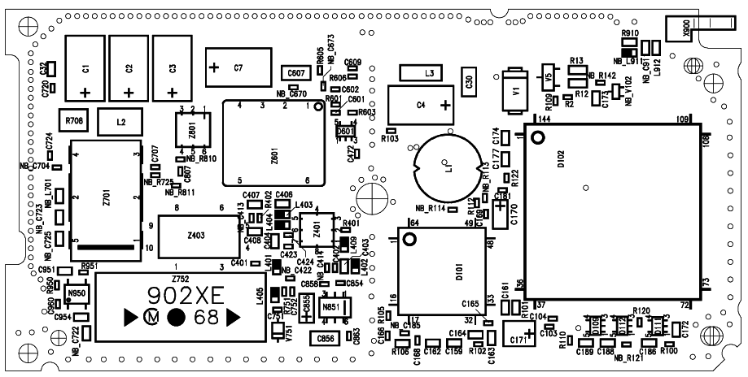

Figure 2: S10 / S10 active Antenna Spring (X900) Placement (Top View)

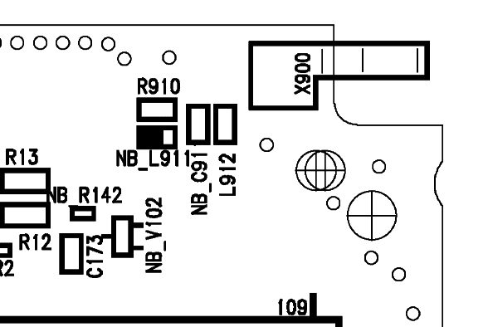

TCXO

Affected Units

Type: S10 old/new and S10 active

Affected IMEIs / Date Codes: All / All

Affected SW-Versions: All

Fault Code for LSO reporting: 3TCX

Fault Description

Fault Symptoms for customers:

Network Search
Handset not logging into network

Fault Symptom on GSM-Tester:

Frequency error in synchronized mode >90 Hz
No location update possible

The TCXO (Temperature Compensated Crystal Oscillator) is responsible for generating the
13 MHz reference frequency of the handset.
If it is defective, the handset cannot synchronize to the base station anymore.

All other frequencies are derived from this 13MHz reference, its stability is vital for the handset function.

The TCXO output frequency is determined by a DC tuning voltage applied to its VC pin. The voltage comes from the microprocessor as a pulse number modulated digital signal.
A lowpass then converts this digital signal to a proportional DC voltage, which is then used to fine tune the TCXO output frequency.

Priority:

❐ ........ Mandatory
 ........ Repair
❐ ........ Optional
❐ ........ Not Yet Defined

Repair Documentation

Description of procedure:

Diagnosis

Check the output frequency of the TCXO using the level-2 testing
program for S10.
Switch off the „CMD in Use“ option in the config file (S6xx.CFG or S611.INI depending on the version of the testsoftware) and restart
the program. Start the S10 test, when the program says „Check power and phase of external antenna with your GSM-Tester“, switch the CMD to „LOCAL“ mode and enter the „MODULE TEST“.
On the CMD display you can see the frequency error of the handset.
(Make sure that the CMD is on channel 124, power level 5!)

If the frequency error is higher than 2kHz, the TCXO has to be replaced.

Repair by component change

Use hot air blower to remove defective TCXO.
Avoid excessive heat!
Watch surrounding components!

Resolder new TCXO afterwards.

Repair by SW-Booting

Not possible!

Test
Retest handset after repair as described above.
The frequency error must now be < 2kHz.

List of needed material

Components
Attention! The S10 and the S10 active/new use a different TCXO. Watch partnumbers below:

TCXO
S10 old: L36145-G300-Y16
S10 new: L36145-G300-Y17
S10 active: L36145-G300-Y17

Jigs and Tools

Hot Air Blower
Soldering Iron

Special Tools

None

Working materials

Desolder Wick / Braid
Solder

Drawings

Figure 1: S10 Board TCXO Side

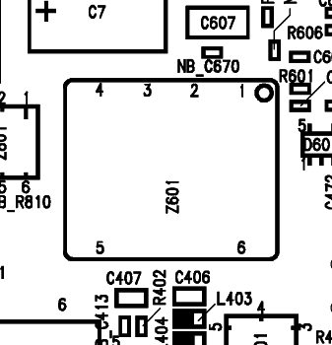

Figure 2: S10 TCXO (Z601) Placement (Top View)

VCO

Affected Units

Type: S10 old/new and S10 active

Affected IMEIs / Date Codes: All / All

Affected SW-Versions: All

Fault Code for LSO reporting: 3VCO

Fault Description

Fault Symptoms for customers:

Network Search
Handset not logging into network
Dropped Calls

Fault Symptom on GSM-Tester:

Phase error in synchronized mode >5 deg rms
or >20 deg or >-20 deg peak.
No location update possible

The VCO (Voltage Controlled Oscillator) is responsible for generating RF frequencies of the
handset.
If it is defective, the handset cannot synchronize to the base station any more.

Priority:

❐ ........ Mandatory
 ........ Repair
❐ ........ Optional
❐ ........ Not Yet Defined

Repair Documentation

Description of procedure:

Diagnosis

See symptoms above.

Repair by component change

Use hot air blower to remove defective VCO.
Avoid excessive heat!
Watch surrounding components!

Resolder new VCO afterwards.

Repair by SW-Booting

Not possible!

Test
Retest handset after repair as described above.
The phase error must now be in the defined range.

List of needed material

Components

VCO
Part-Number: L36851-Z2022-A11

Jigs and Tools

Hot Air Blower
Soldering Iron

Special Tools

None

Working materials

Desolder Wick / Braid
Solder

Drawings
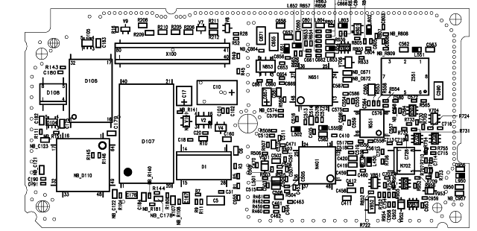

Figure 1: S10 Board VCO Side

Figure 2: S10 TCXO (Z551) Placement (Top View)

Fuse 1A

Affected Units

Type: S10 old/new and S10 active MMI

Affected IMEIs / Date Codes: All / All

Affected SW-Versions: All

Fault Code for LSO reporting: 3FU1

Fault Description

Fault Symptoms for customers:

Battery charging not possible

Fault Symptom on GSM-Tester:

This fault cannot be detected with a GSM-Tester

Priority:

❐ ........ Mandatory
 ........ Repair
❐ ........ Optional
❐ ........ Not Yet Defined

Repair Documentation

Description of procedure:

Diagnosis

Check the status of the fuse by measuring its resistance with
a multimeter. The fuse is defective if the resitance higher than 10 ohms

Repair by component change

Use soldering iron to remove defective fuse.
Avoid excessive heat!
Watch surrounding components!

Resolder new fuse afterwards.

Repair by SW-Booting

Not possible!

Test
Retest handset after repair as described above.
The resistance must now be close to zero.

List of needed material

Components

Fuse
Part-Number: L36145-A820-Y7

Jigs and Tools

Soldering Iron

Special Tools

Multimeter

Working materials

Desolder Wick / Braid
Solder

Drawings

Figure 1: S10 / S10 active MMI Board 1A Fuse Side
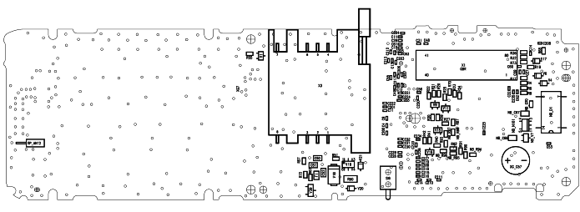

Figure 2: 1A Fuse (F1) Placement (Top View)

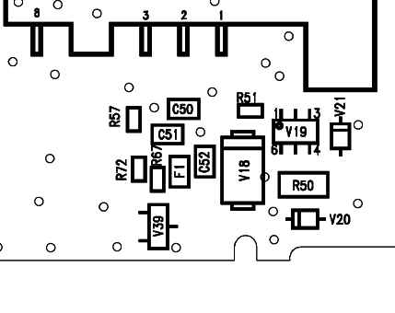

Fuse 0.25 A

Affected Units

Type: S10 old/new and S10 active MMI

Affected IMEIs / Date Codes: All / All

Affected SW-Versions: All

Fault Code for LSO reporting: 3FU2

Fault Description

Fault Symptoms for customers:

Supplying of external accessories through the handset’s
bottom connector is not possible

Fault Symptom on GSM-Tester:

This fault cannot be detected with a GSM-Tester

Priority:

❐ ........ Mandatory
 ........ Repair
❐ ........ Optional
❐ ........ Not Yet Defined

Repair Documentation

Description of procedure:

Diagnosis

Check the status of the fuse by measuring its resistance with
a multimeter. The fuse is defective if the resitance higher than 10 ohms

Repair by component change

Use soldering iron to remove defective fuse.
Avoid excessive heat!
Watch surrounding components!

Resolder new fuse afterwards.

Repair by SW-Booting

Not possible!

Test
Retest handset after repair as described above.
The resistance must now be close to zero.

List of needed material

Components

Fuse
Part-Number: L36145-A820-Y10

Jigs and Tools

Soldering Iron

Special Tools

Multimeter

Working materials

Desolder Wick / Braid
Solder

Drawings

Figure 1: S10 / S10 active MMI Board 0.25A Fuse Side

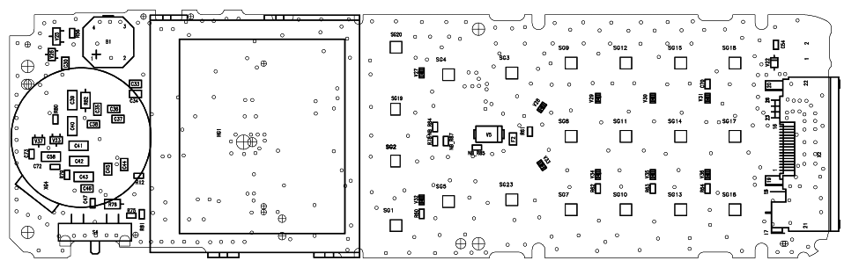

Figure 2: 0.25A Fuse (F2) Placement (Top View)

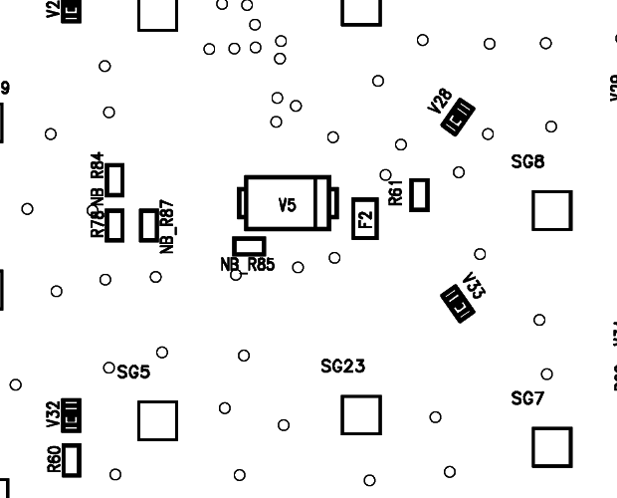

Molex Connector

Affected Units

Type: S10 old/new and S10 active MMI

Affected IMEIs / Date Codes: All / All

Affected SW-Versions: All

Fault Code for LSO reporting: 3MOC

Fault Description

Fault Symptoms for customers:

Charging or operation in a car kit not possible.

Fault Symptom on GSM-Tester:

Output power problems on the external antenna only.

Priority:

❐ ........ Mandatory
 ........ Repair
❐ ........ Optional
❐ ........ Not Yet Defined

Repair Documentation

Description of procedure:

Diagnosis

Visually check the bottom connector. Watch for dry joints.

Repair by component change

Use hot air blower to remove defective connector.
Avoid excessive heat!
Watch surrounding components!

Resolder new connector afterwards.
Make sure that you use just very little flux, otherwise the connector
contacts can become dirty.

Repair by SW-Booting

Not possible!

Test
Retest handset after repair.

List of needed material

Components

Molex Connector
Part-Number: L36334-Z93-C244

Jigs and Tools

Hot Air Blower
Soldering Iron

Special Tools

None

Working materials

Desolder Wick / Braid
Solder
Flux

Drawings

Figure 1: S10 / S10 active MMI Board Bottom Connector Side

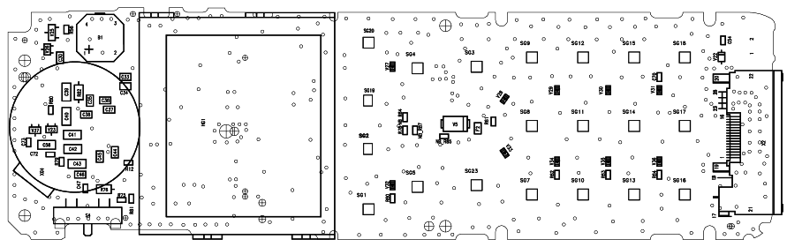

Figure 2: Bottom Connector Placement (Top View)

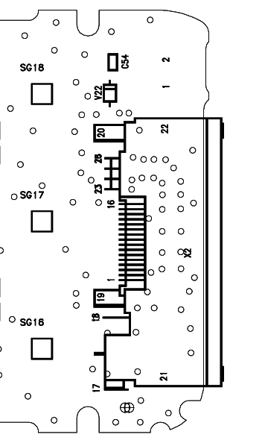

Ringer

Affected Units

Type: S10 old/new and S10 active MMI

Affected IMEIs / Date Codes: All / All

Affected SW-Versions: All

Fault Code for LSO reporting: 3RIN

Fault Description

Fault Symptoms for customers:

No ringer tone audible or ringer tone distorted.

Fault Symptom on GSM-Tester:

Ringer check fails.

Priority:

❐ ........ Mandatory
 ........ Repair
❐ ........ Optional
❐ ........ Not Yet Defined

Repair Documentation

Description of procedure:

Diagnosis

Check ringer functionality either manually with testing program.

Repair by component change

Use hot air blower remove defective ringer.
Avoid excessive heat!
Watch surrounding components, especially the display window!
To protect the display, you can also desolder the ringer with solder
wick.

Resolder new ringer afterwards.
Watch placement of ringer!

Repair by SW-Booting

Not possible!

Test
Retest handset after repair.

List of needed material

Components

Ringer
Part-Number: L36178-Z2-C15

Jigs and Tools

Hot Air Blower
Soldering Iron

Special Tools

None

Working materials

Desolder Wick / Braid
Solder

Drawings

Figure 1: S10 / S10 active MMI Board Ringer Side

Figure 2: Ringer (B1) Placement (Top View)

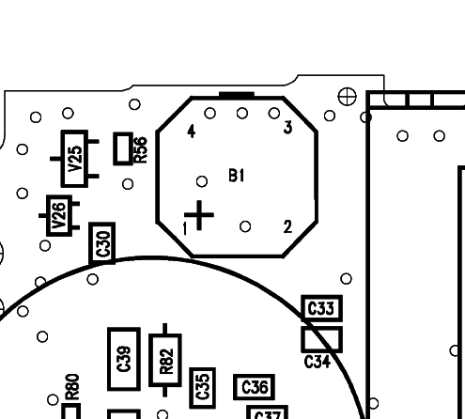

Cardreader

Affected Units

Type: S10 old/new and S10 active MMI

Affected IMEIs / Date Codes: All / All

Affected SW-Versions: All

Fault Code for LSO reporting: 3REA

Fault Description

Fault Symptoms for customers:

Sim card is not accepted or properly read by
the handset.
Sim card ejection mechanism may be damaged.

Fault Symptom on GSM-Tester:

When testing with a test-simcard the above
symptoms will come up.

Priority:

❐ ........ Mandatory
 ........ Repair
❐ ........ Optional
❐ ........ Not Yet Defined

Repair Documentation

Description of procedure:

Diagnosis

Check cardreader functionality with sim card.
Attention: Watch for dry joints (especially pin 7!) or mechanical damage.

Repair by component change
Resolder dry joints.

If the cardreader is mechanically damaged use solder wick to remove
defective component.
Avoid excessive heat!
Watch surrounding components!!

Resolder new cardreader afterwards.

Repair by SW-Booting

Not possible!

Test
Retest handset after repair.

List of needed material

Components

Cardreader
Part-Number: L36334-Z95-C994

Jigs and Tools

Soldering Iron

Special Tools

None

Working materials

Desolder Wick / Braid
Solder

Drawings

Figure 1: S10 MMI Board Cardreader Side

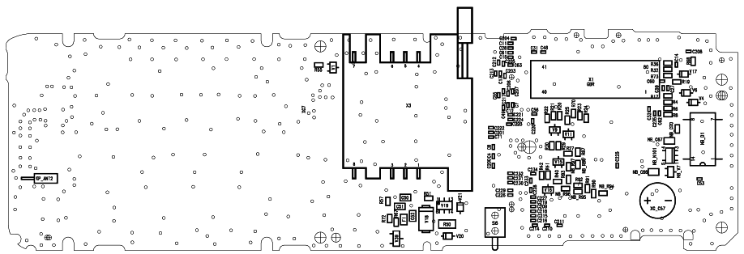

Figure 2: Cardreader Placement (Top View)

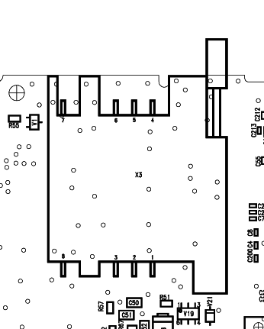

Volumeslider

Affected Units

Type: S10 old/new and S10 active MMI

Affected IMEIs / Date Codes: All / All

Affected SW-Versions: All

Fault Code for LSO reporting: 3VSL

Fault Description

Fault Symptoms for customers:

The volume slider does not work properly.

Fault Symptom on GSM-Tester:

During the keyboard test, the volume slider fails.

Priority:

❐ ........ Mandatory
 ........ Repair
❐ ........ Optional
❐ ........ Not Yet Defined

Repair Documentation

Description of procedure:

Diagnosis

Check volumeslider functionality either manually or with the
testing program.
Watch for dry joints or mechanical damage.

Repair by component change

Use solder wick to remove defective slider.
Avoid excessive heat!
Watch surrounding components!!

Resolder new volumeslider afterwards.

Repair by SW-Booting

Not possible!

Test
Retest handset after repair.

List of needed material

Components

Volumeslider
Part-Number: L36315-Z77-C186

Jigs and Tools

Soldering Iron

Special Tools

None

Working materials

Desolder Wick / Braid
Solder

Drawings

Figure 1: S10 / S10 active MMI Board Volumeslider Side

Figure 2: Volumeslider Placement (Top View)

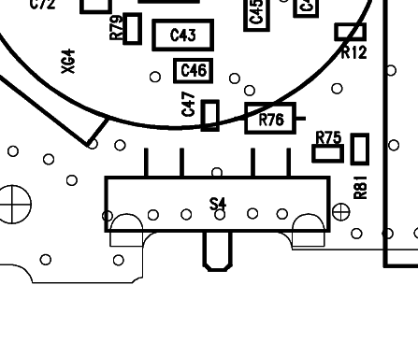

Memoswitch

Affected Units

Type: S10 old/new and S10 active MMI

Affected IMEIs / Date Codes: All / All

Affected SW-Versions: All

Fault Code for LSO reporting: 3MSW

Fault Description

Fault Symptoms for customers:

The memoswitch does not work properly.

Fault Symptom on GSM-Tester:

During the keyboard test, the memobutton fails.

Priority:

❐ ........ Mandatory
 ........ Repair
❐ ........ Optional
❐ ........ Not Yet Defined

Repair Documentation

Description of procedure:

Diagnosis

Check memoswitch functionality either manually or with the
testing program.
Watch for dry joints or mechanical damage.

Repair by component change

Use solder wick or hot air to remove defective switch.
Avoid excessive heat!
Watch surrounding components!!

Resolder new memoswitch afterwards.

Repair by SW-Booting

Not possible!

Test
Retest handset after repair.

List of needed material

Components
Attention! The S10 and the S10 new/active use a different type of memoswitch. Watch part numbers below!

Memoswitch
S10 old Part-Number: L36315-Z77-C185
S10 new Part-Number: L36315-Z77-C192
S10 active: Part-Number: L36315-Z77-C192

Jigs and Tools

Soldering Iron
Hot Air

Special Tools

None

Working materials

Desolder Wick / Braid
Solder

Drawings

Figure 1: S10 / S10 active MMI Board Memoswitch Side

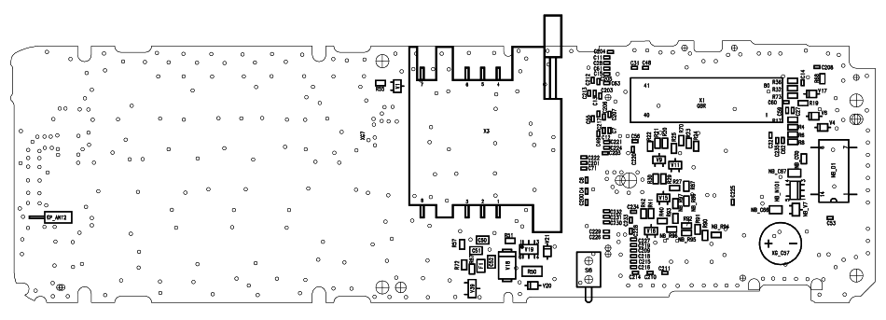

Figure 2: Memoswitch (S6) Placement (Top View)

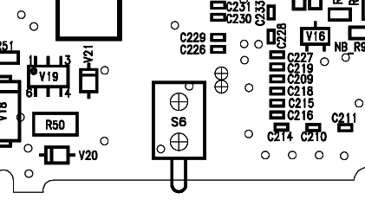

Antennaswitch

Affected Units

Type: S10 old/new and S10 active

Affected IMEIs / Date Codes: All / All

Affected SW-Versions: All

Fault Code for LSO reporting: 3ASW

Fault Description

Fault Symptoms for customers:

No Rx sensitivity and no location update possible.

Fault Symptom on GSM-Tester:

Handset fails with low Tx power on both or either antenna.
No location update possible.

Priority:

❐ ........ Mandatory
 ........ Repair
❐ ........ Optional
❐ ........ Not Yet Defined

Repair Documentation

Description of procedure:

Diagnosis

The antennaswitch is used to switch the Rx and Tx path between the internal an external antenna of the handset

The switched path is determined by two digital inputs A and B (pins 1 and 5).
A | B | Switched path
1 | 0 | External antenna
0 | 1 | Internal antenna
Check antennaswitch functionality either manually or with the
testing program.
Watch for dry joints.
Use an ohmmeter to check the status of the switch:
Pin 5 against ground must be around 50 kOhms.
Pin 1 against ground must be around 1 kOhm.
If any of these resistances are significantly lower (for example pin 5 around 17 Ohms) the antennaswitch is defective and has to be replaced.

Repair by component change

Use solder wick or hot air to remove defective switch.
Avoid excessive heat!
Watch surrounding components!!

Resolder new antennaswitch afterwards.

Repair by SW-Booting

Not possible!

Test
Retest handset after repair.

List of needed material

Components

Antennaswitch
Part-Number: L36810-U6011-D670

Jigs and Tools

Soldering Iron
Hot Air Blower

Special Tools

None

Working materials

Desolder Wick / Braid
Solder

Drawings

Figure 1: S10 / S10 active Board Antennaswitch Side

Figure 2: Antennaswitch (N950) Placement (Top View)

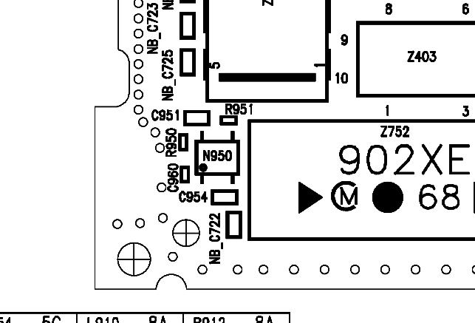

Coil

Affected Units

Type: S10 old/new and S10 active

Affected IMEIs / Date Codes: All / All

Affected SW-Versions: All

Fault Code for LSO reporting: 3COI

Fault Description

Fault Symptoms for customers:

Loud humming noise in loudspeaker.

Fault Symptom on GSM-Tester:

Handset fails with loud humming noise in echo loop.

Priority:

❐ ........ Mandatory
 ........ Repair
❐ ........ Optional
❐ ........ Not Yet Defined

Repair Documentation

Description of procedure:

Diagnosis
The coil is used in the step up converter which is generating a
6.0 V supply voltage for the power amplifier out of the 2.8V battery voltage.
If the coil is mechanically damaged (broken) it produces heavy interference with the acoustical elements of the S10 resulting in a loud humming noise in the earpiece.

A broken coil can easily be diagnosed by trying to move it with two fingers. If it moves, the core is broken and the coil has to be
replaced.

Repair by component change

Use hot air to remove defective coil.
Avoid excessive heat!
Watch surrounding components!!

Resolder new coil afterwards

Repair by SW-Booting

Not possible!

Test
Retest handset after repair, by checking the audio quality with the echo loop of the testprogram.

List of needed material

Components
The S10 and the S10 active use different types of coils!

Part-Number S10 old: L36151-F5273-M2
Part-Number S10 new: L36151-F5273-M3
Part-Number S10 active: L36151-F5273-M3

Jigs and Tools

Soldering Iron
Hot Air Blower

Special Tools

None

Working materials

Desolder Wick / Braid
Solder

Drawings

Figure 1: S10 / S10 active Board Coil (L1) Side

Figure 2: Coil (L1) Placement (Top View)

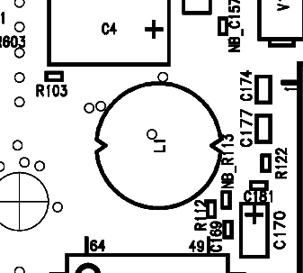

ANNEX / FLOWCHARTS

Tx power problems

If you experience a low output power on either antenna (internal/external) please follow the flowchart below.
For more information about the described components please refer to the respective chapters.

Remark: If the Tx power problem is on both antennas, it is most likely a Power Amplifier problem which cannot be fixed locally.

