S6 Power PCN
S8 PCN
Level 2.5

Repair Documentation

V 1.1

Table of Contents:

1 Introduction
2 TCXO
3 Fuse 1A
4 Fuse 0.25 A
5 Molex Connector
6 Ringer

Introduction

This manual is intended to help you carry out S6 power PCN repairs on level 2.5, meaning limited component repairs. Failure highlights are documented and should be repaired in the local workshops.

The S8 PCN uses the same MMI and RF/Control module as the S6 power PCN but has a different casing.

It must be noted that all repairs have to be carried out in an environment set up according to the ESD (Electrostatic Discharge Sensitive Devices) regulations defined in international standards.

If you have any questions regarding the repair procedures or spare parts do not hesitate to contact our technical support team in Kamp-Lintfort, Germany:

Tel.: +49 2842 95 4666
Fax: +49 2842 95 4302
e-mail: dominik.schnoor@klf.siemens.de

TCXO

Affected Units

Type: S6 Power PCN

Affected IMEIs / Date Codes: All / All

Affected SW-Versions: All

Fault Code for LSO reporting: 3TCX

Fault Description

Fault Symptoms for customers:

Network Search
Handset not logging into network

Fault Symptom on GSM-Tester:

Frequency error in synchronized mode >90 Hz
No location update possible

The TCXO (Temperature Compenseated Crystal Oscillator) is responsible for generating the
13 MHz reference frequency of the handset.
If it is defective, the handset cannot synchronize to the base station anymore.

Priority:

❐ ........ Mandatory
 ........ Repair
❐ ........ Optional
❐ ........ Not Yet Defined

Repair Documentation

Description of procedure:

Diagnosis

Check the output frequency of the TCXO using the level-2 testing
program for S6 Power PCN.
Set the „Simulator“ option in the S611.INI file to 0 and restart
the program. Start the test, when the program says „Check power and phase of external antenna with your GSM-Tester“, switch the CMD to „LOCAL“ mode and enter the „MODULE TEST“.
On the CMD display you can see the frequency error of the handset.
(Make sure that the CMD is on channel 124, power level 5!)

If the frequency error is higher than 2kHz, the TCXO has to be replaced.

Repair by component change

Use hot air blower to remove defective TCXO.
Avoid excessive heat!
Watch surrounding components!

Resolder new TCXO afterwards.

Repair by SW-Booting

Not possible!

Test
Retest handset after repair as described above.
The frequency error must now be < 2kHz.

List of needed material

Components

TCXO
Part-Number: L36145-G300-Y19

Jigs and Tools

Hot Air Blower
Soldering Iron

Special Tools

None

Working materials

Desolder Wick / Braid
Solder

Drawings

Figure 1: S6 Power PCN Board TCXO Side

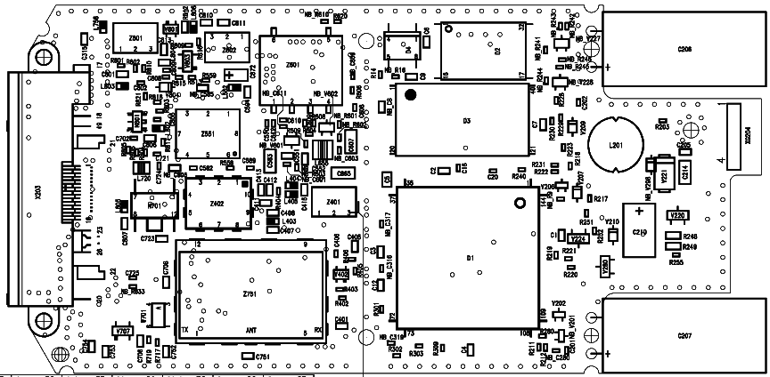

Figure 2: TCXO (Z601) Placement (Top View)

Fuse 1A

Affected Units

Type: S6 Power PCN

Affected IMEIs / Date Codes: All / All

Affected SW-Versions: All

Fault Code for LSO reporting: 3FU1

Fault Description

Fault Symptoms for customers:

Battery charging not possible

Fault Symptom on GSM-Tester:

This fault cannot be detected with a GSM-Tester

Priority:

❐ ........ Mandatory
 ........ Repair
❐ ........ Optional
❐ ........ Not Yet Defined

Repair Documentation

Description of procedure:

Diagnosis

Check the status of the fuse by measuring its resistance with
a multimeter. The fuse is defective if the resitance higher than 10 ohms

Repair by component change

Use soldering iron to remove defective fuse.
Avoid excessive heat!
Watch surrounding components!

Resolder new fuse afterwards.

Repair by SW-Booting

Not possible!

Test
Retest handset after repair as described above.
The resistance must now be close to zero.

List of needed material

Components

Fuse
Part-Number: L36145-A820-Y7

Jigs and Tools

Soldering Iron

Special Tools

Multimeter

Working materials

Desolder Wick / Braid
Solder

Drawings

Figure 1: S6 Power PCN Board 1A Fuse Side

Figure 2: 1A Fuse (F201) Placement (Top View)

Fuse 0.25 A

Affected Units

Type: S6 Power PCN

Affected IMEIs / Date Codes: All / All

Affected SW-Versions: All

Fault Code for LSO reporting: 3FU2

Fault Description

Fault Symptoms for customers:

Supplying of external accessories through the handset’s
bottom connector is not possible

Fault Symptom on GSM-Tester:

This fault cannot be detected with a GSM-Tester

Priority:

❐ ........ Mandatory
 ........ Repair
❐ ........ Optional
❐ ........ Not Yet Defined

Repair Documentation

Description of procedure:

Diagnosis

Check the status of the fuse by measuring its resistance with
a multimeter. The fuse is defective if the resitance higher than 10 ohms

Repair by component change

Use soldering iron to remove defective fuse.
Avoid excessive heat!
Watch surrounding components!

Resolder new fuse afterwards.

Repair by SW-Booting

Not possible!

Test
Retest handset after repair as described above.
The resistance must now be close to zero.

List of needed material

Components

Fuse
Part-Number: L36145-A820-Y10

Jigs and Tools

Soldering Iron

Special Tools

Multimeter

Working materials

Desolder Wick / Braid
Solder

Drawings

Figure 1: S6 Power PCN 0.25A Fuse Side

Figure 2: S6 Power PCN 0.25A Fuse Placement

Molex Connector

Affected Units

Type: S6 Power PCN

Affected IMEIs / Date Codes: All / All

Affected SW-Versions: All

Fault Code for LSO reporting: 3MOC

Fault Description

Fault Symptoms for customers:

Network search.
Charging or operation in a car kit not possible.

Fault Symptom on GSM-Tester:

Output power problems on the external and internal
antenna.
No location update possible.

Priority:

❐ ........ Mandatory
 ........ Repair
❐ ........ Optional
❐ ........ Not Yet Defined

Repair Documentation

Description of procedure:

Diagnosis

Visually check the bottom connector. Watch for dry joints.

Repair by component change

Use hot air blower to remove defective connector.
Avoid excessive heat!
Watch surrounding components!

Resolder new connector afterwards.
Make sure that you use just very little flux, otherwise the connector
contacts can become dirty.

Repair by SW-Booting

Not possible!

Test
Retest handset after repair.

List of needed material

Components

Molex Connector
Part-Number: L36851-Z1351-A70

Jigs and Tools

Hot Air Blower
Soldering Iron

Special Tools

None

Working materials

Desolder Wick / Braid
Solder
Flux

Drawings

Figure 1: S6 Power PCN Board Bottom Connector Side

Figure 2: Bottom Connector Placement (Top View)

Ringer

Affected Units

Type: S6 Power PCN MMI

Affected IMEIs / Date Codes: All / All

Affected SW-Versions: All

Fault Code for LSO reporting: 3RIN

Fault Description

Fault Symptoms for customers:

No ringer tone audible or ringer tone distorted.

Fault Symptom on GSM-Tester:

Ringer check fails.

Priority:

❐ ........ Mandatory
 ........ Repair
❐ ........ Optional
❐ ........ Not Yet Defined

Repair Documentation

Description of procedure:

Diagnosis

Check ringer functionality either manually or with testing program.

Repair by component change

Use hot air blower remove defective ringer.
Avoid excessive heat!
Watch surrounding components, especially the display window!
To protect the display, you can also desolder the ringer with solder
wick.

Resolder new ringer afterwards.
Watch placement of ringer hole!

Repair by SW-Booting

Not possible!

Test
Retest handset after repair.

List of needed material

Components

Ringer
Part-Number: L36178-Z2-C16

Jigs and Tools

Hot Air Blower
Soldering Iron

Special Tools

None

Working materials

Desolder Wick / Braid
Solder

