Local Service Organization Service Manual

M35 Series

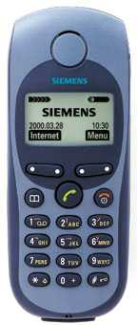

SIEMENS Communications UNLIMITED

Table of Content

Chapter 1
Cellular Communication
Coverage Concept 1
GSM Network Architecture 2
Subscriber Identity Module 3
SIM Application Toolkit 4
Extended GSM 900 - EGSM 5
Built-in Modem 5
Data Application 6
Chapter 2
Level 2 Service Guide
Introduction 7
M35 Series Technical Information 8
Accessories 10
General Information 11
M35 Series Exploded Diagram 13
Mechanical Concept 14
Hardware Concept – Block diagram 15
Hardware Description 16
Power Supply Concept 18
Over voltage Condition 18
Battery Charging 18
Short Circuit Protection 19
Normal Charging 19
Deep Discharge Battery 20
M35i Spare Parts Level 1 & Level 2 21
Disassemble the M35 22
Disassemble/Assemble Lower Housing 24
Disassemble/Assemble Control Board Assy 24
Disassemble/Assemble Display Module 25
Disassemble/Assemble Upper Housing 26
Assemble the M35 27
Mobile Software Programming 29

Language Groups 31
Customer Specific Initialization 33
International Mobile Equipment Identity 33
Phone Unblocking 34
Chapter 3
Siemens Service Equipment
Introduction 36
Other equipment 38
Software Installation 39
Configuring the test software 40
Running the test sequence 41
ANNEX A 45
ANNEX B 48
Chapter 4
Level 2.5 Repair Document
Introduction 49
Antenna Connector 51
Ringer 54
Bottom Connector (Lumberg) 57
Display Connector 61
Keyboard LED 65
Display LED 68
Infrared Diodes 72

ANNEX C
PC Adapter Cable & Accessories M35 75
Power Plug for M35 76
Car installation Ratio Unit, M35 77
Car Installation kit Handfree kit 78
Car Installation kit Handfree Pro. 79
Car Installation Comfort GPS, M35 80
References 82

Cellular Communication
Chapter
1
Coverage Concept.
the cellular systems is made up of numerous transmitting and receiving sites, whose individual coverage areas partially overlap. The concept of frequency re-use, same frequency is used by several sites, allows a high traffic density in a wide area. Due to the limited transmission range of the terminals, cellular systems are based on a large number of base stations on the infrastructure side, scattered over the area to cover, with each covering a fairly small geographical zone called cell. Cells are often represented by hexagons (see figure 1.1.).

Figure 1.1 CELLULAR COVERAGE REPRESENTATION.

GSM Network Architecture.
GSM network can be broadly divided into three broad parts, namely:
- Mobile Station(MS) carried by the subscriber,
- Base Station Sub-system(BSS) which controls the radio link with the mobile station.
- Mobile Switching Center(MSC) which performs the switching of calls between the mobile users, and between mobile and fixed network users.

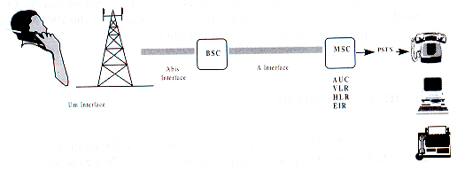
Figure 1.2 GSM Architecture
Each mobile station is given a unique identity. As soon as the mobile phone is turned on, it registers with the network and is authenticated, as such the network could always find the mobile phone.
Larger amount of data is being exchanged to and from the following functional blocks in the MSC:
Visitor Location Register, VLR
Stores information about mobile subscribers that enter it coverage area which is associated with the geographical area where the mobile is currently roaming. When there is an incoming call for the mobile, the HLR is interrogated about the present address of the VLR.

Home Location Register, HLR
A database that contains all data concerning the subscription of the mobile subscriber, i.e. their access capabilities, subscribed services, and supplementary services. It also contains information about the VLR that is handling the mobile station currently. When the mobile changes location, the HLR is updated accordingly. It also provides the MSC with information about the MSC area where the mobile is actually located to allow incoming calls to be routed immediately to the called party.
Authentication Center, AUC
Stored information that is necessary to protect communication through the air interface against any intrusions. The legitimacy of the subscriber is established through authentication and ciphering, which protects the user information against unwanted disclosure.

Equipment Identity Register, EIR
An option the network operator can use to enforce security. With this feature the network can identify defective or stolen mobile that may not be used in the network.

Subscriber Identity Module(SIM)
SIM is a smart card which has a computer and memory chip that is permanently installed in the mobile equipment. It comes in either the size of a credit card or smaller version known as the plug-in SIM.


The subscriber information, which includes a unique number called the International Mobile Subscriber Identity (IMSI) is stored in the SIM card. SIM card identifies the subscriber to the network.
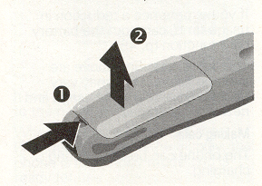
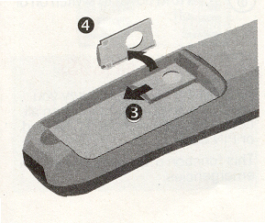
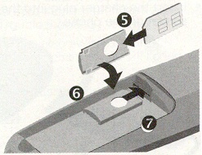

FIGURE 1.3 INSERT SIM CARD
Figure 1.3 illustrates the steps for inserting the SIM card into the M35i series.

To protect the SIM card from improper use, a security feature, a four digits personal identification number(PIN), is built in. The PIN is stored in the card and can be changed by the subscriber. PIN2 is required for additional funtions available with a special SIM card (Consult the operator for more information about the PIN.
A code (PUK) is provided for unlocking the SIM card if the SIM card is blocked

To deactivated SIM locked, due to wrong PIN entry,
Get the unblock code from the operator.

Change PIN Procedures.
MENU

SETUP

SECURITY

CODES

CHANGE PIN CHANGE PIN2

{ENTER PIN NUMBER}

CHANGE

{ENTER NEW PIN} AND PRESS OK KEY.

{ENTER NEW PIN) AND PRESS OK KEY.

CHART 1.1 PIN CONTROL

SIM Application Toolkit
SIM Applications Toolkit (SAT) allows the flexibility to update the SIM, to change the services and download new services over the air. In the SAT specification, the short message service is a key mechanism for personalizing the SIM in each user’s GSM phone. It is designed as a client-server application. M35i series supports SAT Class 3 specification.

When active, the name of the service may appear in the menu, and there will be sub-menu if more than one application is active. Figure 1.4 is the SAT icon.
Figure 1.4 sAT ICON
Extended GSM 900, E-GSM
This is a new standard that allows Network Operators to increase their capacity through an extended frequency. The frequency range of E-GSM is as follows:
- Mobile Transmit: 880 – 915 MHz
- Mobile Receive: 925 – 960 MHz

M35i series is a GSM Phase 2 / Phase 2+ Dualband E-GSM / GSM 1800 mobile phone.

Built-in Modem.
M35i has an integrated modem for direct data communication using the data cable as shown in Figure 1.5. M35 do not have the built–in soft modem for Data Service of GSM network.
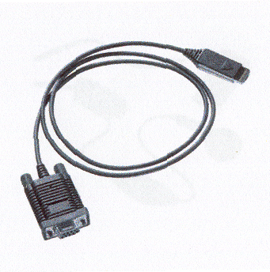
Figure 1.5 data cable.

Data Application Support
Modem driver conforms to V.25 command set, and transmission speed conforms ITU-T-standard of V.22bis. (2400, 4800,and 9600 bits/sec).

Facsimile conforms to Service Class 1, group 3 and operate at 2400, 4800, 7200 and 9600 bit/s.

Data services via GSM network up to 9600 kbps, and remote control using cellular AT commands.

Internet access via the M35i is possible with the inclusion of Wireless Application Protocol (WAP) browser 1.1.
Level 2 Service Guide
Chapter
2
Introduction
The chapter is intended to help you carry out repair up to Level 2 on the M35 series mobile phone.
The repair for international version and Asian variants are identical unless otherwise noted, therefore the description herein is confined to M35i only.

All repairs have to be carried out in an environment set up according to ESD regulations defined in international standards.

ESD procedure is available from your Service Manager. Ask for ASC/T001/98

M35i Technical Information
System GSM Phase 2, Dual Band
EGSM 900, Class 4(2 Watt)
GSM 1800, Class 1(1 Watt)

Operating Voltage 3.6V

Size(LxWxH) 118 x 47 x 22.6 mm
Volume 99cm³ including battery (approx)
Weight 130g including battery (approx)
Battery(Standard) NiMH, 500mAH(Standard)
Li-Ion, 600mAH(Optional)
Standby time1 50 to 180 hours (standard battery)

Talk time¹ 90 to 300 minutes (standard battery)

Charging Time 2 hours

SIM support Plug in card 1.8 V or 3V, SIM Application Tool Kit Class 3
Antenna Integrated.
Speech codec Triple rate Enhance Full Rate
Full Rate
Half Rate
Display 101 x 54 pixel graphical display with up to 5 lines
12 x 12 font size for Chinese

Keypad 12 numeric keys(10 numeric, #, *)
3 function keys(Send, End-ON/OFF, Phonebook)
4 multifunctional softkeys

Key Sound Click/DTMF/None
Key Lock Activation and Deactivation by #-key or
Automatic.

Dialing 10 redial numbers
Last 10 incoming with date/time stamp
Last 10 outgoing calls
Last 10 missed calls with date/time stamp

Ringer On/Beep/Off
Up to 22 melodies and 5 volume settings
(Melody Composer and Crescendo Ringing)
Volume Adjustable in 4 levels during call via softkey
Silent Alert Built-in vibrator
Phone Book Storage depends on the SIM card capacity
Storage of up to 100 list in the phone.
SMS Support MT, MO, CB
Predictive Text Input, Tegic T9.
Supplementary Call Forwarding, Call Hold, Call Wait,
Services Multiparty Conference, CLIP, CLIR, AoCC
AoCI, FDN, LND USSD and SAT

Ciphering A5/1 and A5/2 supported
PIN control PIN 1 & 2 Code Control
Phone code 4 to 8 digit code
Network function Automatic and manual network selection
Chipset Siemens E – GOLD
WAP Browser1 Version 1.1
Other Features Clock / Alarm
Alarm List2
Built-in modem3
Calculator4
Currency Converter
4 Games
7 User Profiles

Accessories:
- Standard Battery L36880-N4001-A100
- Optional Battery L36880-N4001-A101
- Standard Charger L36280-Z4-CXXX (Country Variant)
- Travel Charger L36880-N4001-A103 (EU) / A104 (UK)
Similar to standard charger with an universal input voltage from 90 ~ 240V

- Desk Top Charger L36880-N4001-A102
- Belt Clip L36880-N4001-A113
- Headset L36880-N4001-A123
- Antenna Cradle L36880-N4001-A110
- Car Charger Cable L36880-N4001-A108
- Car Kit Portable1 L36880-N3015-A117
- Car Kit Comfort L36880-N4001-A111
- Car Handset2 L36880-N3015-A123
- Designer Cases L36880-N4001-A119
- Soft Data Link 3.0 L36880-N4001-A122 (Not for 3518i)
- Data Cable3 L36880-N3101-A102
- Car Kit Professional Voice L36880-N4001-A124
- Data Cable Professional4 L36880-N3101-A112

General Information
Information
Due to different requirements of the markets, the M35 has different variants, which broadly classified under International version and Asian version. Marketing name for international version is M35 or M35i, whereas Asian version is named M3508 or M3508i.
Difference between M35(18) and M35(18)i
M35(18)i mobile software has WAP Browser 1.1 incorporated thus enabling user to surf the Internet and it have the built-in soft modem for GSM Data Service. The non-Wap M35(18) do not have the soft modem.
The differences between the M35 and M35i are the hardware and software. The memory size of M35 is 16MB and that of M35i is 32MB.
There are also two variants for 3518, one without the WAP browser is 3518 and that with WAP browser version 1.1 is 3518i.
Wireless Application Protocol, WAP.
Wireless Application Protocol takes a client-server approach that uses the in-built micro-browser to make a request, in wireless markup language (WML), for information or service. The request is passed to a WAP Gateway which then retrieves the information from a Internet server, in HTML format, and translate it into WML. The requested information is then sent to from the WAP Gateway to WAP client (mobile) using the available and most appropriate mobile network bearer services.

Wireless Protocol Stack.
Wireless Application Environment (WAE)
Wireless Session Protocol (WSP)
Wireless Transaction Protocol (WTP)
Wireless Transport Layer Security (WTLS)
Wireless Datagram Protocol (WDP)
Bearers e.g. Data, SMS, USSD
table 1..1 Wap Protocol stack
- Wireless Application Environment
Defines the user interface on the phone. WAE contains the WML,WML script and the wireless telephony application (WTA).
- Wirelss Session Protocol
Link the WAE to two session services – one connection oriented operating above the WTP and a connectionless service operating above WDP.

- Wireless Transaction Protocol
Runs on top of the datagram service and part of the standard suite of TCP/IP protocols, to provide a simplified protocol suitable for low bandwidth mobile station.

- Wireless Transport Layer Security
WTLS incorporates security features that are based upon the established Transport layer Security (TLS) protocol standard, that include data integrity checks, privacy on the WAP Gateway to client leg and authentication.
- Wireless Datagram Protocol
Allows WAP to be bearer independent by adapting the transport layer of the under-laying bearer. WDP presents a consistent data format to the higher layer on the WAP stack.

M35 Series Mechanical Diagram
Figure 2.1 M35i mechanical diagram.
Please take note that the number(s) used here IS NOT the part number, DO NOT used it in your spare parts purchase order.

Always refer to the SERVICE PART PRICE LIST for your spare part order.
Mechanical Concept
Note: All numbers refer to mechanical drawing in Figure 2.1.
The mechanical concept of the M35 differs in various points from the one of the other Siemens mobile telephones.

The first thing you will experience is how the housing is locked. In M35 no screws are used to keep the housing closed. Also inside the telephone no screws are used anymore. To open the housing, which is kept closed by catches only, a special opening tool has been defined. Once the phone is open the catches will be damage and a new housing need to be used. For details on disassembly tool please refer to Photo 2.5 in the Disassembly Section of this chapter.

Inside, the M35 consists of just one board (1010) which carries display module(1170), control part and RF section of the mobile.

The display module (1170) is connected to the board by a flexible cable which is inserted into a plug. In case the display is defective electrically or mechanically it can be exchanged very easily.

M35i does have an external connector of a new type. Since S6 a so called “Molex”-connector was used, which also offered the possibility to connect an external antenna to it. The new “Lumberg”-connector which is used in M35 does not feature such a connection, because the connector for external antenna is located at the back side of the upper end of the mobile, close to the internal antenna. As a consequence of this there is no need anymore for a RF cable mounted to the board nor for a RF plug on it to connect this cable. This improves RF-properties of the mobile and lowers production costs.

To be able to do measurements on and software update of the telephone, an adapter cable between Molex and Lumberg connector will be available. See photos in Additional Tools of Chapter 3.

M35 antenna is an integral part of the lower case shell (1030). The antenna can only be changed by open up the M35i phone and replace the housing.


The M35i is a dual-band mobile operating on GSM900 and GSM1800, the antenna is an integral part of the lower housing.

The keypad, the microphone and the loudspeaker are mounted into the upper case shell (1020). Make sure that the microphone and the earphone contact springs are not dirty or damaged during repair process.

The dust protection frame and the display window are included in the display module(1170).

Hardware Concept – Block Diagram
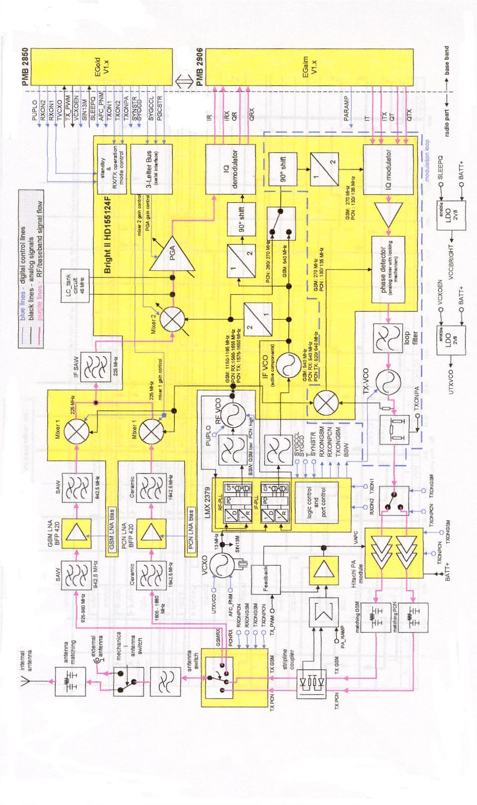
Figure 2.2 m35 block diagram.
Hardware Description
The handset consists of the following major integrated circuits:

1) E-GOLD – PMB2851E

This IC is a combination of microprocessor, signal processor and real-time clock.

The microprocessor part of this component is responsible for controlling the keyboard, SIM-Card, Flash and RAM. Furthermore it controls the power saving, power up/power down of the RF module and sets the amplification of the PA.

The signal processor part of PMB 2851E is responsible for processing the Rx I/Q signals (filtering, equalizing, speech and channel decoding).
Furthermore it does the speech and channel encoding and the GSMK modulation of the Tx I/Q signals. The Voice CODEC part is used to realize advanced features regarding coding of the speech signal. These are:

- Halfrate-Encoding
- Halfrate-Decoding
- Enhanced Fullrate Encoding
- Enhanced Fullrate Decoding
- Voice Activity Detection
- Comfort Noise

2) GAIM – PMB2906

The GAIM (GAIM = GSM Analog Interfacing Module) provides the interface between the analogue and its digital representation signals (Base-band I/Q, Voice-band, PA-control, Voltage & Temperature Measurement - Charging control).

3) 13Mhz Ref Oscillator Circuit -

This circuit provides the following main functions:

- Generate 13Mhz clock signal for Logic Circuits – SIN13M.
- Generate 13Mhz reference signal for the PLL circuits for the Tx & Rx of GSM RF signal.
- Received the frequency steering control AFC_PNM from the HiGOLD IC for fine tuning of the Tx & Rx frequency.
- Temperature dependent resistor sited near the 13MHz oscillator measure the environment temperature.

4) Power Supply ASIC – D0767BA

This circuit provides the following main functions:

- Control of switch on of the Mobile phone by ON/OFF button, Ext Power (Charger) or real time clock.
- Watchdog monitor – switch off the mobile phone if no proper Watchdog signal send from HiGOLD IC.
- Voltage supply to the logic circuits – 2.90V, 2.65V & 1.92V, Simcard & real time clock in HiGOLD IC.
- Switch on the linear regulator to supply the 2.8V for the13Mhz Oscillator circuit.
- RESET signal for the logic circuit.
- Charge control signal for switching the charge FET.
- Low battery detector.
- Over voltage protection.

5) Receiver Circuit – Bright II HD155124F

This circuit provides the following main functions:

- Low Noise Amplifier (LNA) with a fixed amplification of +20dB to amplify the input RF signal.
- Mixer to mix down the RF signal to the Intermediate Frequency (IF)
- Programmable IF amplifier with a dynamic range of 60dB ( -10dB ~+50dB in steps of 2dB).
- Mixer to mix down the IF signal to the baseband, generating and inphase (I) and a quadrature (Q) signal and feed the GAIM IC base-band signal, RX I/Q for the decoding of the digital signal for the HiGOLD IC.

6) Transmitter Circuit – Bright II HD155124F

The GAIM IC generate the MOD I/Q base-band signal under the control of the HiGOLD IC and feed the IQ modulator of the Bright II IC. The Bright II IC provides the IF synthesizer, the I/Q modulator, prescaler to regulate the dual-band TX-VCO and feed the modulated GSM signal to the PA.



The telephone support only 1.8V and 3V SIM card
For user with 5V SIM card, he need to upgrade the SIM card through his service provider/network operator

Power Supply Concept
The M35i has two main power inputs:
- Battery voltage(3.6V) connected at the battery contact
- Charging voltage(6.5V) delivered by the different charger type(see Accessory List) via the Lumberg connector at the bottom of the telephone.
Since the battery voltage is supplying the power supply ASIC, it is always needed to operate the phone. You cannot switch on the handset if the battery voltage is not present.
From the battery voltage, all other supply voltages are derived and controlled by the power supply ASIC.
The RF power amplifier is directly connect to the battery, a bad battery with high internal resistance can cause malfunction of the M35i phone.
The Logic module uses 1.92V, 2.65V & 2.9V generated by voltage regulators inside the ASIC.
Furthermore, the ASIC generates the supply voltage for the SIM card and the RESET signal for the logic devices.
The ASIC also checks the presence of the watchdog signal from the microprocessor and provides the switching on functionality (ON_OFF button or Ignition signal).


Wrong polarity or battery voltage setting that exceed the +6.5V could damage the phone.

Over-voltage Condition
- Battery voltage
If the supply voltage rises above 6.2V, the phone will switch off and it cannot be switched on again before the voltage is lower than 6.2V. If the supply voltage rises above 7V, the phone can be damaged
- Charging Current
The charging current must not rise above 1A or a track fuse in the phone will blow. As a result charging the battery will no longer by possible.

Be careful with NON-original SIEMENS accessories or chargers. Make sure that the charging current is limited to value below 1A.

Battery Charging
M35 series uses a Nickel Metal Hyride (NiMH) 500mAH battery pack as standard battery. It also support the Lithium Ion 600mAH battery pack (For S35i phone) as optional battery for customer want longer talk time.
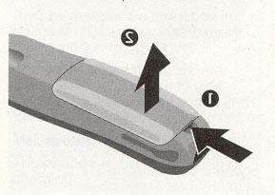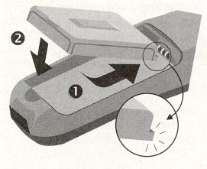
PHOTO 2.3 M35i SERIES INSERTING BATTERY.
For M35, BATT+ has a voltage level from +3.0V to 5.5V, and a BATT_TEMP contact is used for detecting abnormal increase in temperature of the battery.
If the temperature is too high or too low, there is a high probability that the battery is not charged. To enable the charging process again, battery and phone needs to cools down or warm up. Battery replacement is not required.

Avoid shorting the battery terminals.
Short Circuit Protection
For the Nickel Metal Hydride battery, a polyswitch in the battery pack protecting the battery from short circuit and it should reset by itself after some time removing the short circuit.
For the Lithium Ion battery, it is short-circuit protected by an electronics fuse. The fuse will be activated in case a too high current is drawn. This fuse will not reset automatically.
The resetting of the L-ion battery fuse can be done with either of the following procedures:
- Insert the battery into the M35 and then connect the rapid charger to the phone. Wait for approximately 10 second, then the mobile can be turned on again.
- Plug the battery separately into the desktop charger. The fuse is reset immediately.
- Insert the battery into the M35 and put the phone into the desktop charger. Wait for approximately 10 second, then the mobile can be switched on.
Normal Charging
The battery can be charged when it is inserted into the phone. The charging process is completely controlled by the mobile. Charging can be done with any of the following accessory:

- Rapid charger
- Travel charger
- Car charger
- Desktop charger

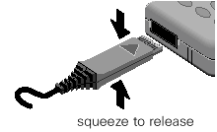
photo 2.4 insert charger
Photo 2.4 shows the correct way of inserting and removing the charger plug.
Deep Discharge Battery
In case of a deeply discharged battery, the voltage of the battery is too low to operate the charging circuit and the display controller, the phone can not be turned on and the normal charging process can not be started. No charging symbol is visible in the display.

In this case, charging the battery is divided into two different steps, which have to be run subsequently:

a) Trickle charge for M35 Phone

Trickle charge mode is automatically started if the battery voltage is below 3.0V when the charger is connected to the mobile. The charging current in Trickle mode is appr. 10mA.

Trickle charge mode has to last minimum until the battery voltage has exceeded 3.2V, then the phone will switch on and the charging icon appear. During trickle charge the charging symbol will not be visible and the telephone can not be turned on. This is because the battery voltage is too low to operate the telephone.

Action:

Insert battery into handset and connect travel charger to the telephone. If within 4 hours the battery voltage is high enough again, the charging symbol will come up.

If the battery is discharged very deeply, the symbol may not come up and the trickle charge time possibly has to be extended up to 24 hours.

b) Normal charge

When the battery voltage is above the a.m. value (e.g. by trickle charge) the mobile will start the normal charging mode and show a charging symbol in the display. * Always normal charge a new battery or a deep discharged battery for more then 12 hours before first use.

Action:
Connect charger to the telephone (see section on Charging).

The charging symbol will come up as an indication that the normal charging process has been started by the mobile.

Mobile Phone M35 Spare Parts Level 1 and Level 2
Level 1 Part No.

L36158-A33-C101 Display Cover (Displaymodule) C35/C35i/M35i
L36158-A33-C103 Display Sealing (Displaymodule) C35/C35i/M35i
L36158-A36-A1 Upper Case Shell M35i blue
L36158-A36-A4 Upper Case Shell M35i yellow
L36158-A36-A5 Upper Case Shell M35i grey
L36158-A36-A12 Upper Case Shell M35 (China) grey black
L36158-A36-A30 Lower Case Shell M35i dark blue (including antenna)
L36158-A36-A31 Lower Case Shell M35i yellow blue (including antenna)
L36158-A36-A32 Lower Case Shell M35i grey black (including antenna)
L36158-A36-A40 Battery Cover M35 blue
L36158-A36-A43 Battery Cover M35i yellow blue
L36158-A36-A44 Battery Cover M35 grey black
L36158-A36-B70 Keypad M35
L36158-A36-B72 Keypad 3518
L36158-A36-B299 Splash water covers M35i (set)
L36158-A36-C250 Battery Sealing M35
L36158-A36-C260 Buzzer Sealing M35
L36158-A36-C280 Case Sealing M35
L36212-Z3-C34 Earphone C35/C35i/S35i/M35
L36254-Z6-C82 Microphone C35/C35i/S35i/M35
L36334-Z97-C112 SIM-Card Holder C35/C35i/S35i/M35i
L36334-Z97-C113 Battery Contact Spring C35/C35i/S35i/M35i
L36334-Z97-C163 SIM-Card Reader with Card Holder
L36453-Z5-C77 Vibra-Alert Unit C35/C35i/S35i/M35
L36851-Z1508-A51 Display module C35/C35i/M35I

Level 2 Part No.

L36880-Q4250-A201 RF Control Board M35i
L36880-Q4250-A211 RF Control Board M35i SIM-Lock 1
L36880-Q4250-A213 RF Control Board M35i SIM-Lock 3

Disassemble the M35
A case opener is needed to disengage the latch of the M35 casing.
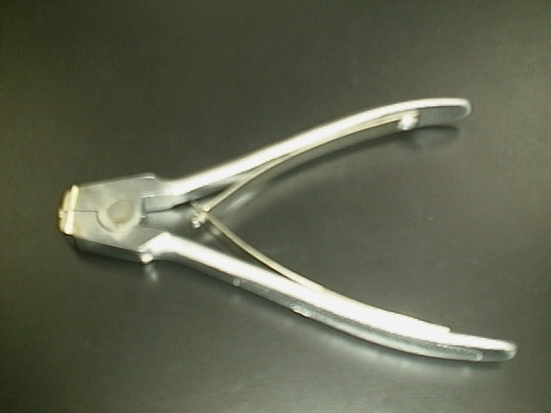
PHOTO 2.5 C35/M35i/S35i CASE OPENER

The part number for this mandatory tool is F30032-P46-A1
Refer to ANNEX B of Chapter 3 for Service Equipment List.

Step 1:
Unlock the battery cover of the battery with the plastic coin that shipped with the M35i phone as shown in photo 2.6 & PHOTO 2.7
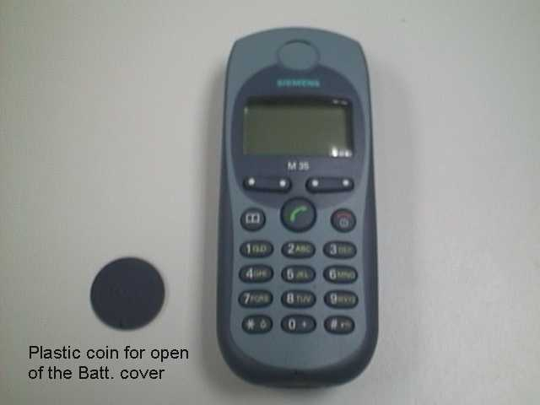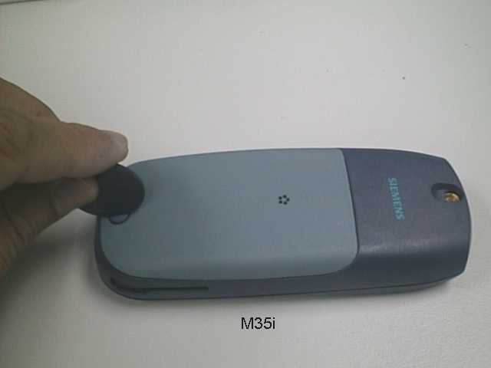
PHOTO 2.6 DISASSEMBLE M35i – STEP 1 PHOTO 2.7 DISASSEMBLE M35i – STEP 1

Step 2:
Remove the battery cover and the battery as shown in photo 2.8 & PHOTO 2.9 and keep the Battery Cover, Battery, Battery Sealing, Accessory Connector Cover and External Antenna Cover for Assembly of M35i .

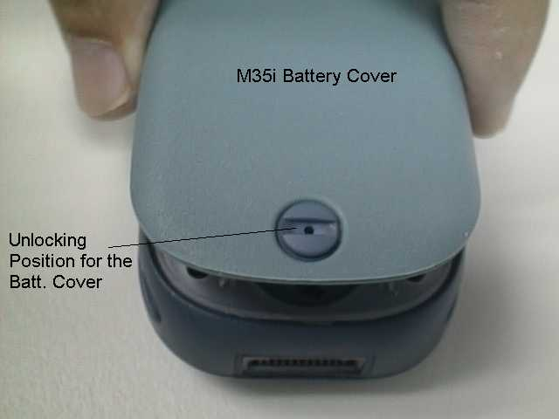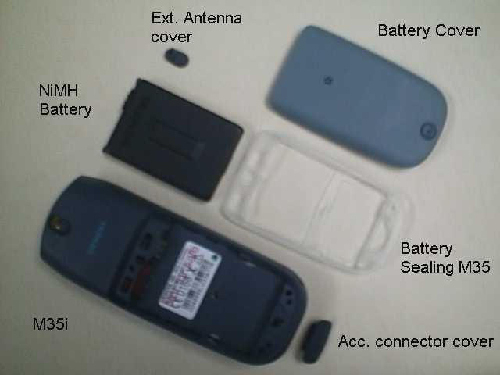
PHOTO 2.8 DISASSEMBLE M35i – STEP 2 PHOTO 2.9 DISASSEMBLE M35i – STEP 2

Step 3:
Open the housing with the opening tool and carefully pull the lower housing section off as illustrated in photo 2.10
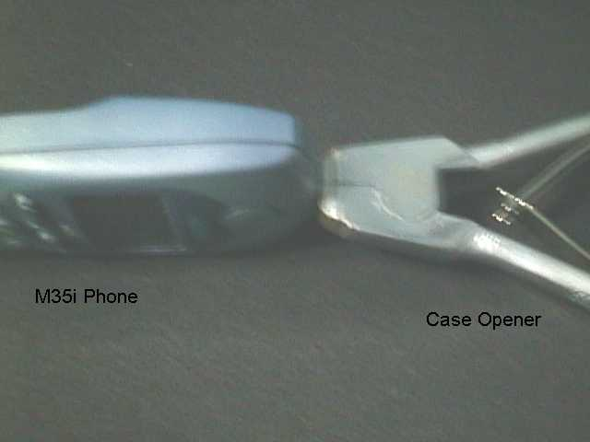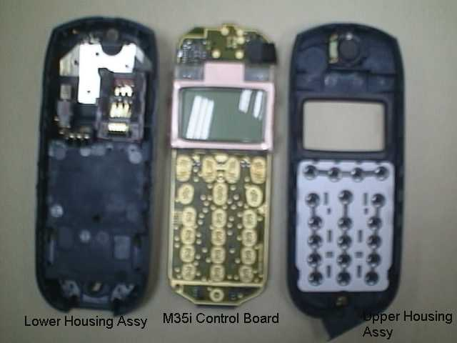
PHOTO 2.10 DISASSEMBLE M35i – STEP 3 PHOTO 2.11 DISASSEMBLE M35i – STEP 4
Step 3:
Use the Case Opener carefully disengaged the catches of the Lower housing and Upper housing to separate the housing and the Control Board Assembly as in photo 2.11

Disassemble/Assemble of the Lower Housing Assembly
Step 1:
Open the housing with the opening tool and carefully pull the lower housing section off as illustrated in photo 2.12
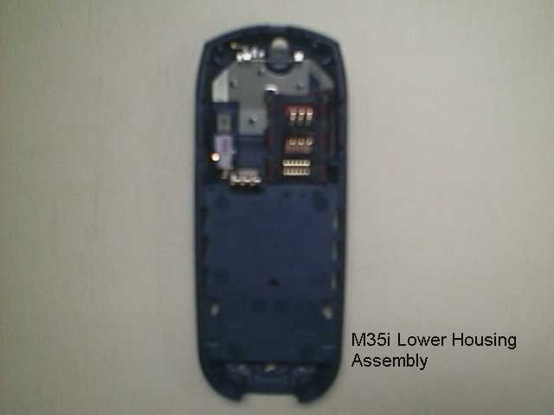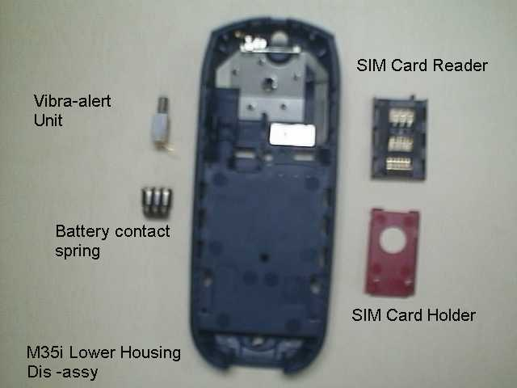
PHOTO 2.12 Lower Housing Assy – STEP 1 PHOTO 2.13 Disassembly Lower Housing – STEP 2

Step 2:
remove in sequence by hand the SIM Card Holder, SIM Card Reader, Battery Contact Spring, and Vibra-Alert Unit as illustrated in photo 2.13
For the assembly of the Lower Housing just reverse the sequence for the disassembly, watch out for the guide notches.

Disassemble/Assemble the Control Board Assembly
Step 1:
Open the housing with the opening tool and carefully pull the lower housing section off as illustrated in photo 2.14
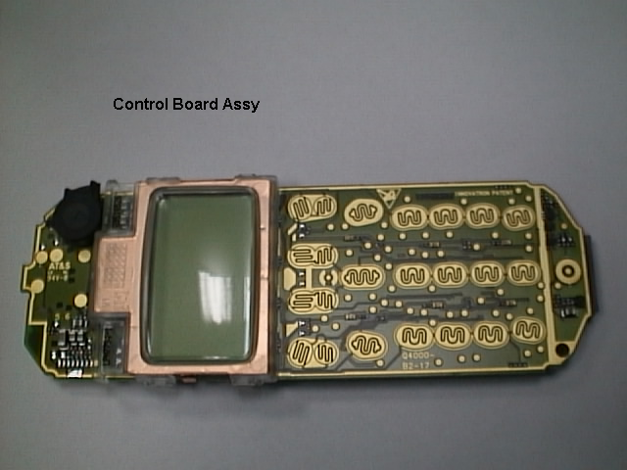
PHOTO 2.14 Control Board Assy – STEP 1

Step 2:
Unlock the catches of the Display Module from the Control Board and move the display module to the lower part of the PCB. Lift up carefully the retaining clip of the display connector on the Control Board as illustrated in photo 2.15
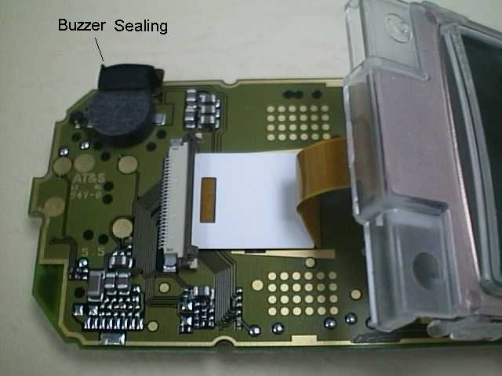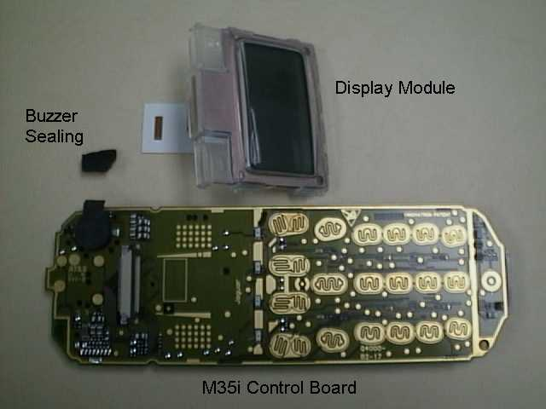
PHOTO 2.15 Disassemble Control Board Assy – STEP 2 PHOTO 2.16 Disassemble Control Board Assy – STEP 3
Step 3:
Remove the Display Module and the Buzzer Sealing from the Control Board as illustrated in photo 2.16
For Remove/Install the display module, watch out for the catches on the display module and the guide hole of the PCB. For the assembly of the Control Board assembly, just reverse the sequence for the disassembly.

Disassemble/Assemble of the Display Module (For changing of a scratched Display Cover)
Step 1:
Remove the copper strips that was glued to the back cover of the Display Module with a flat tips tweezer with care for not to break the copper strips as illustrated in photo 2.17 & PHOTO 2.18
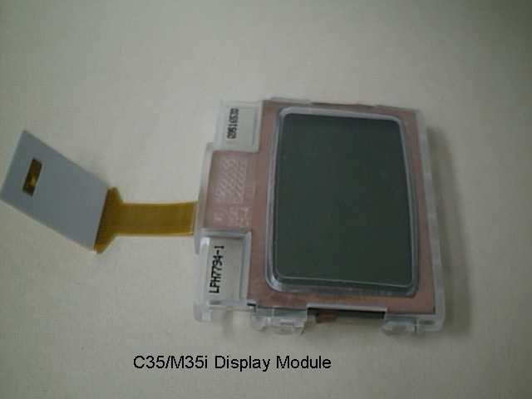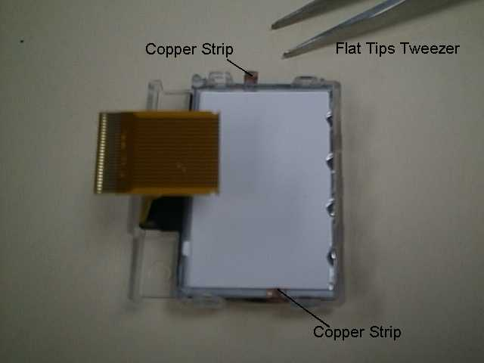
PHOTO 2.17 Disassembly Display Module – STEP 1 PHOTO 2.18 Disassembly Display Module – STEP 1

Step 2:
Disengaged the catches of the Back Cover and Front Display Cover to separate the housing and the Control Board Assembly as in photo 2.19 and remove in sequence by hand the Back Cover, LCD Flexi-PCB and the Display Mask as illustrated in photo 2.20
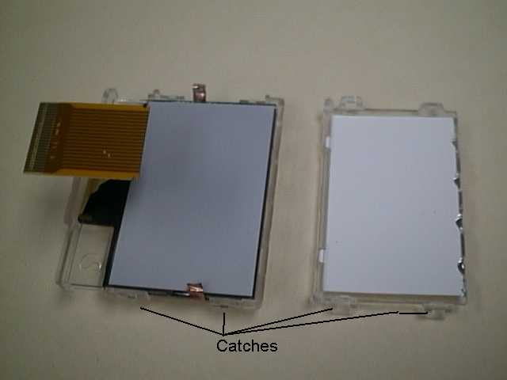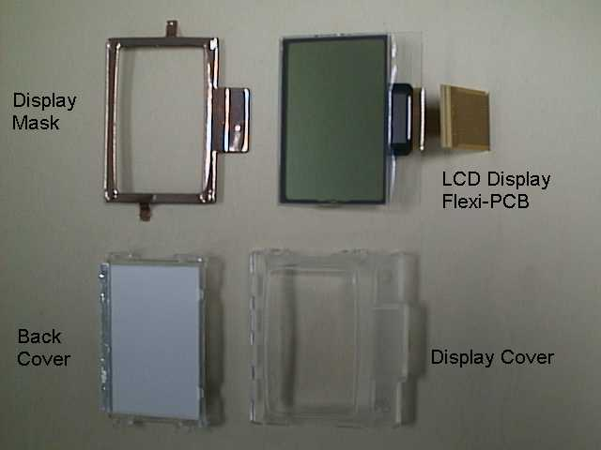
PHOTO 2.19 Disassembly Display Module – STEP PHOTO 2.20 Disassembly Display Module – STEP 1

For the assembly of the Display just reverse the sequence for the disassembly. (watch out for the guide notches and blow off the dust on the LCD screen and Display Cover.)

Disassemble/Assemble of the Upper Housing Assembly
Step 1:
Open the housing with the opening tool and carefully pull the lower housing section off as illustrated in photo 2.21
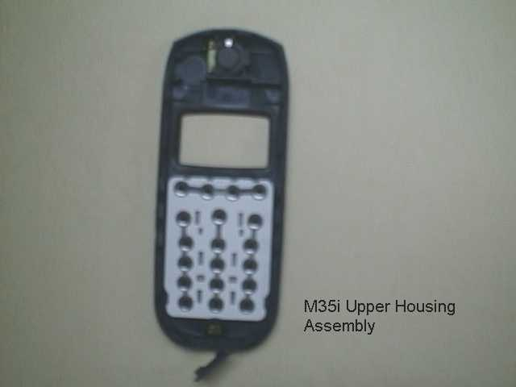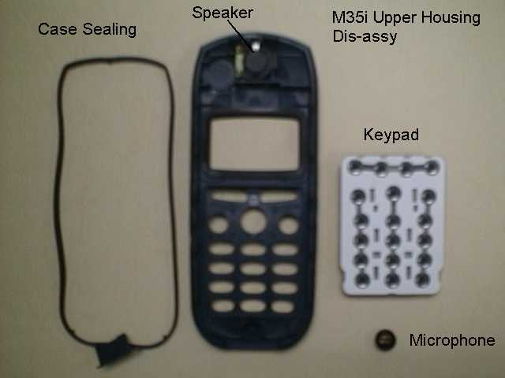
PHOTO 2.21 Upper Housing Assy – STEP 1 PHOTO 2.22 Disassemble Upper Housing – STEP 2

Step 2:
remove the Keypad, Case Sealing by hand and use a fine point metal tweezers to remove the microphone as illustrated in photo 2.22

The loudspeaker is glued to the upper housing section by a foam covered with glue on both sides. When you remove it, the foam will be damaged. Please use new loudspeaker for assembling Upper Housing Assembly.

For assembly of a new Upper Housing install a new earphone first, watch out for the orientation. For install of the other parts just reverse the sequence for the disassembly.

Assemble the M35
Step 1:
Check that the Lower Housing Assembly, Control Board Assembly and Upper Housing Assembly are in good order. Check if the Buzzer sealing was installed on the Control Board.

New Upper and Lower Casing must be used. All contact pins must not be dirty, damaged or bent!
If any part is not O.K please replace it with a new part.

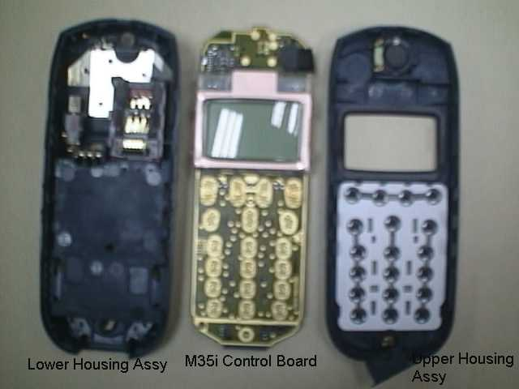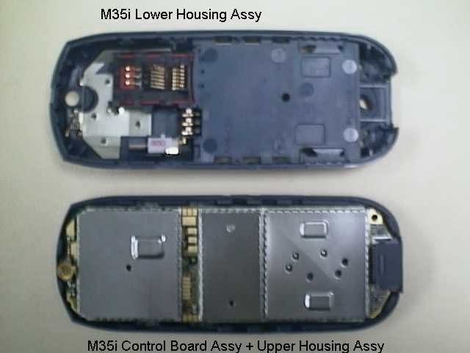
PHOTO 2.23 ASSEMBLE M35i – STEP 1 PHOTO 2.24 ASSEMBLE M35i – STEP 2

Step 2:
Place the Control Board Assembly in the Upper Housing as illustrated in PHOTO 2.24.

Step 3:
Close the device by putting on the Upper casing section as illustrated in PHOTO 2.25. Hold the phone and use both hands to close the casing starting from the catches at the top part near the antenna, watch out for leaving any finger marking on the display screen.
Do not place the phone on the table to close up the housing as the Antenna may be damage.

ALL CATCHES MUST ENGAGE COMPLETELY!

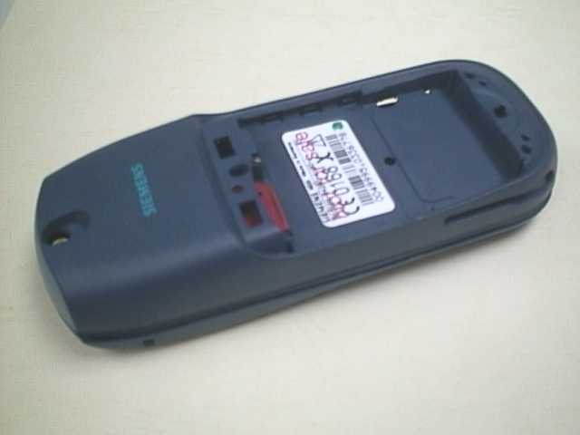
PHOTO 2.25 ASSEMBLE M35i – STEP 3
Step 4:
Remove old IMEI label from the old housing using a hair-dryer for re-use of the IMEI label or paste the new IMEI label supplied for control board replacement. Insert the battery and put back the battery cover. Ready for testing.
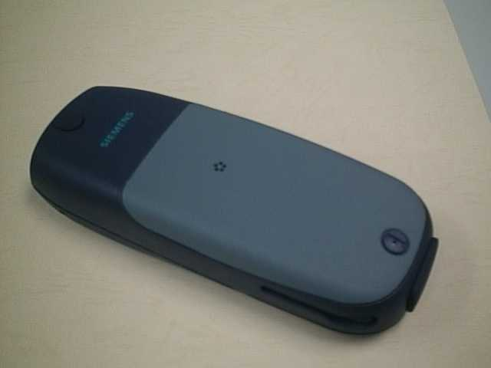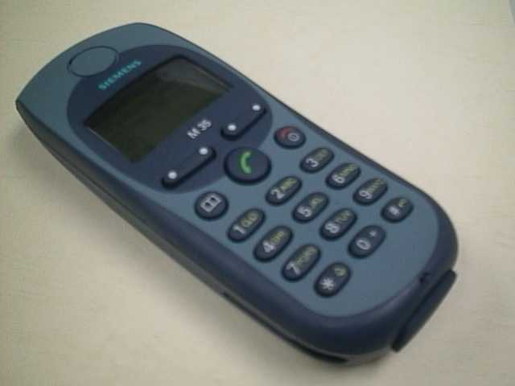
PHOTO 2.26 ASSEMBLE M35i – STEP 4 PHOTO 2.27 ASSEMBLE M35i – STEP 4

Mobile Software Programming
Model before X25 and X35, software used for the mobile are similar except for their differences in the language group. Customer specific values (e.g. ringing tones etc) are seldom, but there were some, were included in the common mobile software.
X25 and X35 has changed. There is still a common mobile software available which is divided into language groups. However, this software does not contain the specific settings, such as ringing tones, greeting text, short dial list etc., required by the operator(s) or service provider(s). Therefore, it is not uncommon to have some menu item(s) differ in different variants or are not visible at all. These settings are stored in different memory area of the mobile and will be activated depending on the customer specific model or variant of the phone by a separate test step during the production process.
Due to this separation of common mobile software and customer specific initialization, it is possible to fulfill the demands of the market requiring customization and flexibility.
As a consequence the software programming process in the LSO is divided into two different steps as followed:
- Software update to actual version and appropriate language group
- Programming of CUSTOMER SPECIFIC INITIALIZATION

Mobile Software Updating
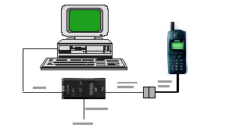
The software of the mobile, M35 series, is loaded from a PC directly. Hardware interconnection between the mobile and the PC is shown in Figure 2.6
RS232 Port
Adaptor-Cable -Bootadptor
Bootadptor
AC Adaptor

Figure 2.28 X35 series software programming setup

Because of the new type of external connector used in X35 (Lumberg type) an additional adaptor cable between mobile and boot adaptor is required. Table 2.1 listed all the hardware requirements

If you use the X35 battery dummy, then make sure that the power supply voltage is correctly adjusted 4.0V & 3A current rating.
Description | Part No.
Adaptor-Cable-Bootadaptor, X25/X35 | V30146-A5004-D
Boot Adaptor | L24857-F1006-A30
IBM Compatible PC – Pentium | -
tAble 2.1 equipment list for software programming.

software is a DOS-based program, it is advisable to do the software upgrade in dos environment.

Languague Groups

There are over 20 languages for the M35 series in total. These languages are divided into groups as follows
M35i
Group | Languages
1 | English, German, French, Italian, Dutch, Swedish, Finnish, Norwegian, Danish.
2 | English, German, French, Italian, Dutch, Swedish, Finnish, Norwegian, Danish.
3 | English, German, French, Italian, Spanish, Catalan, Portugese, Dutch.
4 | English, German, Hungarian, Polish, Russian, Bulgrian, Czech, Slovakian.
5 | English, French, Italian, Arabic, Greek, Turkish, Hebrew, Bahasan Malaysia, Bahasan Indonesia.
8 | English2, Chinese Simplified, Chinese Traditional.
Note: Tegic- T9 Input method support in for the languages BOLD.

tAble 2.2 software language groups.

This information is subject to change!

Contact your Service Manager for the order number of the right version of mobile software for your market.

The mobile software file is named using this convention:

M35_(Version)(LG).EXE

e.g. M35_0501 ➔ Version = 05; Language Group = 1
M35_0508 ➔ Version = 05; Language Group = 8.
This executable file needs a definition or init file, named SWUP.INI, to define the message language preferences and the hardware communication port set up.
The content of this file consists of the following text:
Language=English
COM=x

Where x is the number that corresponds to the serial port that is used, either 1, 2 or 3.

Flow chart 2.1 illustrates the software programming process.
No
Yes
Yes
No
No
Yes
Yes
No
Yes
No
Plug in the Boot Adaptor to the PC and Mobile
Connect the AC adaptor to the Boot Adaptor
Power up Boot Adaptor &
Check LED
OK
?
Check AC Adaptor
OK
?
Faulty AC Adaptor
Faulty Boot Adaptor
Power up the PC in DOS environment
Execute the “Mobile S/W”
Error
?
Check
H/W setup = S/W settings.
OK
?
Software upgrading in progress
Correct settings.
Error
?
Test Mobile
Take note of error and repeat process again
Feedback Error to ICP CD ASC
END

FlowChart 2.1 software programming. process

Customer Specific Initialization
Refer to the Customization Guide

LSO has to make sure that after repair the customer gets the mobile with correct variant specific initialization.

For more information about the configuration tool, refer to Service Information dated 30th April 1999, or contact your Service Manager.

International Mobile Equipment Identity, IMEI
The mobile equipment is uniquely identified by the International Mobile Equipment Identity, IMEI, which consists of 15 digits. Type approval granted to a type of mobile is allocated 6 digits. The final assembly code is used to identify the final assembly plant and is assigned with 2 digits. 6 digits have been allocated for the equipment serial number for manufacturer and the last digit is spare.
The part number for the M35i is S36880-S4250-Axxx where the last 4 letters specify the housing and software variant.
M35i series IMEI label is accessible by removing the battery. It is illustrated in Photo 2.18.
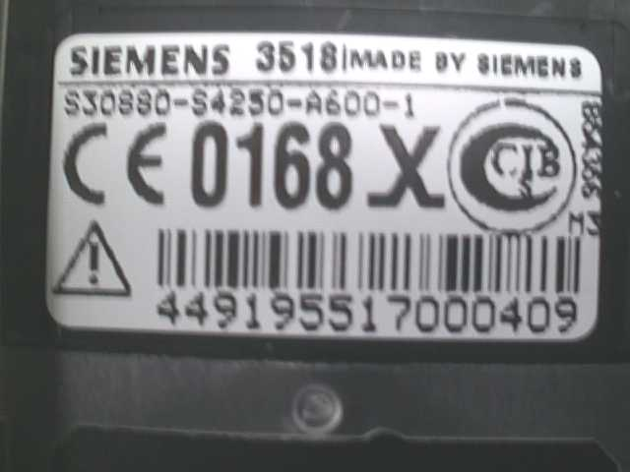
photo 2.18 3518i iMeI label

Re-use of IMEI label is possible by using a hair-dryer to remove the IMEI label.

On this IMEI label, Siemens has also includes the date code for production or service, which conforms to the industrial standard DIN EN 60062. The date code comprises of 2 characters: first character denotes the Year and the second character denotes the Month. Fr example, the IMEI above show date code M3.

Year | Date Code | Month | Date Code
1999 | L | December | D
2000 | M | January | 1
2001 | N | February | 2

tAble 2.3 DIN eN 60062 date code

Phone Unblocking
When the phone is disable due to wrong entry of PHONECODE, it can be re-activated by entering the right unblocking code. This unblocking code is derived from the IMEI number of the mobile.
The unblocked code, also known as Master Phone Code, has to be entered in the following format:
*#0003*--------#

The Master Phone Code can be obtained by:
- Fax to Siemens Hotline in Germany
Siemens AG
ICP CD SH
World Service Center, Bocholt, Germany
+49-2871-91-3007

- Fax to Siemens Hotline in Singapore
Siemens Advanced Engineering Pte Ltd
ICP CD ASC
Ms Ginny Siew
+65-842-6641

- Internet Solution
A password protected homepage where LSO can enter IMEI number of a disable phone. The generated Master Code will then be presented for unblocking purpose. This service is offered to all LSOs.
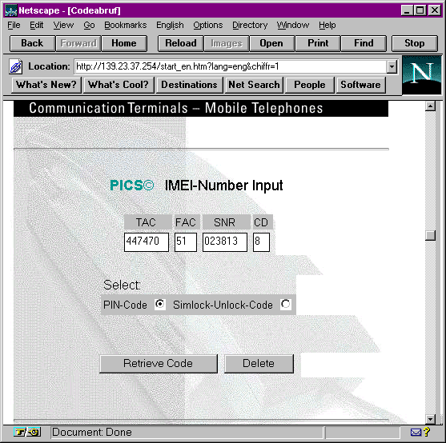
photo 2.19 Internet page

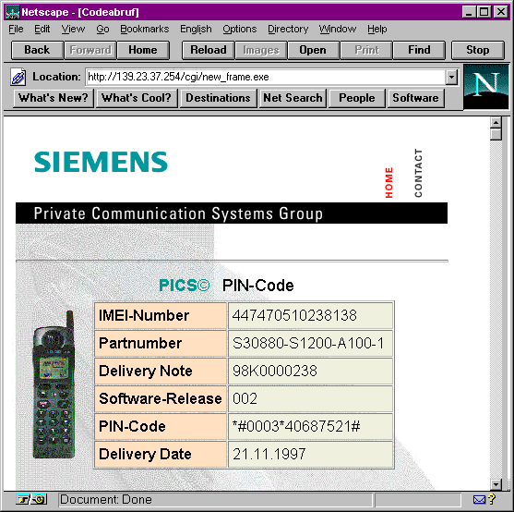
photo 2.20 internet page: master phone code

Contact your Service Manager for more information regarding setting up of the INTERNET SOLUTION & its installation procedure, ASC/T002/98.


Siemens Service Equipment
Chapter
3

User Manual
Introduction
Every LSO repairing Siemens handset must ensure that the quality standards are observed. Siemens has developed an automatic testing system that will perform all necessary measurements. This testing system is known as
Siemens Mobile Service Equipment
Using this system vastly simplifies the repair of the phones and will make sure that:
- All possible faults are detected
- Set which pass the test will be good enough to return to customer.

Starting from the P35 Series, Siemens will introduce a simpler and faster testing platform for testing a repaired Siemens mobile phone. The testing platform are either base on R&S CMD 53/55 or CTS55 GSM test set.

There is also test software under development for testing with the Wavetek 4201S and the 4107 GSM test set.

A Level 2.5 service software is also under development for more elaborate testing for the repair for the P35 series mobile phone.

THE LSO WILL HAVE TO PURCHASE THE SYSTEM, CHOOSING BETWEEN THE COMPLETE PACKAGE OR SUB-SET OF IT.

A FULLY AUTOMATIC TEST PROCEDURE IS ONLY POSSIBLE IF THE COMPLETE SYSTEM IS INSTALLED.

Make sure that your CTS firmware is Version 3.01 or higher. For CMD 55 it must be Version 4.03 and higher. Please check with the Service Info SB_0500 for the CTS/CMD Hardware Options.

R&S CMD55 Test Station
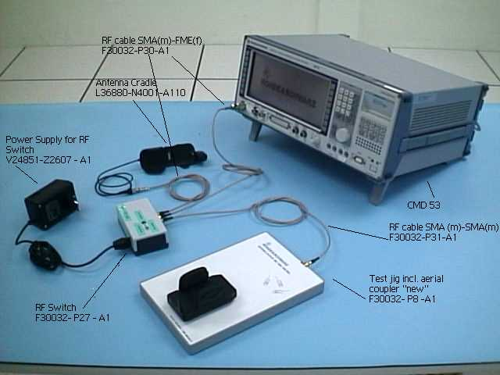
R&S CTS55 Test Station
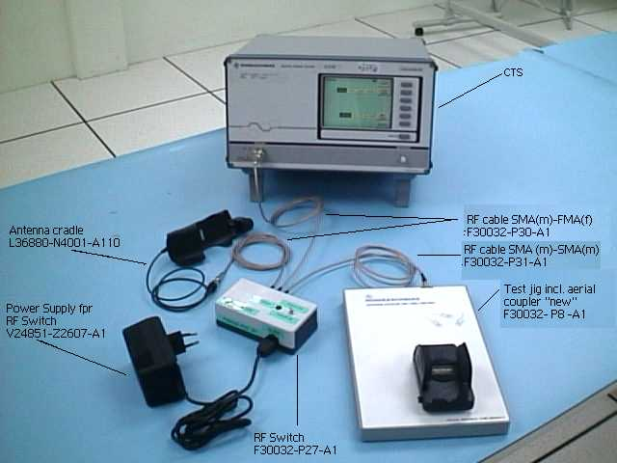

Wavetek 4201S Test Station
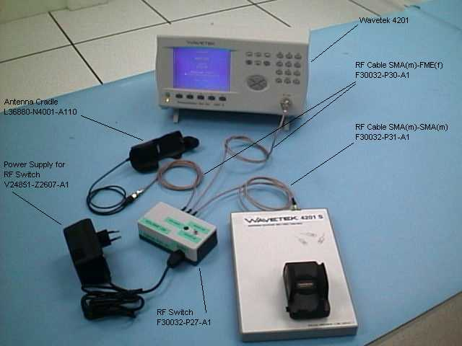
Other equipment
One Pentium MMX Window 95/98 PC with a serial port to connect to the GSM test set through the PC serial cable provided for the GSM test set.
One Test SIM card and a fully charged battery for used with the mobile phone model.
Additional RF connector will be needed for setup using Wavetek 4107 test set and Wavetek Antenna Coupler.
For LSO Test Station setup base on the Wavetek 4107 test set, you need a TNC(male) to SMA(female) connector. For the Wavetek Antenna Coupler, you need a TNC(female) to SMA(female) connector. The part number for the connectors will be announced soon.

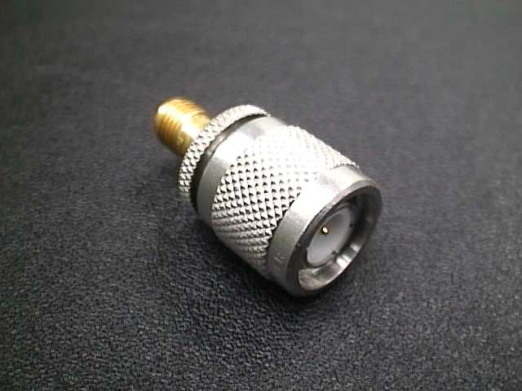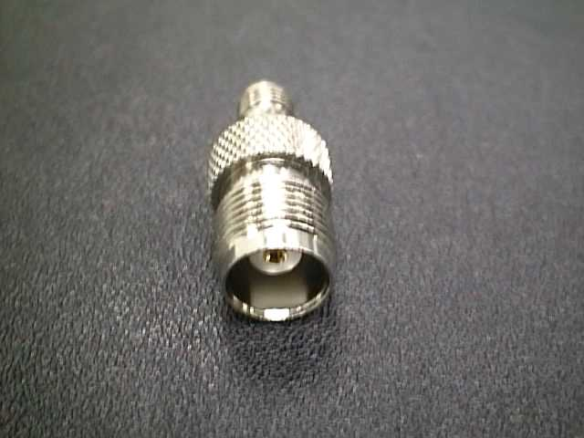
For Wavetek GSM test set For Wavetek Antenna Coupler

Software Installation
Before executing the test software, it is important to ensure that the software configuration matches that of the hardware set up. Each GSM Tester will have a specific test software. The test software are name CMD_GO, CTS_GO and for Wavetek test set, CAT4200 respectively.
First, copy the installation software for the specific GSM tester to a temporary directory on the harddisk of the Window PC and then Run the Setup from the first sub directory – Disk1 for CMD_GO test software.

After the installation for the test software, RUN the Test software and check the configuration setting for the Serial port.

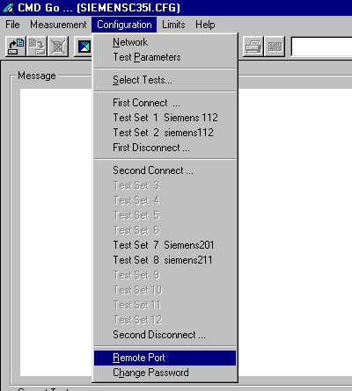

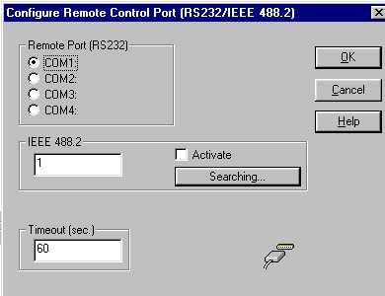

Configuring the test software
For each model of the P35 series mobile phone, Siemens will distribute the testing configuration file for the specific test station. For testing the phone, just go to the File menu and select Load Configuration.

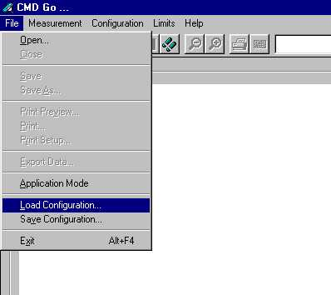

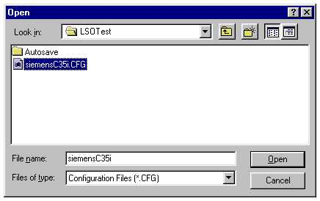

Running the test sequence

Make sure that your CTS firmware is Version 3.01 or higher. For CMD 55 it must be Version 4.03 and higher. Please check with the Service Info SB_0500 for the CTS/CMD Hardware Options.


Insert a Test SIM card and a fully charged battery into the Siemens mobile phone and place it onto the phone holder on the Antenna Coupler. Switch the RF switch to INT ANT position and select the Start button to run the test sequence in the configuration file.

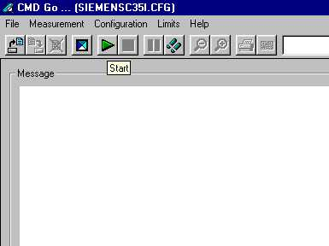

Follow the instruction on the screen and switch on the phone. The mobile phone will start Network Search and doing Location Update to the GSM test set through the off-air signal from Antenna Coupler.

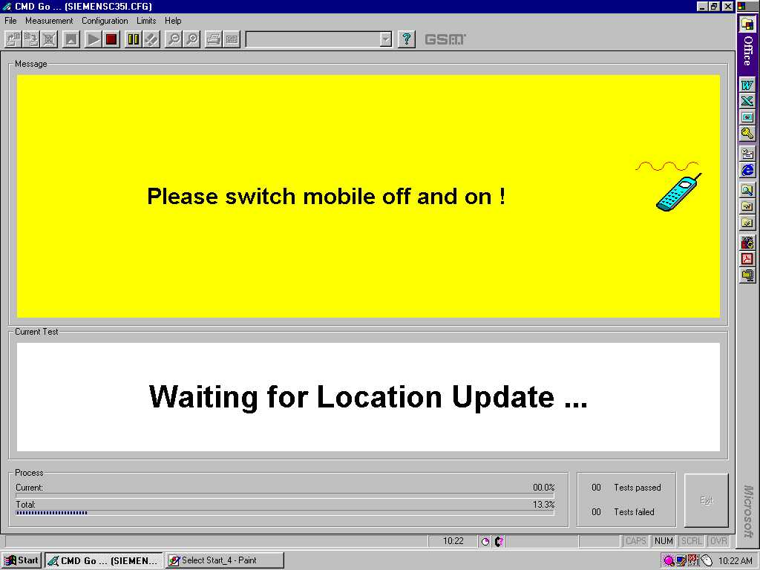

Next, the GSM test set will initial a call to the mobile phone through the Antenna Coupler. Press the Call key when the mobile phone ring, and the GSM test set will start Tx Power measurements on the GSM and GSM1800 channel specified by the configuration setting.

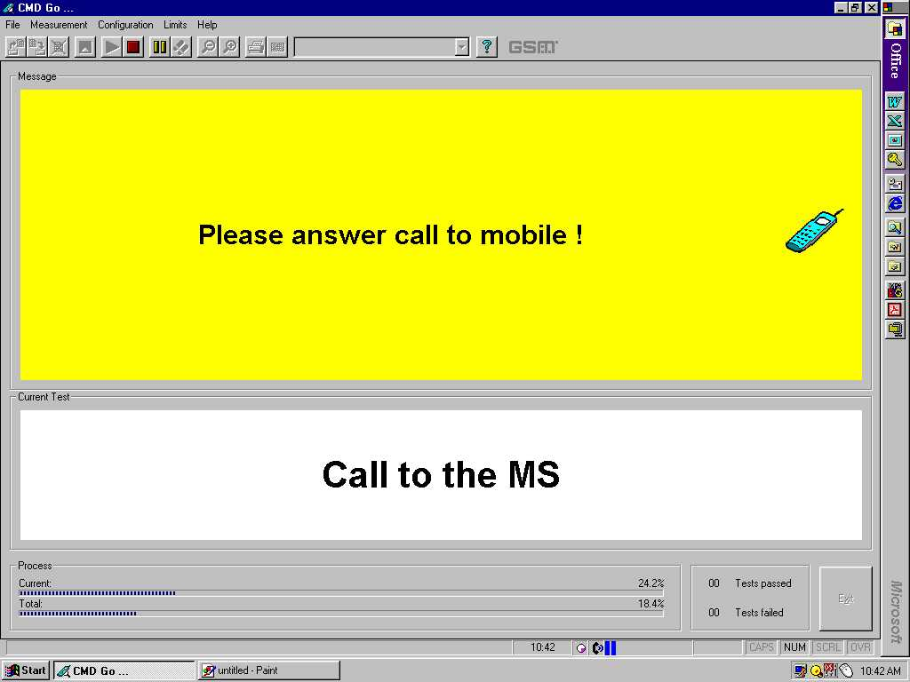

Next, the GSM test set will end the call to the mobile phone and the screen will prompt for Dialing from the mobile phone. At this test step, please move the mobile phone to the Antenna Cradle and switch the RF switch to EXT ANT position. Once the mobile phone log to the GSM test set, dial 1234 and the Send key.

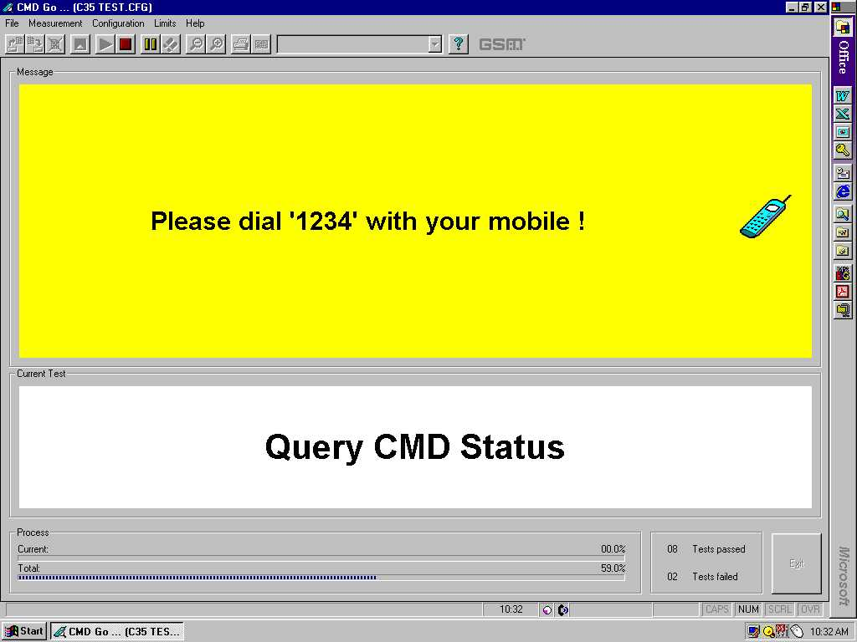

The GSM test set will make Tx Power measurements, Rx BER measurement, Echo Loop test on the GSM and GSM1800 channel specified by the configuration setting. There will be 2 Echo Loop Back test for checking the speech quality – one for GSM and one for GSM1800. Speak into the mobile phone when prompted and listen the voice after appr. 1 second and check the speech quality. If not O.K, it may be microphone or the earphone defective.

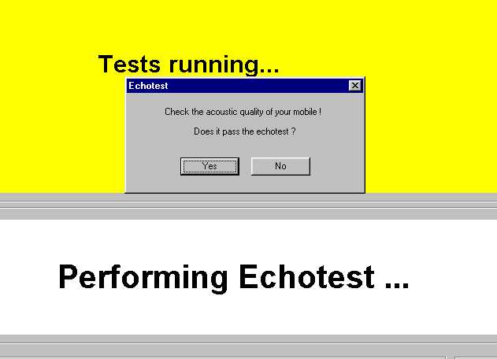

The last test is Disconnect Call from the mobile phone. Press the End Call key and the test sequence will end.

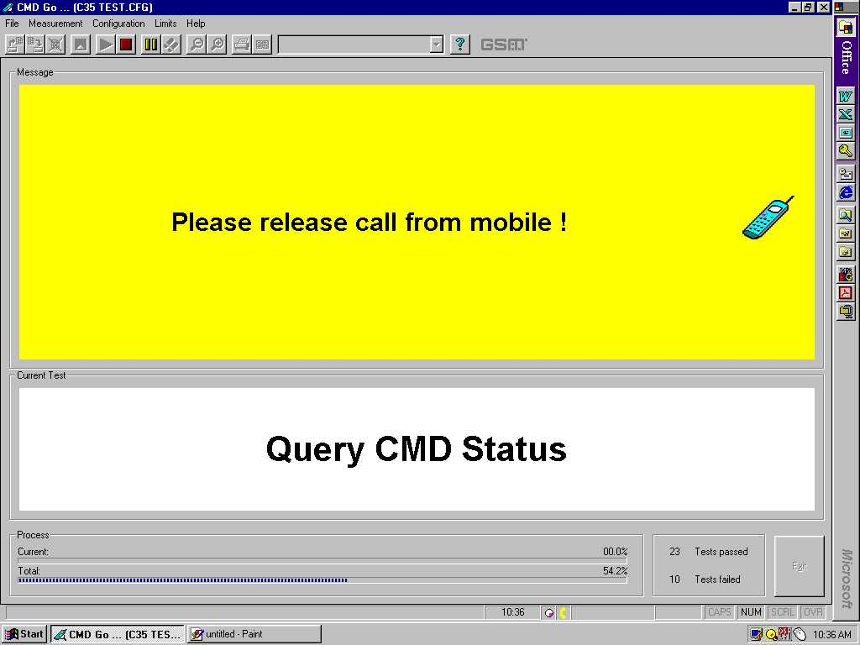

A measurement report screen will show up and a hardcopy can be printed if a printer is connected to the PC. To close the measurement report screen, click the third button from the left.

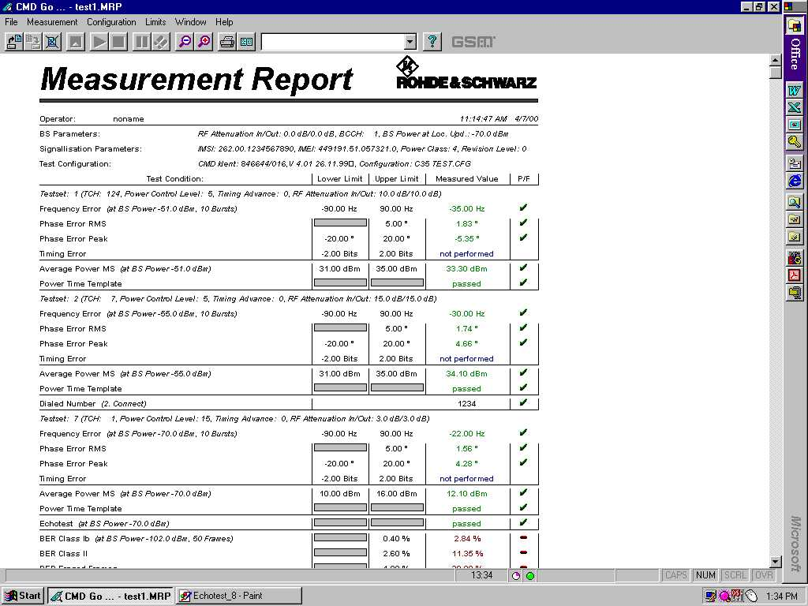
Once the mobile phone pass all the test steps, please make a check for all the key and the display. After this we can confirm on the proper functioning of the mobile phone after repair and return the phone back to the customer.

ANNEX A
Cable Specifications
- PC to NGSM(Power Supply)
Depending on the type of serial connector that is used by the PC. The cable layout for both 9pins and 25pin are listed below:

Computer:  Sub-D 25 pins | NGSM:  Sub-D 25 pins
TxD Pin 2 | RxD Pin 3
RxD Pin 3 | TxD Pin 2
RTS Pin 4 | DCD Pin 8
DCD Pin 8 | RTS Pin 4
CTS Pin 5 | DTR Pin 20
DSR Pin 6 | DTR Pin 20
DTR Pin 20 | CTS Pin 5
DTR Pin 20 | DSR Pin 6
GND Pin 7 | GND Pin 7
table a.1 D25 to D25 connection

Computer:  Sub-D 9 pins | NGSM:  Sub-D 25 pins
TxD Pin 2 | RxD Pin 3
RxD Pin 3 | TxD Pin 2
RTS Pin 7 | DCD Pin 8
DCD Pin 1 | RTS Pin 4
CTS Pin 8 | DTR Pin 20
DSR Pin 6 | DTR Pin 20
DTR Pin 4 | CTS Pin 5
DTR Pin 4 | DSR Pin 6
GND Pin 5 | GND Pin 7
table a.2 D9 to D25 connection

- PC to CMD 53 or CTS 55
Depending on the type of connector used for the PC serial interface, two different type of cables can be used:

Computer:  Sub-D 25 pins | CMD / CTS:  Sub-D 9 pins
TxD Pin 2 | RxD Pin 2
RxD Pin 3 | TxD Pin 3
DSR Pin 6 | DTR Pin 4
GND Pin 7 | GND Pin 5
DTR Pin 20 | DSR Pin 6
CTS Pin 5 | RTS Pin 7
RTS Pin 4 | CTS Pin 8
table a.3 D25 to D9 connection

Computer:  Sub-D 9 pins | CMD / CTS:  Sub-D 9 pins
RxD Pin 3 | TxD Pin 2
TxD Pin 2 | RxD Pin 3
DSR Pin 6 | DTR Pin 4
GND Pin 5 | GND Pin 5
DTR Pin 4 | DSR Pin 6
CTS Pin 8 | RTS Pin 7
RTS Pin 7 | CTS Pin 8
table a.4 D9 to D9 connection
- PC to Adaptor Box

Computer:  Sub-D 9 pins | Adaptorbox:  Sub-D 9 pins
TxD Pin 2 | RxD Pin 3
RxD Pin 3 | TxD Pin 2
DTR Pin 4 | DSR Pin 6
GND Pin 5 | GND Pin 5
DSR Pin 6 | DTR Pin 4
RTS Pin 7 | CTS Pin 8
CTS Pin 8 | RTS Pin 7
table a.5 D9 to D9 connection
Jumper Settings of NGSM(Power Supply
Internal dip switches of the power supply, NGSM 32/10, must be set correctly to ensure proper communication between PC and the NGSM. These switches are set up by Siemens and tested before delivery, hence it is not necessary to change it normally.
These switches are located under the left side of the cover of the NGSM.

Position | OFF | ON | OFF | OFF | ON | OFF | OFF | ON
Switch No. | 1 | 2 | 3 | 4 | 5 | 6 | 7 | 8
table a.6 switch settings

Test SIM card Information
For testing purposes, in combination with the Rohde & Schwarz GSM tester, CMD or CTS, it is mandatory to use the enclosed test SIM card.
If you do not use this test SIM card, you will encounter difficulties in getting correct measurement for the Bit Error Rate.

When the SIM card simulation is set to ‘1’ in the INI file, then this test SIM card is not needed at all

There are two different PIN numbers stored in the SIM card. The PINs and their respective Master-PIN are:
PIN 1 | 12 34
Master-PIN 1 | 76 54 32 10
PIN 2 | 56 78
Master-PIN 2 | 98 76 54 32
table a.7 D25 to D25 connection

ANNEX B
Service Equipment List
All purchases of jigs, tools and test equipment must be order directly from Siemens Germany. Attach the standard form with your purchase order and send it to ICP CD SL and ICP CD ST.
Pos.  No. | Name | Siemens  Partnumber | Order?  (ý=Yes)
 | Special testequipment for use with CMD 53
1 | GSM Tester CMD 53 incl. Options B1, B4, B30 | F30032-P1-A1 | r
11 | RF-Switch | F30032-P27-A1 | r
12 | Powersupply for RF-Switch | V24851-Z2607-A1 | r
13 | RF-cable SMA(m) ↔ FME(f) | F30032-P30-A1 | r
14 | RF-cable SMA(m) ↔ SMA(m) | F30032-P31-A1 | r
15 | RF-cable SMA(m) ↔ SMA(f) | F30032-P32-A1 | r
 | Special testequipment for use with CTS 55
10 | GSM-Tester CTS 55 incl. Options B1,B7,K6,K9,K18 | F30032-P24-A1 | r
11 | RF-Switch | F30032-P27-A1 | r
12 | Powersupply for RF-Switch | V24851-Z2607-A1 | r
13 | RF-cable SMA(m) ↔ FME(f) | F30032-P30-A1 | r
14 | RF-cable SMA(m) ↔ SMA(m) | F30032-P31-A1 | r
15 | RF-cable SMA(m) ↔ SMA(f) | F30032-P32-A1 | r
 | Testequipment for use with CTS 55 or CMD 53
16 | Test-SIM-Card (plug-in type) | F30032-P2-A1 | r
17 | RS 232 cable PC ↔ CMD / CTS (9pins.) | F30032-P3-A1 | r
21 | Printer incl. parallel cable | F30032-P7-A1 | r
22 | Test jig incl. aerial coupler “new” | F30032-P8-A1 | r
23 | Connector N ↔ FME(m) | F30032-P11-A1 | r
24 | User manual test software CMD / CTS | F30032-P13-A1 | r
25 | Disk with test software CMD / CTS | F30032-P19-A1 | r
 | Antenna Cradle C35/S35/M35 | L36880-N4001-A110 | r
 | For use with X25/ X35 SW Upgrade Station
26 | Boot Adapter incl. AC-Adapter, serial cable & Mobile  connection cable. Need nos 41 for X35. | L24857-F1006-A30 | r
43 | Adapter-Cable-Bootadapter X25/X35 | V30146-A5004-D | r
 | Opening -Tools for use with X25/X35
44 | Case opener X25/X35 | F30032-P46-A1 | r
 | Battery Analyser
45 | CADEX Tester C7000 | F30032-P49-A1 | r
46 | Universal Adapter | F30032-P59-A1 | r

table B.1 service equipment order form
For detail information, contact your Service Manager

Level 2.5 Repair Document
Chapter
4

Introduction

The C/M/S35 product family consists of 5 different dualband handsets (GSM-900 and GSM-1800), which can easily be distinguished from the second block of the part number printed on the IMEI label. There also exist Asian variants of C/M/S35 named 3508 / 3518 / 3568 respectively. All information below also applies to the Asian variants unless otherwise noted.

Partnumber on IMEI label:

- C35 / 3508: S30880-S4000-Xxxx

- C35i / 3508i: S30880-S4050-Xxxx
Same as C35 / 3508 but with additional WAP and fax/data capabilities

- M35 / 3518: S30880-S4200-Xxxx

- M35i / 3518i: S30880-S4250-Xxxx
Same as M35 / 3518 but with additional WAP and fax/data capabilities

- S35i / 3568i: S30880-S4100-Xxxx

This manual is intended to help you carry out repairs on level 2.5, meaning limited component repairs. Failure highlights are documented and should be repaired in the local workshops.

It must be noted that all repairs have to be carried out in an environment set up according to the ESD (Electrostatic Discharge Sensitive Devices) regulations defined in international standards.


All repairs have to be carried out in an environment set up according to ESD regulations defined in international standards.
ESD procedure is available from your Service Manager. Ask for ASC/T001/98

Fault code listed must be used for LSO reporting purpose.
Fault Description | Fault Code | Part Number

If you have any questions regarding the repair procedures or spare parts do not hesitate to contact our technical support team in Kamp-Lintfort, Germany:

Tel.: +49 2842 95 4666
Fax: +49 2842 95 4302
e-mail: dominik.schnoor@klf.siemens.de
This manual is intended to help you carry out repair on Level 2.5, i.e. limited component repair. Failure highlighted in this document should be repaired in the local workshop.

Antenna Connector

Affected Units

Type: C/M/S35

Affected IMEIs / Date Codes: All / All

Affected SW-Versions: All

Fault Code for LSO reporting: 3ANC

Fault Description

Fault Symptoms for customers:

Network Search when using the external antenna (carkit)
No location update possible on external antenna (carkit)

Fault Symptom on GSM-Tester:

Output power problems on the external antenna
No location update possible

Component Information
The Antenna Connector is a mechanical switch operated by the RF plug of a carkit or, for testing purposes, of an RF clip.
Normally the RF signal goes to and comes from the internal antenna. Whenever an RF plug is plugged into the antenna connector the connection to the internal antenna is opened and the connection to the external antenna socket is made. See drawing below.

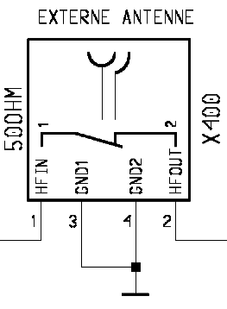
From Power Amplifier/
To Receiver

To / From Internal Antenna

Priority:

❐ ........ Mandatory
 ........ Repair
❐ ........ Optional
❐ ........ Not Yet Defined

Repair Documentation

Description of procedure:

Diagnosis

Check the output power of the handset with the LSO testprogram. Especially watch the external antenna power!

Repair by component change

Use hot air blower to remove defective connector
Avoid excessive heat!
Watch surrounding components!

Resolder new connector afterwards.

Repair by SW-Booting

Not possible!

Test
Retest handset after repair as described above.

List of needed material

Components

X35 antenna connector
Attention: This is not the same connector as C25/S25 !!!

Part-Number: L36334-Z93-C272

Jigs and Tools

Hot Air Blower
Soldering Iron

Special Tools

None

Working materials

Desolder Wick / Braid
Solder

Drawings
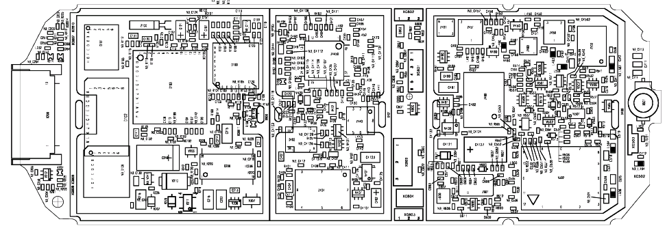

Figure 1: X35 Board Antenna Connector Side (Top View)

Ringer

Affected Units

Type: C/M/S35

Affected IMEIs / Date Codes: All / All

Affected SW-Versions: All

Fault Code for LSO reporting: 3RIN

Fault Description

Fault Symptoms for customers:

Problems with the handset ringer. No ringer tone audible.

Fault Symptom on GSM-Tester:
Handset fails ringer test.

Priority:

❐ ........ Mandatory
 ........ Repair
❐ ........ Optional
❐ ........ Not Yet Defined

Repair Documentation

Description of procedure:

Diagnosis

Visually check the ringer. Watch for physical damage or dry joints.

Repair by component change
Resolder dry soldering joints.
If the ringer is physically damaged use hot air blower or wick to remove defective connector.
Avoid excessive heat!
Watch surrounding components!

Resolder new ringer afterwards.

Repair by SW-Booting

Not possible!

Test
Retest handset after repair.

List of needed material

Components

Ringer P35:
Part-Number: L36178-Z2-C26

Jigs and Tools

Hot Air Blower
Soldering Iron

Special Tools

None

Working materials

Desolder Wick / Braid
Solder
Flux

Drawings

Figure 1: X35 Board Ringer Side

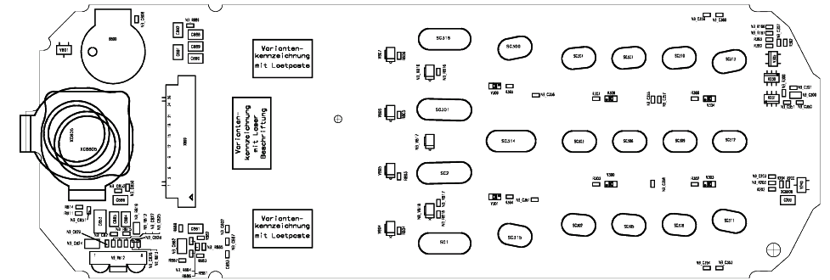
Figure 2: X35 Ringer (B800) Placement (Top View)

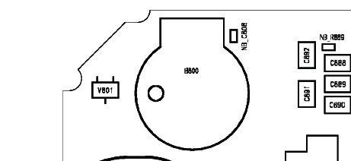

Bottom Connector (Lumberg)

Affected Units

Type: C/M/S35

Affected IMEIs / Date Codes: All / All

Affected SW-Versions: All

Fault Code for LSO reporting: 3LUC

Fault Description

Fault Symptoms for customers:

Charging problems.
Problems with external loudspeaker or microphone when using a car kit.
Problems with accessories connected at the bottom connector.
Problems with SW booting.

Fault Symptom on GSM-Tester:

This problem cannot be detected with a GSM-Tester.

Priority:

❐ ........ Mandatory
 ........ Repair
❐ ........ Optional
❐ ........ Not Yet Defined

Repair Documentation

Description of procedure:

Diagnosis

Visually check the bottom connector. Watch for dry joints!

Repair by component change

Use hot air blower remove defective bottom connector.
Avoid excessive heat!
Watch surrounding components!

Resolder new bottom connector afterwards.

Repair by SW-Booting

Not possible!

Test
Retest handset after repair.

List of needed material:

Components

Bottom Connector X35
Part-Number: L36334-Z93-C262

Jigs and Tools

Hot Air Blower
Soldering Iron

Special Tools

None

Working materials

Desolder Wick / Braid
Solder

Drawings

Figure 1: X35 Board Bottom Connector Side

Figure 2: X35 Bottom Connector Placement (Top View)
Pin 12
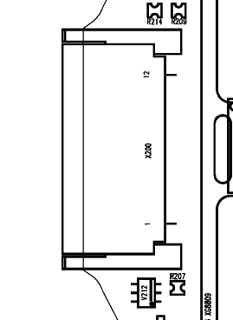
Pin 1

Table 1: X35 Bottom Connector Pin Description

Pin | Name | IN/OUT | Notes
1 | GND
2 | SB | I/O | Charger coding and charger control.
3 | POWER | I | Charging Current
4 | FBatt+ | O | Power supply for the accessories.
5 | TX | O | Serial interface
6 | RX | I | Serial interface
7 | ZUB_CLK | I/O | Clock line for accessory bus  Use as DTC In data operation
8 | ZUB_DATA | I/O | Data line for accessory bus.  Use as CTS in data operation
9 | GND_MIC |  | For external microphone
10 | HF_MIC | I | External microphone
11 | AUDO | O | Trigger for external loudspeaker
12 | GNDA |  | For external loudspeaker

Display Connector

Affected Units

Type: C/M/S 35

Affected IMEIs / Date Codes: All / All

Affected SW-Versions: All

Fault Code for LSO reporting: 3DIC

Fault Description

Fault Symptoms for customers:

Display problems, like missing lines or columns on the LCD or display contrast problems.

Fault Symptom on GSM-Tester:

Display test fails.

Priority:

❐ ........ Mandatory
 ........ Repair
❐ ........ Optional
❐ ........ Not Yet Defined

Repair Documentation

Description of procedure:

Diagnosis
Visually check the status of the display connector. Watch for oxidation and dry solder joints.
Mechanically check the opening / closing mechanism.

Repair by component change

Use hot air to remove defective connector
Avoid excessive heat!
Watch surrounding components!!

Resolder new connector afterwards

Repair by SW-Booting

Not possible!

Test
Retest handset after repair.

List of needed material

Components Display connector
Part-Number: L36195-Z26-C629

Jigs and Tools

Soldering Iron
Hot Air Blower

Special Tools

None

Working materials

Desolder Wick / Braid
Solder

Drawings

Figure 1: X35 board display connector side

Figure 2: X35 display connector placement (Top View)

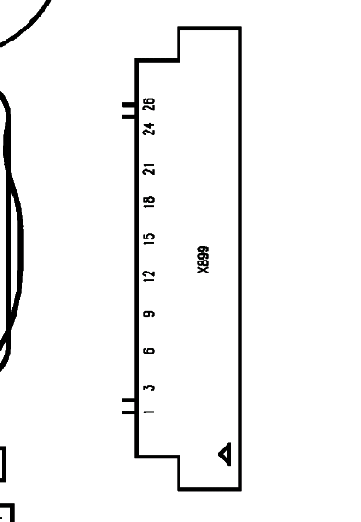

Keyboard LEDs

Affected Units

Type: C/M/S 35

Affected IMEIs / Date Codes: All / All

Affected SW-Versions: All

Fault Code for LSO reporting: 3LED

Fault Description

Fault Symptoms for customers:

Keyboard Illumination not working.

Fault Symptom on GSM-Tester:

This fault cannot be detected with a GSM-Tester

Priority:

❐ ........ Mandatory
 ........ Repair
❐ ........ Optional
❐ ........ Not Yet Defined

Repair Documentation

Description of procedure:

Diagnosis

Use the diode test function of a multimeter to check the status of the diode.
The typical voltage drop on the diode is 1.7V when testing the diode function with the multimeter.

Repair by component change

Use soldering iron to remove defective diode
Avoid excessive heat!
Watch surrounding components!

Resolder new diode afterwards.

Repair by SW-Booting

Not possible!

Test
Retest handset after repair.

List of needed material

Components

LED keyboard X35
Part-Number: L36840-L2031-D670

Jigs and Tools

Hot Air Blower
Soldering Iron

Special Tools

None

Working materials

Desolder Wick / Braid
Solder

Drawings

Figure 1: X35 board keyboard LED Side

Figure 2: X35 keyboard LED placement and polarity (top view)

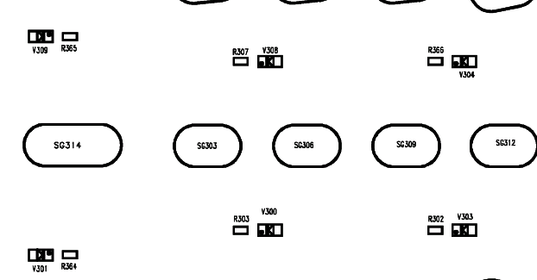
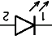


Display LEDs

Affected Units

Type: C/M/S 35

Affected IMEIs / Date Codes: All / All

Affected SW-Versions: All

Fault Code for LSO reporting: 3LED

Fault Description

Fault Symptoms for customers:

Display Illumination not working.

Fault Symptom on GSM-Tester:

This fault cannot be detected with a GSM-Tester

Priority:

❐ ........ Mandatory
 ........ Repair
❐ ........ Optional
❐ ........ Not Yet Defined

Repair Documentation

Description of procedure:

Diagnosis

Use the diode test function of a multimeter to check the status of the diode.
The typical voltage drop on the diode is 1.7V when testing the diode function with the multimeter.
Attention: There are two different types of display LEDs, one for C/M35 and one for S35! Also they use different placement location, see drawings 1 and 3.

Repair by component change

Use soldering iron to remove defective diode
Avoid excessive heat!
Watch surrounding components!

Resolder new diode afterwards.

Repair by SW-Booting

Not possible!

Test
Retest handset after repair.

List of needed material

Components

Display LED S35
Part-Number: L36840-L2048-D670
Display LED C/M35
Part-Number: L36840-L2047-D670

Jigs and Tools

Hot Air Blower
Soldering Iron

Special Tools

None

Working materials

Desolder Wick / Braid
Solder

Drawings

Figure 1: C/M35 board display LED Side

Figure 2: C/M35 board display LED placement and polarity

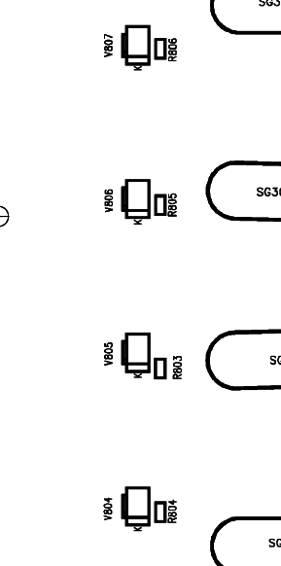


Figure 3: S35 board display LED side

Figure 4: S35 board display LED placement and polarity

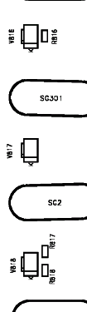

Infrared Diodes

Affected Units

Type: S 35

Affected IMEIs / Date Codes: All / All

Affected SW-Versions: All

Fault Code for LSO reporting: 3INF

Fault Description

Fault Symptoms for customers:

No infrared connection possible.

Fault Symptom on GSM-Tester:

This fault cannot be detected with a GSM-Tester.

Priority:

❐ ........ Mandatory
 ........ Repair
❐ ........ Optional
❐ ........ Not Yet Defined

Repair Documentation

Description of procedure:

Diagnosis
Visually check the status of the IrDa module. Watch for dry solder joints.
Use a reference infrared port (eg. from a notebook) to check the IrDa function. If the notebook recognizes the S35, the infrared function is ok.

Repair by component change

Use hot air to remove defective infrared module.
Avoid excessive heat!
Watch surrounding components!!

Resolder new module afterwards

Repair by SW-Booting

Not possible!

Test
Retest handset after repair.

List of needed material

Components Infrared module S35
Part-Number: L36810-U6030-D670

Jigs and Tools

Soldering Iron
Hot Air Blower

Special Tools

None

Working materials

Desolder Wick / Braid
Solder

ANNEX C
PC Adaptor Cable & Accessories C35
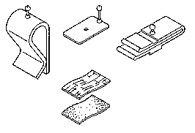
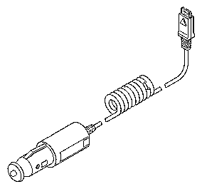
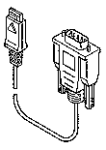
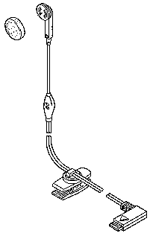
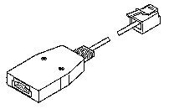
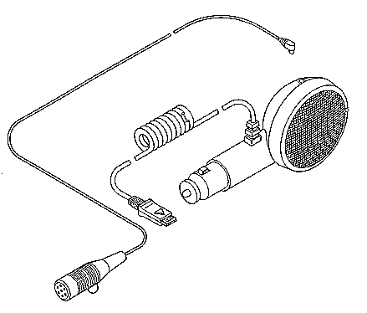
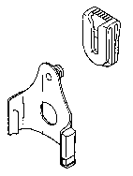
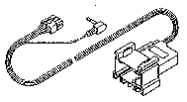
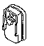
Belt Clip
L36880-N4001-A113
Car Kit Portable Handsfree Set
L36880-N3015-A117
Car Charger Cable 10,8-24V
L36880-N4001-A108
Adapter Cable E-Box-PC
L36880-N3101-A112
Adapter Cable PC-Mobilephone
L36880-N3101-A102
Headset
L36880-N4001-A123
Microphone Accessories Kit
L36158-A98-C6
Car Holder
L36158-A24-C25
Car Kit Portable Handsfree Microphone
L36254-Z6-C75
VDA Adaptercable
L36880-N4001-A121
12 V

Power Plug for C35, M35 , S35
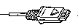
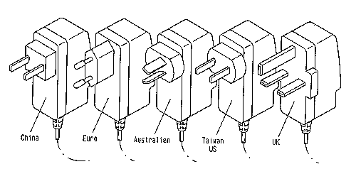
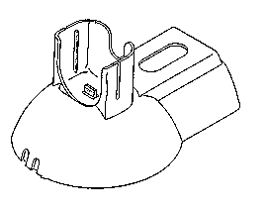
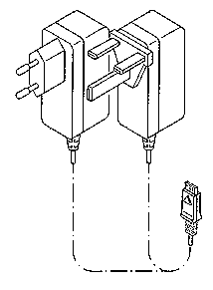
Desktop Charger
L36880-N4001-A102
Travel Charger 90-240 VTravel Charger 90-240V
L36880-N4001-A103L36880-N4001-A104
Euro
UK
Power Plug
L36280-Z4-C325
L36280-Z4-C321
L36280-Z4-C323
L36280-Z4-C324
L36280-Z4-C322

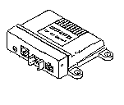
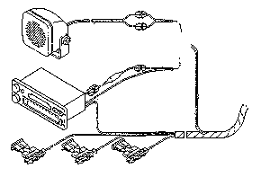
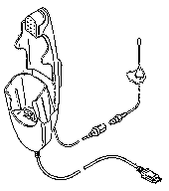
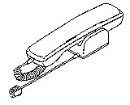

Car installation kit Ratio unit C35, M35 & S35
Handsfree Microphone
L36880-N4001-A116
Not included in our Standard Dellivry Program
OR
Handset
L36880-N3015-A123
Cradle Comfort
L36158-A37-B1
Connection Box Ratio
L36880-S4001-A300
Con. Cable Battery Comfort
L36146-A2053-D
Phone In Adapter
L36880-N3015-A137

Car installation kit hands free unit C35, M35, S35
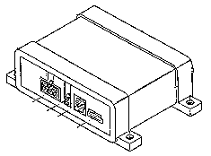
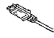


Radio Mute black
Battery red
Battery Ground brown
Ignition violet
Handsfree Microphone
L36254-Z6-C76
Connection Box
L36880-S2001-A100
3m
Handset
L36880-N3015-A123
Handsfree Loudspeaker
L36104-F3090-X902
Phone In Adaptor
L36880-N3015-A137
1,8m
OR
Cradle Comfort
L36158-A37-B1
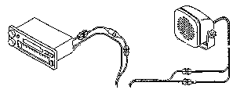

Con. Cable Battery Comfort
L36146-A4013-D

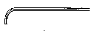
Fuses 3A
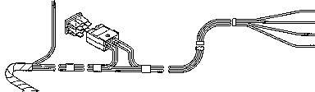

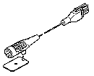

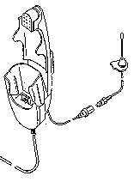

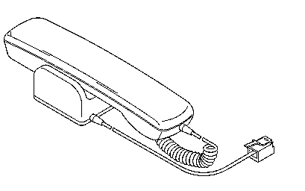

Not included in our Standard Dellivry Program

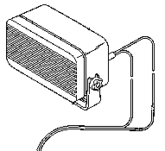
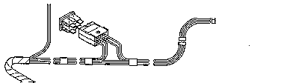
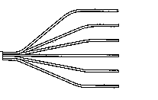
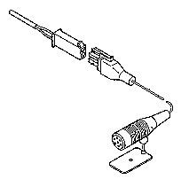
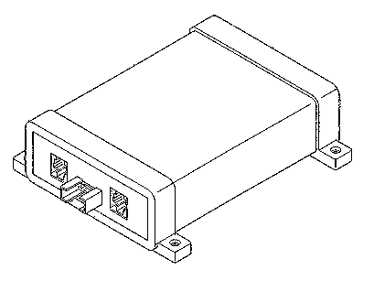
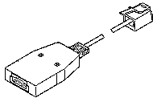
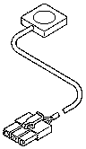
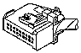





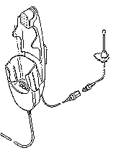
Carkit installation kit hand free unit Professional C35, M35, S35
Handsfree Loudspaker
L36104-F3090-X901
Fuses 3A
1,9m
Handset
L36880-N3015-A123
3m
Radio Muteblack
Lights Dimmeryellow
Automatic Antennawhite
Batteryred
Battery groundbrown
Ignitionviolet
Adapter Cable E-Box-PC
L36880-N3101-A112
Con. Cable Battery
L36146-A1030-D
Push to talk cable
L36146-A4012-D
Handfree Microphone
L36254-Z6-C63
Connection Box engl.
L36880-N3101-A110
Cradle Comfort
L36158-A37-B1
Not included in our Standard Dellivery Program

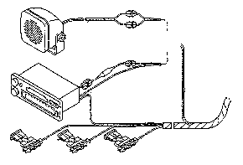
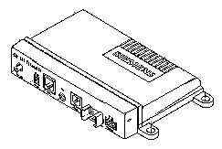
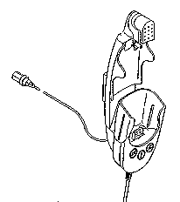
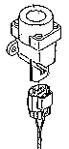
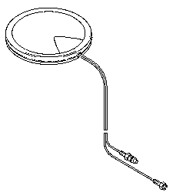
Carkit installation Comfort GPS C35, M35, S35
Handsfree Microphone
L36880-N4001-A116
Antenna
Crash Sensor
L36880-N4001-A115
Not included in our Standard Dellivry Program
Handset
L36880-N3015-A123
OR
Con. Cable Battery
L36146-A2053-D
Connection Pox GPS
L36880-S4001-A4
Car Cradle Telematic
L36158-A37-B6
Con. Pox
Combi Antenna GPS
L36851-Z1901-A46
Handsfree Loudspeaker
L36104-F3090-X902
Phone In Adapter
L36880-N3015-A137

PC Adaptar Cable & Accessory C35, M35, S35
Belt Clip
L36880-N4001-A113
Car Kit Portable Handsfree Set
L36880-N3015-A117
Car Charger cable 10, 8 – 24V
L36880-N4001-A108
Adaptor Cable E-Box -PC
L36880-N3101-A112
Adapter Cable PC-Mobilephone
L36880-N3101-A102
Headset
L36880-N4001-A123
Microphone Accessories Kit
L36158-A98-C6
Car Holder
L36158-A24-C25
Car Kit Portable Handsfree Microphone
L36254-Z6-C75
VDA Adaptercable
L36880-N4001-A121
12 V

References:
- Mouly M. & Pautet M-B. (1992) The GSM System for Mobile Communications, A comprehensive overview of the European Digital Cellular Systems France: Published by authors.
- Scourias, J Overview of the Global System for Mobile Communications University of Waterloo: Published by author.
- - (1998) GSM Introduction Published by Wavetek Wireless Communication Division.
- Barnes, N SIM Application Toolkit, Article by author on ETSI Website.
- Mehrotra A, (1994), Cellular Radio Analog and Digital System, Artech House Inc, USA.
- IrDA(Infrared Data Association), Serial Infrared Physical Layer Link Specification, Version 1.1, October 15, 1995.

Disclaimer: This content is subjected to change without notice.

Copyright © 2000 Siemens Advanced Engineering Pte Ltd
ICP CD Asia Service Center,
164, Kallang Way, #04-22, Kolam Ayer Industrial Estate, Singapore 349248
Author: Tan Guan San.
Phone +65-8454822 • Fax +65-8426641
First Print: May, 00
Revised Print:
Date Print: May 26, 2000

The reproduction and transmission of this document to unauthorized parties is not permitted without written authority. Offender will be liable for damages.

1 Actual time dependent on the network.
1 Only for Model M35i.
2 Not available in M35 International version.
3 Not available in M35 International version.
4 Not available in M35 International version.
1 Same as C25(88)
2 Same as C25(88)
3 Same as C25(88)
4 Same as C25(88)

