Information and Communication Mobile
ICM MP Customer Care Information SI_5403.doc

«Name_LSO» | From (Name) |  | Thomas v. Slingerlandt
«Anrede» «Vorname» «Name» | Dept. |  | ICM MP CCQ SLI
«Zeile_1» | Telephone |  | + 49 89 722 22513
«Zeile_2» | Fax |  | + 49 89 722 63314
«Zeile_3»
«Zeile_4» | Your Service Manager |  | «Anrede_SK»«Name_SK»
 | Telephone |  | «Telefon_SK»
Tel : «Telefon» | Our ref. |  | SI_5403.doc
Fax : «Fax» | Date |  | November 05th, 2003

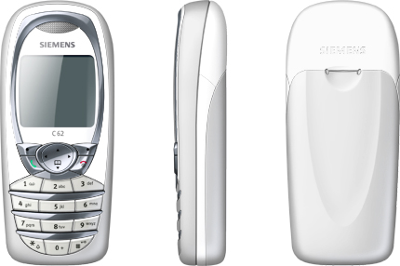
Subject: Service Guideline C62

Dear «Anrede» «Name»

The delivery of our new mobile phone C62 (ODM bar phone, colour display, no Clip-It) to operators starts in CW 44.
Please find attached the corresponding Service Guideline with explosion view diagram, Accessory overview, SIM-Lock description, data sheet and technical instructions.
Additional information, like Variant overview, you can find on IMS:

https://ims.icn.siemens.de/livelink/livelink/Open/324790712

All spare parts and accessories can be ordered via e-commerce. At present not all spare parts are in e-commerce yet, but they will be complete soon.

The lower mounting frame (B cover) is pre-assembled with board shielding and antenna connector. The antenna is assembled in an extra cover. The upper case shell (A cover) will be delivered without keypad.

For feature description see enclosed data sheet and article 1.1 of the attached Service Guideline.

The Call Centres have been trained and all the relevant information is stored in the knowledge database in the “FAQs General” from CW 44 onwards (in Kana, latest knowledge base).
Important Notes:

The repair concept is based worldwide on personalized repair, therefore only swap boards – no swap units – are available. Swap boards will be provided through your responsible Service Manager.

Please report in IRIS and send the Level 2 boards in on a weekly basis – for very small quantities (<5) pls. contact the CCQ BA for further proceeding!
Because the C62 is a ODM phone, the timely reports and shipments are indispensable conditions for the accurate processing.

No local scrap for swap boards!
Due to the repair concept of only Level 0- Level2,5 through Siemens repair partners, all non repairable in-warranty boards have to be sent back as Level 2 (Level 2,5e / Level 3 repair at ODM repair facilities).

Best regards from ICM MP Customer Care.

sign. Wolfgang Royer sign. Hans-Juergen Burghart
Director Customer Care O EMEA Customer Care BA EMEA

