C45/M50/MT50/A50

Level 2.5

Repair Documentation

V 1.1

Table of Content

1 Introduction 3
2 I/O Connector (Lumberg) 4
3 Battery Connector 8
4 Display Connector 11
5 Antenna Connector 14
6 Card Reader 18
7 Keypad LEDs 21
8 Display LEDs 24

Introduction

C45/M50/MT50/A50 product family consists of 6 different dualband handsets (GSM-900 and GSM-1800), which can easily be distinguished from the second block of the partnumber printed on the IMEI label.

Partnumber on IMEI label:

- C45: S30880-S5100-#xxx

, while # may be any letter (A-Z) and xxx may be any number from 100, 101, 102....

- 2118: S30880-S5100-#xxx (China Version C45)

, while # may be any letter (A-Z) and xxx may be any number from 800, 801, 802....

- M50 S30880-S5150-#xxx

, while # may be any letter (A-Z) and xxx may be any number from 100, 101, 1 02....

- MT50 S30880-S5120-#xxx

, while # may be any letter (A-Z) and xxx may be any number from 100, 101, 1 02....

- 3118: S30880-S5150-#xxx (China Version M50)

, while # may be any letter (A-Z) and xxx may be any number from 800, 801, 802....

- A50: S30880-S5110-#xxx

, while # may be any letter (A-Z) and xxx may be any number from 800, 801, 802....

This manual is intended to help you carry out repairs on level 2.5, meaning limited component repairs. Failure highlights are documented and should be repaired in the local workshops.

It must be noted that all repairs have to be carried out in an environment set up according to the ESD (Electrostatic Discharge Sensitive Devices) regulations defined in international standards.

If you have any questions regarding the repair procedures or technical questions about the spare parts do not hesitate to contact our technical support team in Kamp-Lintfort, Germany:

Tel.: +49 2842 95 4666
Fax: +49 2842 95 4302
e-mail: st-support@klf.siemens.de

I/O Connector (Lumberg)

Affected Units

Type: C45/M50/MT50/A50

Affected IMEIs / Date Codes: All / All

Affected SW Versions: All

Fault Description

Fault Symptoms for customers:

- Charging problems.
- Problems with external loudspeaker or microphone
when using a car kit.
- Problems with accessories connected at the I/O -
connector.
- Problems with SW booting

Fault Symptoms on GSM Tester:

This fault cannot be detected with a GSM-Tester

Priority:

◻ Mandatory
☑ Repair
◻ Optional
◻ Not Yet Defined

Repair Documentation:

Description of procedure:

Diagnosis:

Visually check the bottom connector. Watch for dry joints:

Repair by component change:

Use hot air blower remove defective I/O connector.
Avoid excessive heat!
Watch surrounding components!

Resolder new I/O connector afterwards.

Repair by Software booting:

Not possible!

Test:

Retest handset after repair.

List of needed material:

Components:

I/O Connector C45/M50/MT50/A50
Part-Number: L36334-Z93-C262

Jigs and Tools:

Hot Air Blower
Soldering Iron

Special tools:

None

Working materials

Desolder Wick / Braid
Solder

Drawings

Figure 1: C45/M50/MT50/A50 board I/O connector
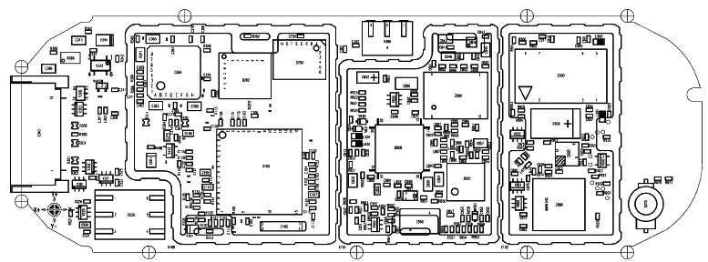
Figure 2: C45/M50/MT50/A50 I/O connector placement (top view)
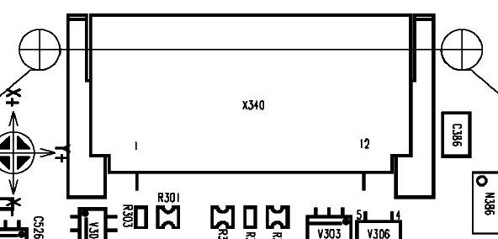

Table 1: C45/M50/MT50/A50 Bottom Connector Pin Description

Pin | Name | IN/OUT | Notes
1 | GND
2 | SB | I/O | Charger coding and charger control.
3 | POWER | I | Charging Current
4 | FBatt+ | O | Power supply for accessories.
5 | TX | O | Serial interface
6 | RX | I | Serial interface
7 | ZUB_CLK | I/O | Clock line for accessory bus  Use as DTC In data operation
8 | ZUB_DATA | I/O | Data line for accessory bus.  Use as CTS in data operation
9 | GND_MIC |  | For external microphone
10 | MICP2 | I | External microphone
11 | EPP2 | O | External loudspeaker
12 | EPP1 | O | External loudspeaker

Battery Connector

Affected Units

Type: C45/M50/MT50/A50

Affected IMEIs / Date Codes: All / All

Affected SW Versions: All

Fault Description

Fault Symptoms for customers:

Mobile does not switch on.
Error message “WRONG BATTERY” on display.

Fault Symptoms on GSM Tester:

This fault cannot be detected with a GSM-Tester.

Priority:

◻ Mandatory
☑ Repair
◻ Optional
◻ Not Yet Defined

Repair Documentation:

Description of procedure:

Diagnosis:

Visually check the status of the Battery connector. Watch for oxidation and dry solder joints.
Mechanically check the opening / closing mechanism.

Repair by component change:

Use hot air blower remove defective Battery connector.
Avoid excessive heat!
Watch surrounding components!

Resolder new Battery connector afterwards.

Repair by Software booting:

Not possible!

Test:

Retest handset after repair.

List of needed material:

Components:
Battery Connector C45/M50/MT50/A50
Part-Number: L36158-A54-C215

Jigs and Tools:

Hot Air Blower
Soldering Iron

Special tools:

None

Working materials

Desolder Wick / Braid
Soldering Iron

Drawings

Figure 1: C45/M50/MT50/A50 board Battery connector

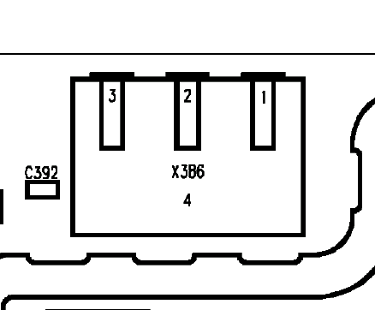
Figure 2: C45/M50/MT50/A50 Battery connector placement (top view)

Display Connector

Affected Units

Type: C45/M50/MT50/A50

Affected IMEIs / Date Codes: All / All

Affected SW Versions: All

Fault Description

Fault Symptoms for customers:

Display problems, like missing lines or columns on the LCD or display contrast problems.

Fault Symptoms on GSM Tester:

Display tests failed.

Priority:

◻ Mandatory
☑ Repair
◻ Optional
◻ Not Yet Defined

Repair Documentation:

Description of procedure:

Diagnosis:

Visually check the status of the Display connector. Watch for oxidation and dry solder joints.
Mechanically check the opening / closing mechanism.

Repair by component change:

Use hot air blower remove defective Display connector.
Avoid excessive heat!
Watch surrounding components!

Resolder new Display connector afterwards.

Repair by Software booting:

Not possible!

Test:

Retest handset after repair.

List of needed material:

Components:

Battery Connector C45/M50/MT50/A50
Part-Number: L36195-Z26-C629

Jigs and Tools:

Hot Air Blower
Soldering Iron

Special tools:

None

Working materials

Desolder Wick / Braid
Soldering Iron

Drawings

Figure 1: C45/M50/MT50/A50 board Display connector
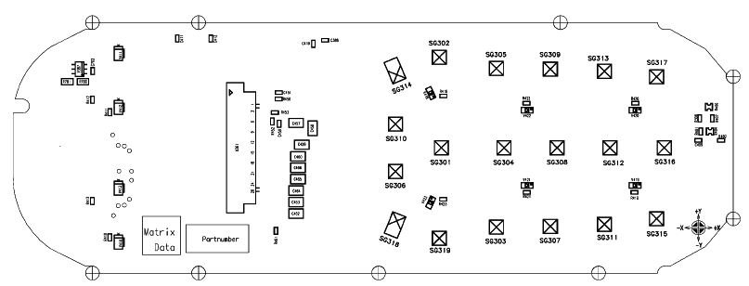

Figure 2: C45/M50/MT50/A50 Display connector placement (top view)

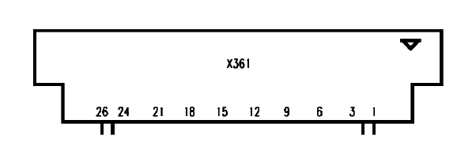
Pin1
Pin 26

Antenna Connector

Affected Units

Type: C45/M50/MT50/A50

Affected IMEIs / Date Codes: All / All

Affected SW Versions: All

Fault Description

Fault Symptoms for customers:

Network Search
No location update possible

Fault Symptoms on GSM Tester:

Output power problems on the external and internal antenna
No location update possible

Component Information:
The Antenna Connector is a mechanical switch operated by the RF plug of a car kit.
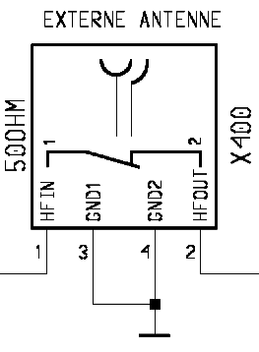
Normally the RF signal goes to and comes from the internal antenna. Whenever an RF plug is plugged into the antenna connector the connection to the internal antenna is opened and the connection to the external antenna socket is made. When the antenna connector is blocked without RF plug the connection to the internal antenna is also opened. See drawing below.

From Power Amplifier/
To Receiver
To/From Internal Antenna

Priority:

◻ Mandatory
☑ Repair
◻ Optional
◻ Not Yet Defined

Repair Documentation:

Description of procedure:

Diagnosis:

Check the output power of the handset with the LSO test program. Especially watch the external antenna power!

Repair by component change:

Use hot air to remove defective antenna connector.
Avoid excessive heat!
Watch surrounding components!!

Resolder new module afterwards

Repair by Software booting:

Not possible!

Test:

Retest handset after repair.

List of needed material:

Components:

Antenna Connector C45/M50/MT50/A50
Part-Number: L36334-Z93-C261

Jigs and Tools:

Hot Air Blower
Soldering Iron

Special tools:

None

Working materials

Desolder Wick / Braid
Soldering Iron

Drawings

Figure 1: C45/M50/MT50/A50 board Antenna connector

Figure 2: C45/M50/MT50/A50 Antenna connector placement (top view)

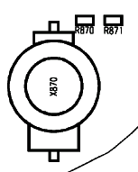

Card Reader

Affected Units

Type: C45/M50/MT50/A50

Affected IMEIs / Date Codes: All / All

Affected SW Versions: All

Fault Description

Fault Symptoms for customers:

Handset does not accept SIM.

Fault Symptoms on GSM Tester:

This fault cannot be detected with a GSM-Tester

Priority:

◻ Mandatory
☑ Repair
◻ Optional
◻ Not Yet Defined

Repair Documentation:

Description of procedure:

Diagnosis:

Visually check the Card Reader. Watch for dry joints:

Repair by component change:

Use soldering iron to remove defective component.
Avoid excessive heat!
Watch surrounding components!

Resolder new Card Reader afterwards.

Repair by Software booting:

Not possible!

Test:

Retest handset after repair.

List of needed material:

Components:

Card Reader C45/M50/MT50/A50
Part-Number: L36158-A54-C211

Jigs and Tools:

Hot Air Blower
Soldering Iron

Special tools:

None

Working materials

Desolder Wick / Braid
Soldering Iron

Drawings

Figure 1: C45/M50/MT50/A50 board Card Reader site

Figure 2: C45/M50/MT50/A50 Card Reader placement (top view)

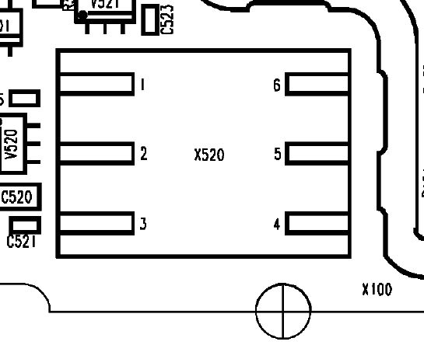

Keypad LEDs

Affected Units

Type: C45/M50/MT50/A50

Affected IMEIs / Date Codes: All / All

Affected SW Versions: All

Fault Description

Fault Symptoms for customers:

Keyboard Illumination does not work.

Fault Symptoms on GSM Tester:

This fault cannot be detected with a GSM-Tester

Priority:

◻ Mandatory
☑ Repair
◻ Optional
◻ Not Yet Defined

Repair Documentation:

Description of procedure:

Diagnosis:

Use the diode test function of a multimeter to check the status of the diode. The typical voltage drop on the diode is 1.7V when testing the diode function with the multimeter

Repair by component change:

Use soldering iron to remove defective diode.
Avoid excessive heat!
Watch surrounding components!!

Resolder new diode afterwards.

Repair by Software booting:

Not possible!

Test:

Retest handset after repair.

List of needed material:

Components:

LEDs C45/M50/MT50 Amber /A50
Part-Number: L36840-L2056-D670

Jigs and Tools:

Hot Air Blower
Soldering Iron

Special tools:

None

Working materials

Desolder Wick / Braid
Soldering Iron

Drawings

Figure 1: C45/M50/MT50/A50 board keyboard LEDs side

Figure 2: C45/M50/MT50/A50 LEDs placement (top view
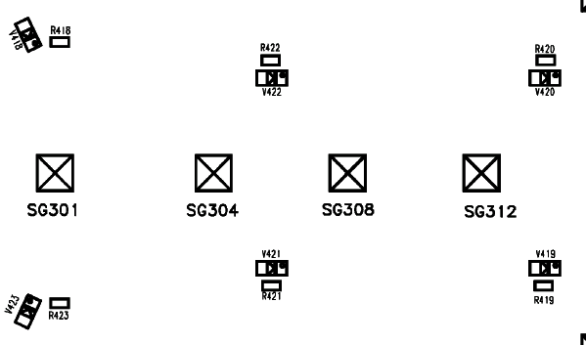

Display LEDs

Affected Units

Type: C45/M50/MT50/A50

Affected IMEIs / Date Codes: All / All

Affected SW Versions: All

Fault Description

Fault Symptoms for customers:

Display Illumination does not work.

Fault Symptoms on GSM Tester:

This fault cannot be detected with a GSM-Tester

Priority:

◻ Mandatory
☑ Repair
◻ Optional
◻ Not Yet Defined

Repair Documentation:

Description of procedure:

Diagnosis:

Use the diode test function of a multimeter to check the status of the diode. The typical voltage drop on the diode is 1.7V when testing the diode function with the multimeter

Repair by component change:

Use soldering iron to remove defective diode.
Avoid excessive heat!
Watch surrounding components!!

Resolder new diode afterwards.

Repair by Software booting:

Not possible!

Test:

Retest handset after repair.

List of needed material:

Components:

LEDs C45/M50/MT50 Amber /A50
Part-Number: L36840-L2055-D670

LEDs M50/MT50 Blue
Part-Number: L36197-F5005-F782

Jigs and Tools:

Hot Air Blower
Soldering Iron

Special tools:

None

Working materials

Desolder Wick / Braid
Soldering Iron

Drawings

Figure 1: C45/M50/MT50/A50 board keyboard LEDs side

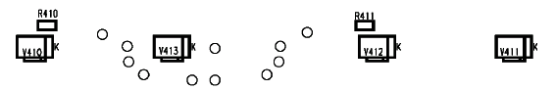
Figure 2: C45/M50/MT50/A50 LEDs placement (top view)

