

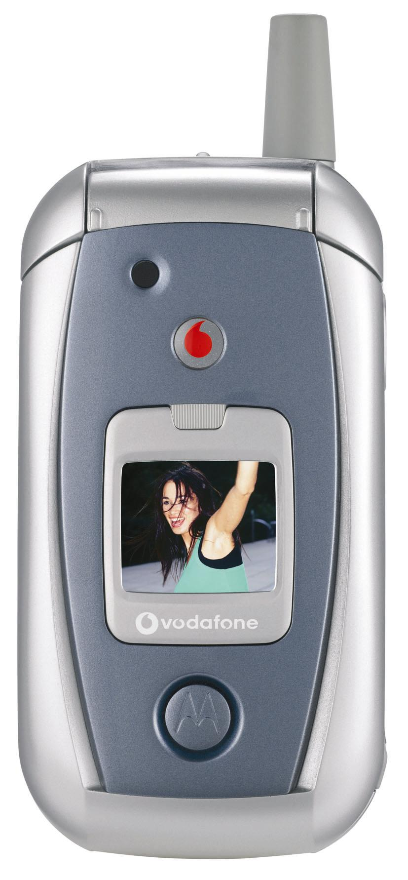
MOTOROLA V980
The compact Motorola V980 is equipped with mighty features, an affordable price tag and multi-media galore. The clamshell Motorola V980 delivers broadband-like 3G speeds and with large internal and external color displays, it offers quick and easy video streaming, capture, download and playback. For your listening pleasure, the Motorola V980 comes equipped with an integrated MP3 player to make downloading and streaming your favorite songs easier than ever. The unit is loaded with a VGA digital camera with 4x zoom for instant picture taking and 2-way video calling to always keep you connected and entertained. With a built-in speakerphone, synchronization, advanced messaging and an endless array of downloading options, the Motorola V980 promises to keep up with your globe-trotting needs anywhere, anytime. The V980 also supports the latest Vodafone Live! features, enabling you instant access to fun and entertainment at the push of a button.

Motorola V980
Bands: WCDMA / UMTS 2100; GSM 900/1800/1900; GPRS
Dimensions | 94 x 49 x 27 mm; 3.7 x 1.93 x 1.06 in
Size | 105 cc
Weight | 4.83 ounces; 137 grams
Battery | 820mAh Li-Ion Battery  Talk Time**: up to 110 - 130 mins (WCDMA, CS) / up to 220 – 260 mins. (GSM, DTX on)  Standby Time**: up to 120 - 145 hrs (WCDMA, K=7) / up to 215 hrs. (GSM DRx9)  Video Talk Time: up to 60 – 70 minutes (WCDMA)
Display | Internal 1.9 inch display (176 x 220 TFT)  External 1 inch CLI display (96x80 Color STN)
Features | - Global roaming via support of WCDMA and tri-band GSM/GPRS  - 3G technology for broadband-like speed  - Integrated VGA digital camera with 4x zoom / CIF digital camera for P2P  - 2-Way video conferencing  - Embedded digital imaging enhancing application  - Streaming audio and video capture, download and playback  - Multi-Media Messaging Service (MMS) for sharing video clips and photos  - E-mail (POP3,IMAP4, SMTP) access and IM with presence  - 2MB built-in memory and up to 256MB additional capacity via removable TransFlash external memory.  - Supports MPEG4, WMV, WMA, MP3, AAC, MIDI and XMF multi-media files  - Built-in speakerphone and voice recognition feature  - Synchronization (Over The Air (SyncML) and Desktop)  - Enhanced WAP 2.0 Internet browser  - Java™ MIDP 2.0 for easy download of games, musical ringtones, graphics and more  - 16mm polyphonic speaker (24 voice polyphony, 16 channels)  - Lighting solution (LED lamp) located on outer flip

The Motorola V980 is available exclusively through Vodafone and is expected to be available in Q4 2004. For more information regarding pricing and product availability in your region, please check with your local Motorola representative.

*Network, subscription and SIM card or service provider dependent feature. Not available in all areas. **All talk and standby times are quoted in Digital Mode, and are approximate. Battery performance depends on network configuration, signal strength, operating temperature, features selected, and voice, data and other application usage patterns. MOTOROLA and the Stylized M Logo are registered in the US Patent & Trademark Office. All other product or service names are the property of their respective owners. © Motorola, Inc. 2004.

