T720i Recovery (Unbricking) Procedure 9/3/03

- Open FDI Analysis Tool. Do not install phone battery in UUT. Connect Full Rate Charger (SPN5049A) to Force Flash cable (SKN6168A) and connect to UUT and your PC. Do not use a Mid Rate Charger. Monitor the Device Manager on your PC. When the UUT is in Flash Mode, the Device Manager will display the following under Motorola USB Device:

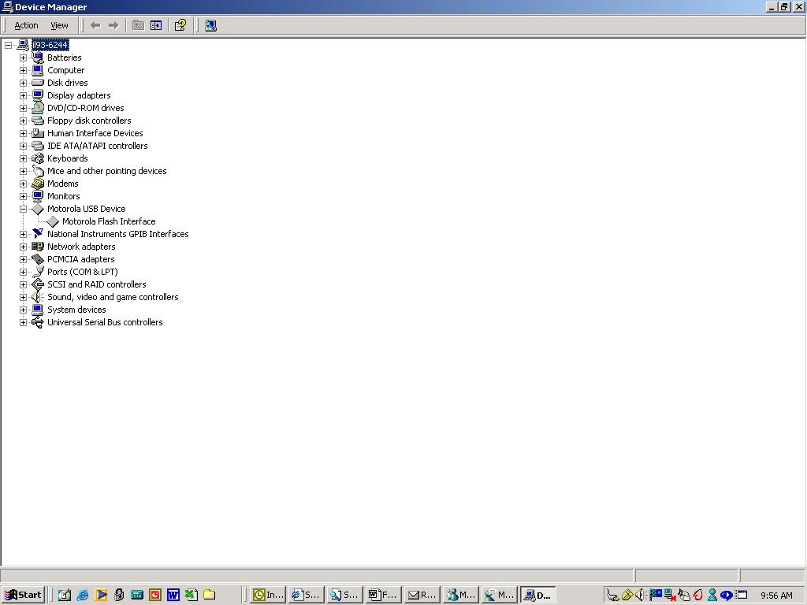

- Run the Analysis tool. If UUT has FDI corruption, proceed to step 3.
- Open FDI Reclaim Tool. No change in setup. You may have to disconnect Force Flash cable from UUT and reconnect in order get back into Flash mode. Monitor the Device Manager to determine Flash Mode status. Run the Reclaim tool.
- If recovery is successful, open the MultiFlashFlex tool to load in the correct phone software. Under Preferences check the box which states “Power down all phones at completion of flashing or flexing” You may have to again disconnect Force Flash cable from UUT and reconnect in order get back into Flash Mode.
- If phone sw is flashed successfully, remove the Force Flash cable and Full Rate Charger from the UUT and PC. Open RadioComm (Analyzer Version) to load appropriate Display flex. Install a fully charged battery into the UUT and power on the phone using it’s Power key. Connect a regular flash cable (SKN6311B) to the UUT and PC. The Device Manager on your PC with display the following under Motorola USB Device:

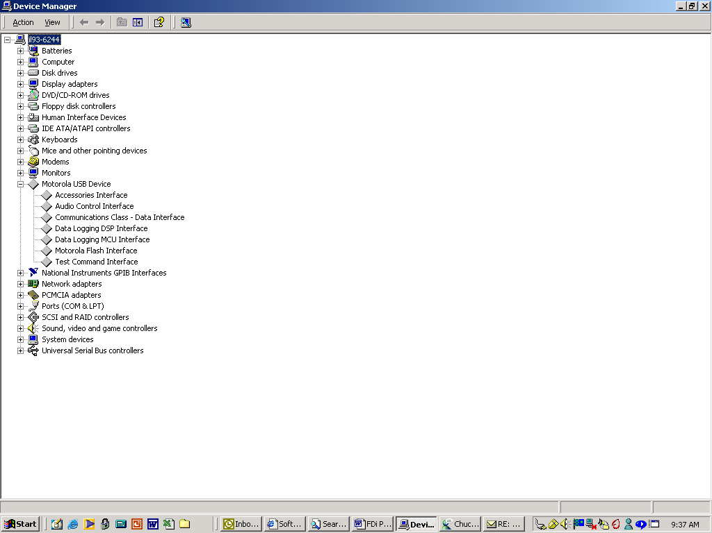

- If Display flex is loaded successfully, proceed to load customer flex using the same setup as step 4. It is not necessary to disconnect and reconnect the flash cable.
- After customer flex is loaded, remove the flash cable and phone battery. Install a test SIM and power up on the phone using it’s Power key. The unit should now be functional at this point.
- Reload MSN.
- Phase the unit.

