MOTOROLA Q FLASHING PROCUDURE

Prerequisites for Motorola Q flashing environment

Download and install the below software from the respective locations

Microsoft Active sync 4.5

RSDLite

Motorola driver installer

Note: Restart the PC after above installation is completed.

System requirements:
Microsoft Windows XP SP2

Steps to Flash the PRI:

1) Start RSD Lite.

2) Power up the phone and coonect with RSD Lite with Mini USB data Cable.

3)Make sure that all the devices connected are detected as shown in the screen shot below

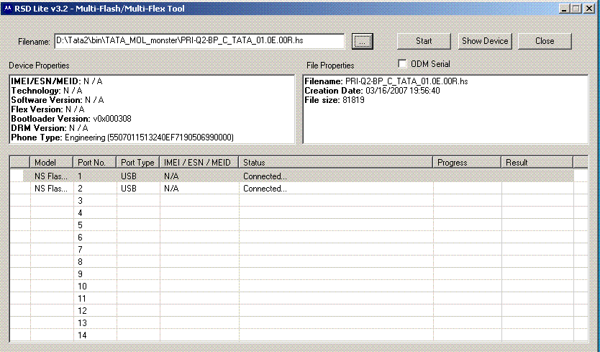

4) Browse and choose the PRI file name and Click on Start

5) Once flashing is completed phone will get restarted.

6) Wait till the RSDLite displays PASS as given in the screen shot below

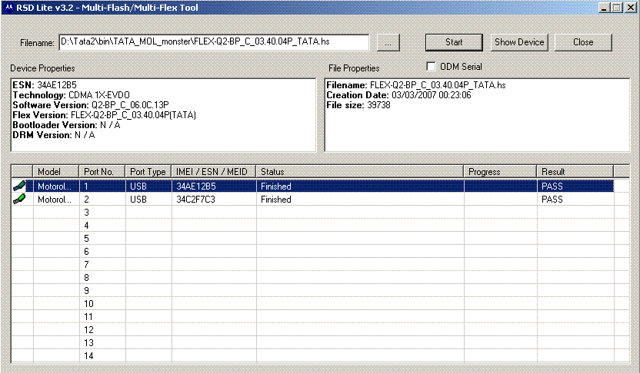

Flashing procedure for Monster:

- Browse and choose the monster file name and Click on Start

- Make sure that all the devices connected are detected as shown in the screen shot below

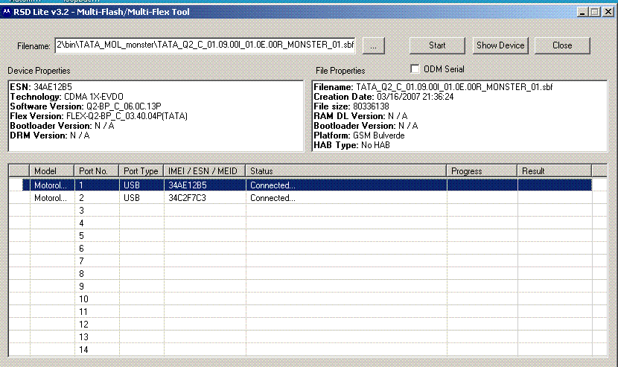

- Once flashing is completed phone will get restarted.

- Wait till the RSDLite displays PASS for all the devices connected.

- Do the Master reset/Clear after SW flashed successfully.

