EEPROM REPLACEMENT PROCEDURE FOR LCA PRODUCTS
(C33X & C350)

This document is prepared to guide on the procedure to wake-up the PCB of LCA products after Eeprom replacement.

Common requirements for C33x and C350:
Because of the version of the Neptune IC, this procedure can be applied with only Windows NT.
New version of Neptune IC can support Windows 2000.
Windows 98 is not supported.

Eeprom (U701) part number: 5199491A01 (same for C33x & C350)

NOTE: Writing IMEI is allowed only once because of the security reasons same as other P2K products. The procedure for IMEI writing is same with P2K as well.
Phasing/call processing must be performed as a last step.

C33x Eeprom replacement;

1. Replace U701 with a blank one.
2. Remove resistor R810 as shown on the figure below.
3. Apply voltage from an external power supply. (Do not press the “Power” button)
4. Launch PST on the PC.
5. Connect C33x PCB to PC via mini USB.
6. PST should detect the device as usual flashing.
7. Flash with the internal flash file, which has a name like: “TA02_G_06.04.1FR_gsm_flash_dev_8M.shx”. (It’s not a reflash file)
8. Put R810 back on its original place.
9. The unit can be powered on with no display, but keypad LEDs will be on.
10. Flash with language pack, which has name like:
“TA02_G_06.04.1FR_gsm_lang0011_ext_8M_reflash.shx”.
11. Use Displayflex “GrayScale_Display_settings P5.0.hs”
12. Use Factoryflex “Factoryflex GM5L0E1078.hs”
13. Use Customerflex “SExxxxxxxxxxxx”
(Note: Display will be powered on after flexing with standard flex file)

How to understand that C33x is in internal flash mode:
PCB will drain 28-35 mA after applying voltage as described on 3rd step.

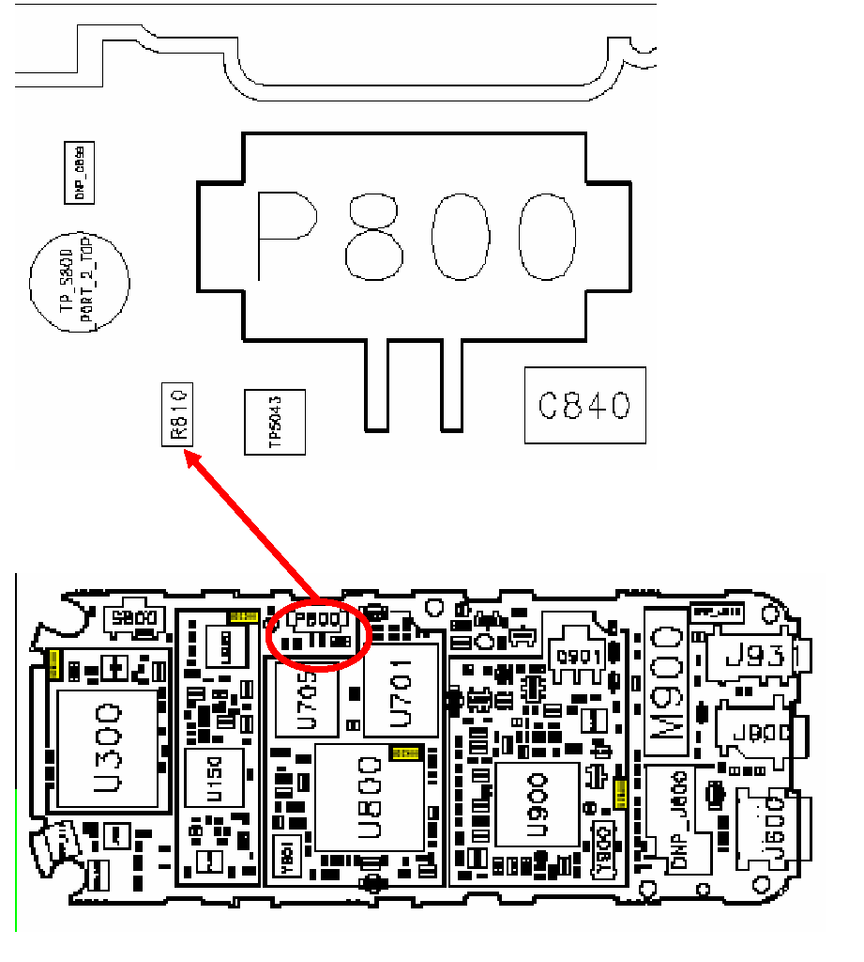

BOARD LAYOUT FOR C33X

C350 Eeprom replacement;

1. Replace U701 with a blank one.
2. Make a short-circuit with a tweezer between the closest points of resistors R810 & R924 as shown on the figure below.
3. Apply voltage from an external power supply. (Do not press to “Power” button)
4. Tweezer can be removed after applying voltage.
5. Launch PST on the PC.
6. Connect C350 PCB to PC via mini USB.
7. PST should detect the device as usual flashing.
8. Flash with the internal flash file, which has a name like: “C350_G_09.04.37R_gsm_flash_dev_8M.shx”. (It’s not a reflash file)
9. The unit can be powered on with no display, but keypad LEDs will be on.
10. Flash with language pack, which has name like:
“ C350_G_09.04.37R _gsm_lang0011_ext_8M_reflash.shx”.
12. Use Displayflex for C350 “Alps_ Display_Settings_M5_ES3.hs”
13. Use Factoryflex “Factoryflex GI6L0AA039.hs”
14. Use Customerflex “SExxxxxxxxxxxx”

(Note: Display will be powered on after flexing with standard flex file)

How to understand that C33x is in internal flash mode:
To see the correct current value, two battery contacts (shown in RED below) must be connected.
PCB will draw 28-35 mA after applying voltage as described on 3rd step.
Remove the connection before moving to 4th step.

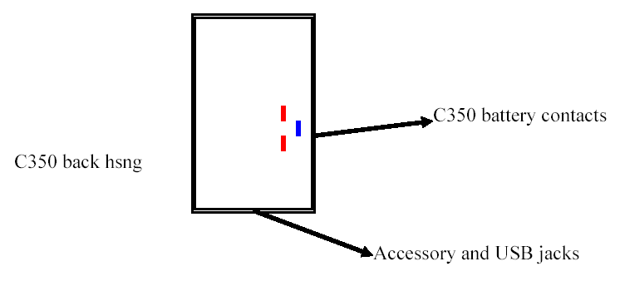

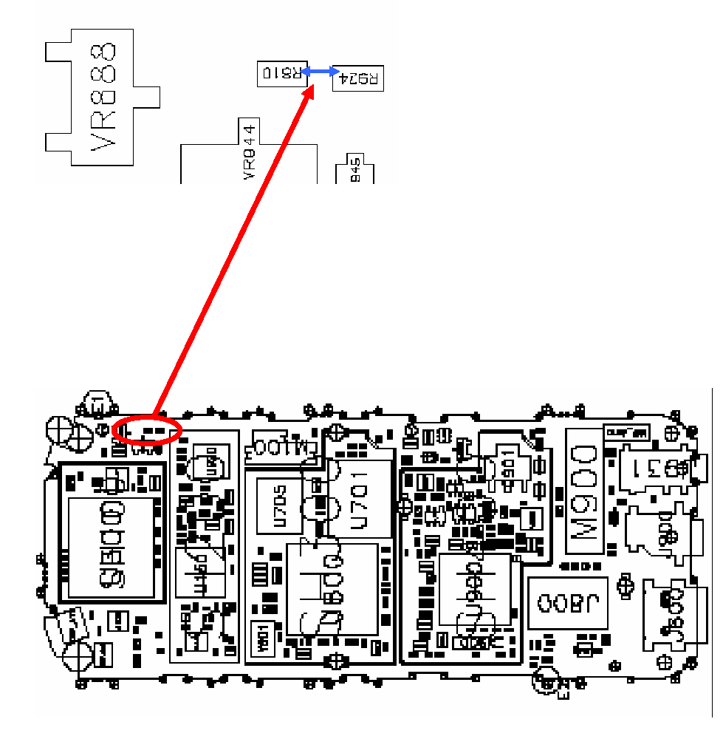

BOARD LAYOUT FOR C350

