S88750
Maintenance manuals

LENOVO

Catalogue

1. Teardown guidance 3
2. The main board layout is introduced 10
2.1 The mainboard positive figure 10
2.2 Main board on the back of the figure 11
2.3 Motherboard, figure a PDF document 11
2.4 The main board schematic PDF document 11
3.Failure analysis flow chart 12
3.1 Don't start up 12
3.2 Touch screen failure 13
3.3 charge fault 14
3.4 The receiver malfunction 15
3.5 The horn fault 16
3.6 LCD display failure 17
3.7 The key fault 18
3.8 Mobile communication failures 19
3.9 MIC fault 20
3.10 Camera malfunction 21
3.11 Vibration fault 23
3.12 SIM card not to identify 24
3.13 SD card can't identify 25
3.14 FM fault 26
3.15 Bluetooth/WLAN fault 27
3.16 Fingerprint fault 28

Teardown guidance

a. Disassembly battery cover &battery
Open the battery cover from the left bottom to take out the SIM card and T flash card；Remove the battery from the right bottom
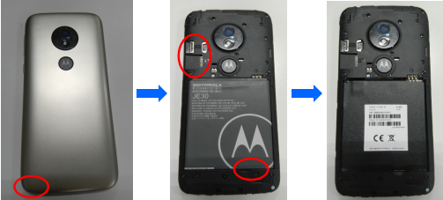

b. Remove the back cover
Release 10pcs screw (M1.4*3.0) from rear housing by screwdriver；Open the rear housing left side to remove rear housing from front housing
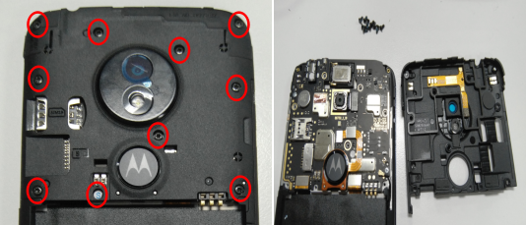

c. Remove the BTB connection device
Release main camera BTB connecter and fingerprint BTB connecter；Remove the fingerprint holder；Checking BTB connecter of camera and fingerprint and make sure it no damage before reuse
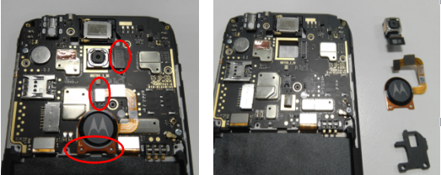

d. Release LCM FPC BTB connecter
Release LCM FPC BTB connecter 、main FPC BTB connecter and RF cable connecter
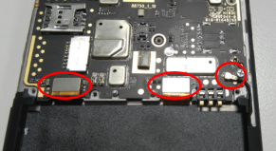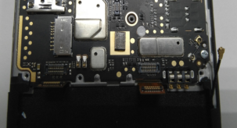

e. Remove PCBA and front camera BTB
Release 2pcs screw (M1.4*2.3) from PCBA with screwdriver；Remove the PCBA from front housing；Release front camera BTB connecter and remove it from PCBA。
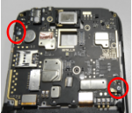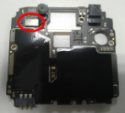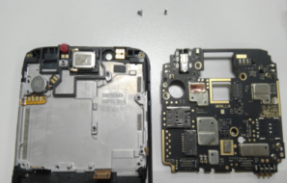

f. Remove motor、speaker、side key FPC and sub-Mic rubber
Remove motor、speaker 、side key FPC and sub-Mic rubber from front housing with tweezers；Checking the speaker and make sure vibrating diaphragm no damage。
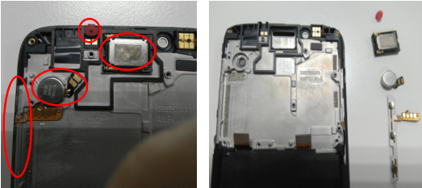

g. Separate battery label
Lift up main FPC to Separate battery label slowly； Clean front housing surface adhesive residue before reuse。
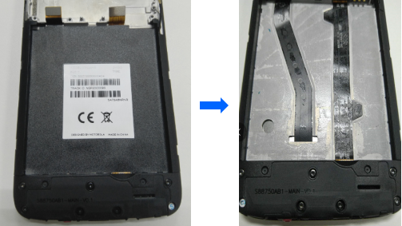

h. Remove stents
Release 5pcs screw (M1.4*2.5) from main antenna holder with screwdriver；Remove the holder from front housing
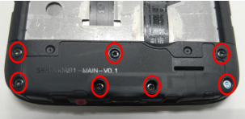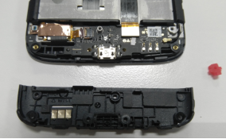

i. Remove main FPC BTB connector and rf cable connector
Release main FPC BTB connecter and RF cable connecter to remove it from Front housing； Cosmetic inspect of FPC and RF cable before reuse
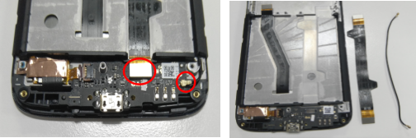

j. Remove TP_FPC, ZIF_FPC
Remove Copper foil with tweezers;Release TP FPC ZIF FPC and remove Sub-board from front housing.
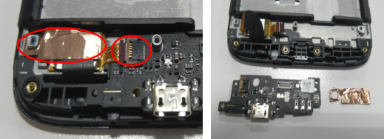

k. Remove the map
Don’t separate speaker FPC 、PCBA cooling copper and battery cover cooling film if material not damage
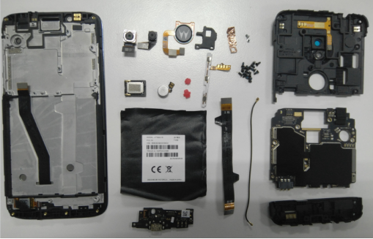

l. Dismantling LCM
Put the Front housing module on the hot plat surface ( TP surface adown); Put the Front housing module into the disassembly equipment ( TP surface adown).
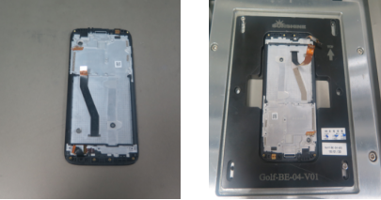

m. Remove front shell tp_lcd
Take out the Front housing module from disassembly equipment；Separate TP module and front housing slowly；Separate TP and LCM slowly； Cover TP and LCM surface with protection film。
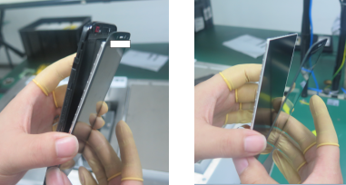

The main board layout is introduced
2.1 The mainboard positive figure
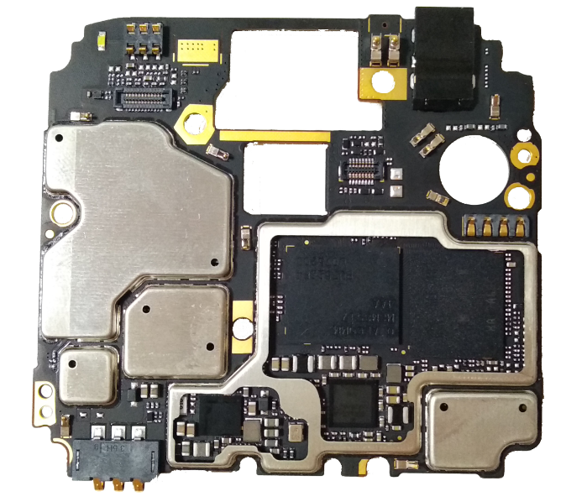

2.2 Main board on the back of the figure
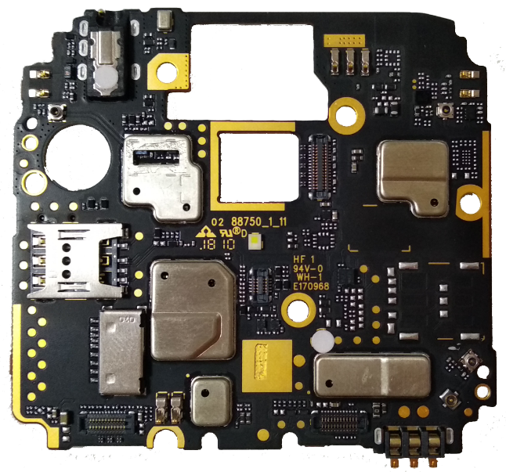
2.3 Motherboard, figure a PDF document
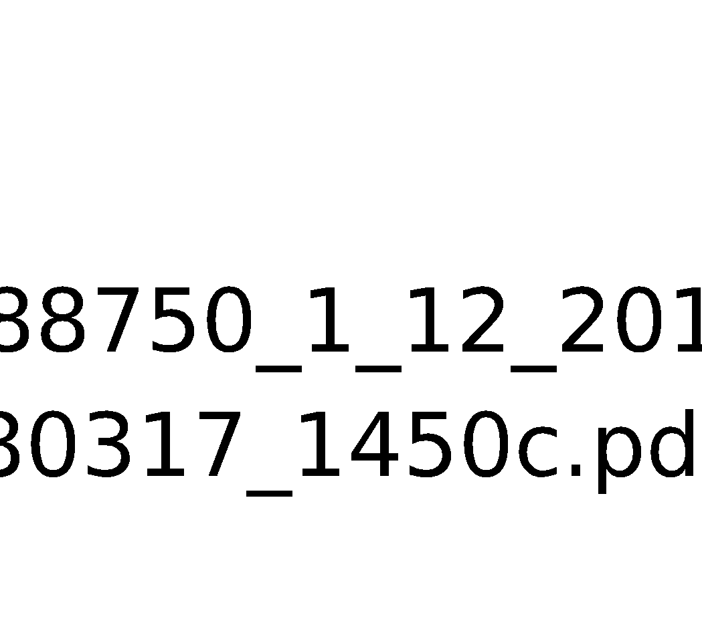
2.4 The main board schematic PDF document
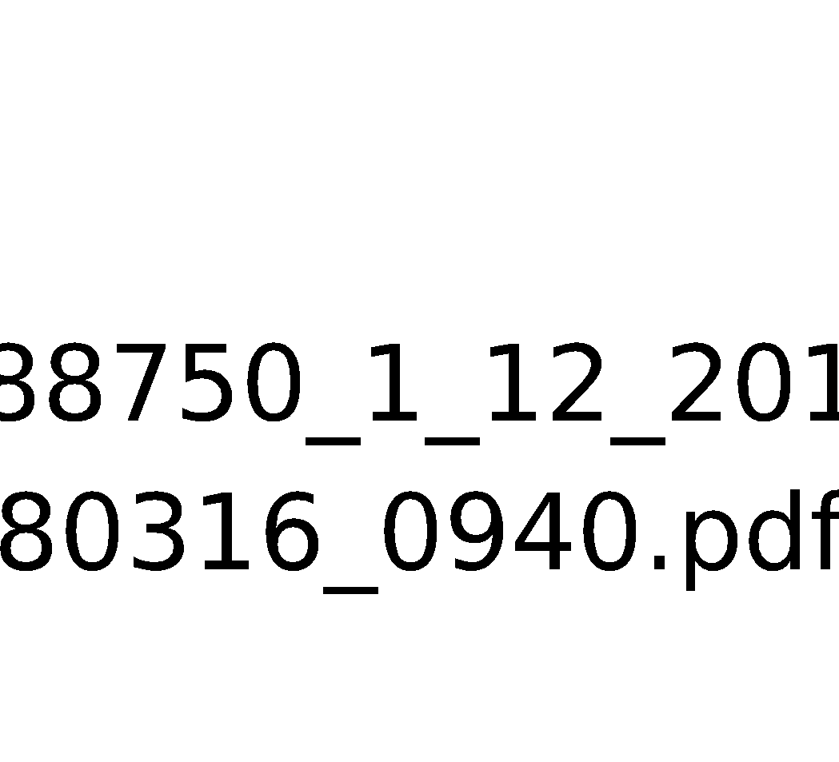
3.Failure analysis flow chart
3.1 Don't start up
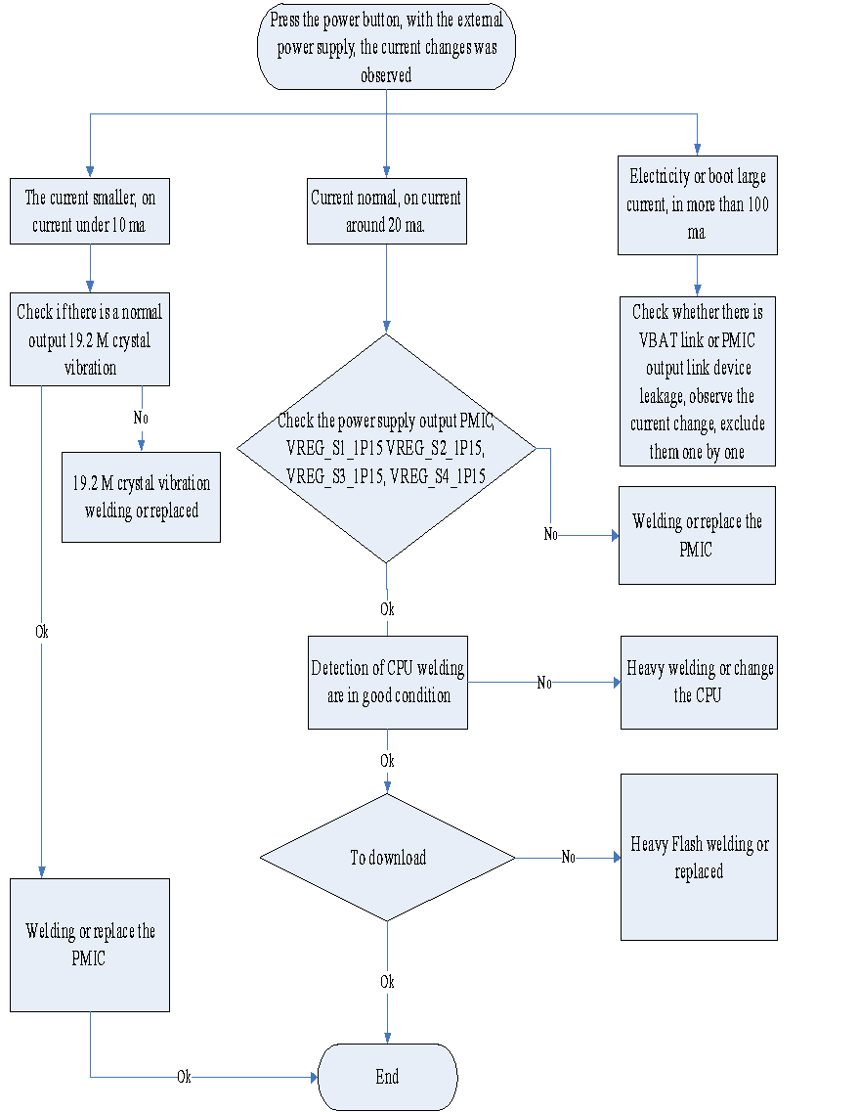
3.2 Touch screen failure
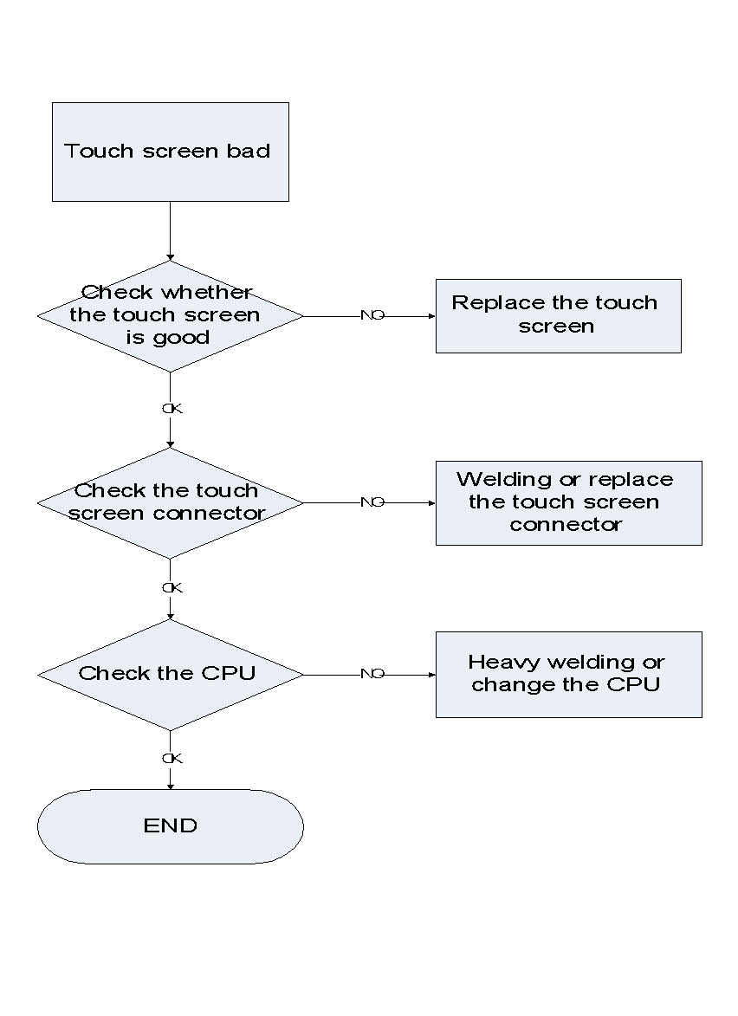

3.3 charge fault
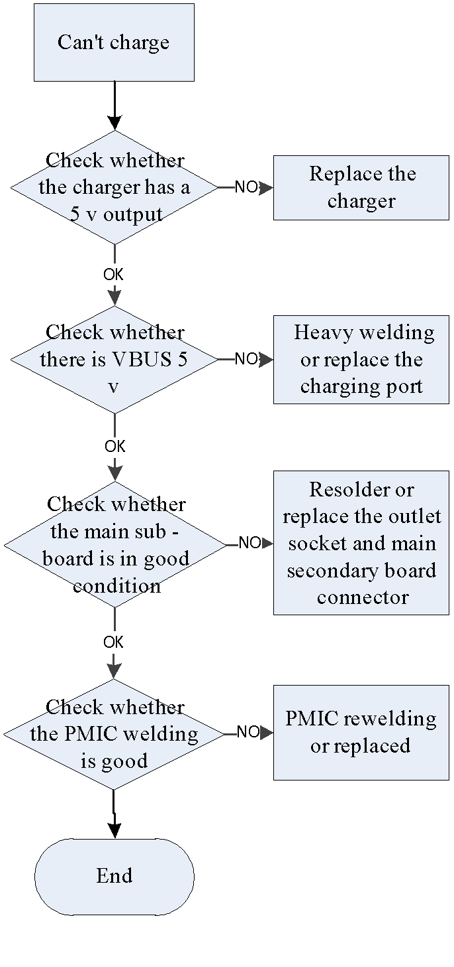
3.4 The receiver malfunction
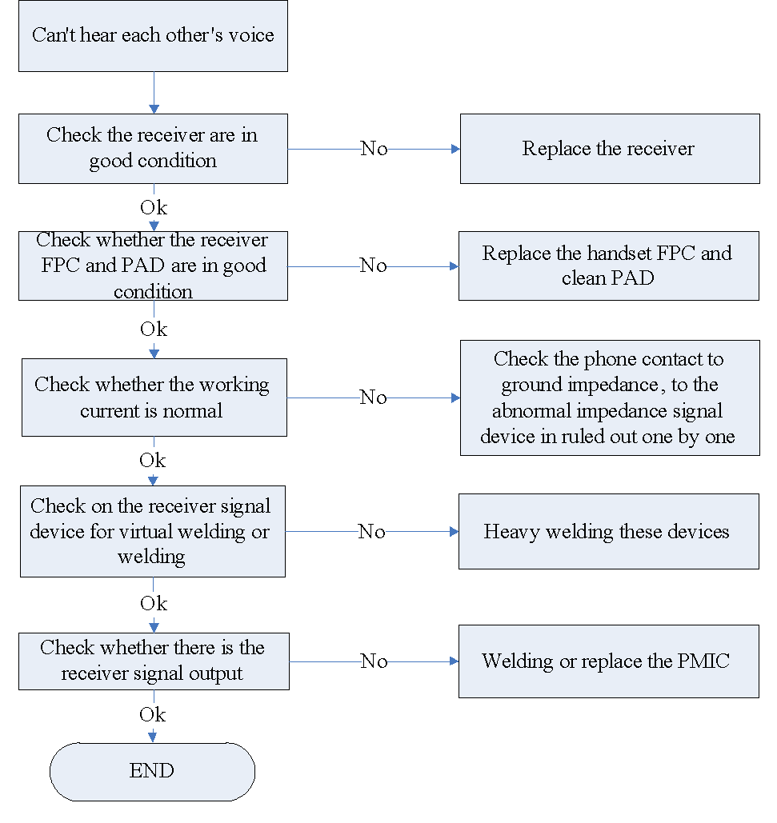

3.5 The horn fault
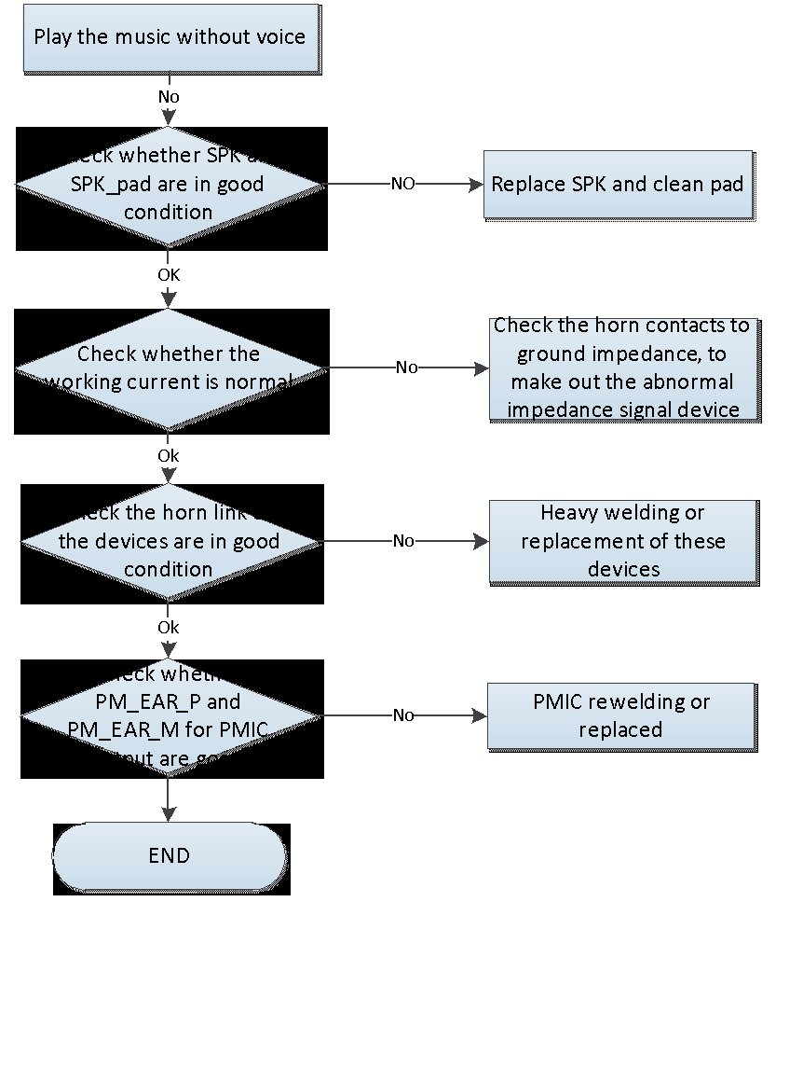

3.6 LCD display failure
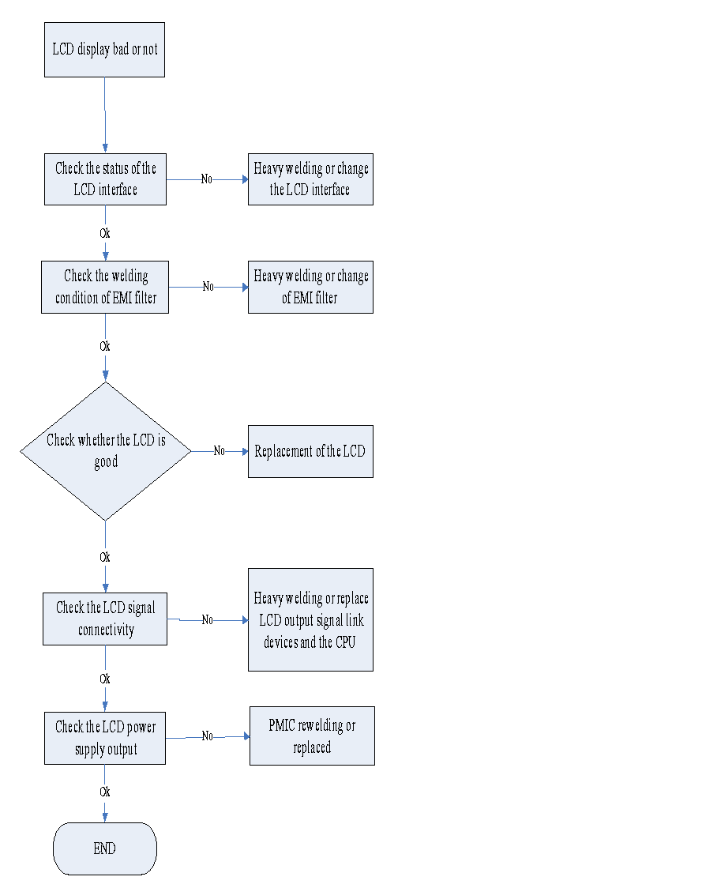

3.7 The key fault
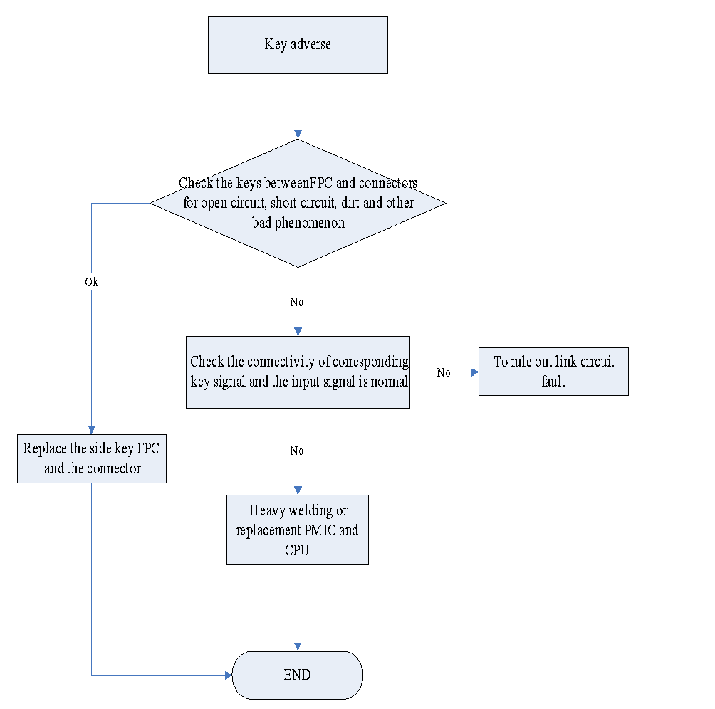

3.8 Mobile communication failures
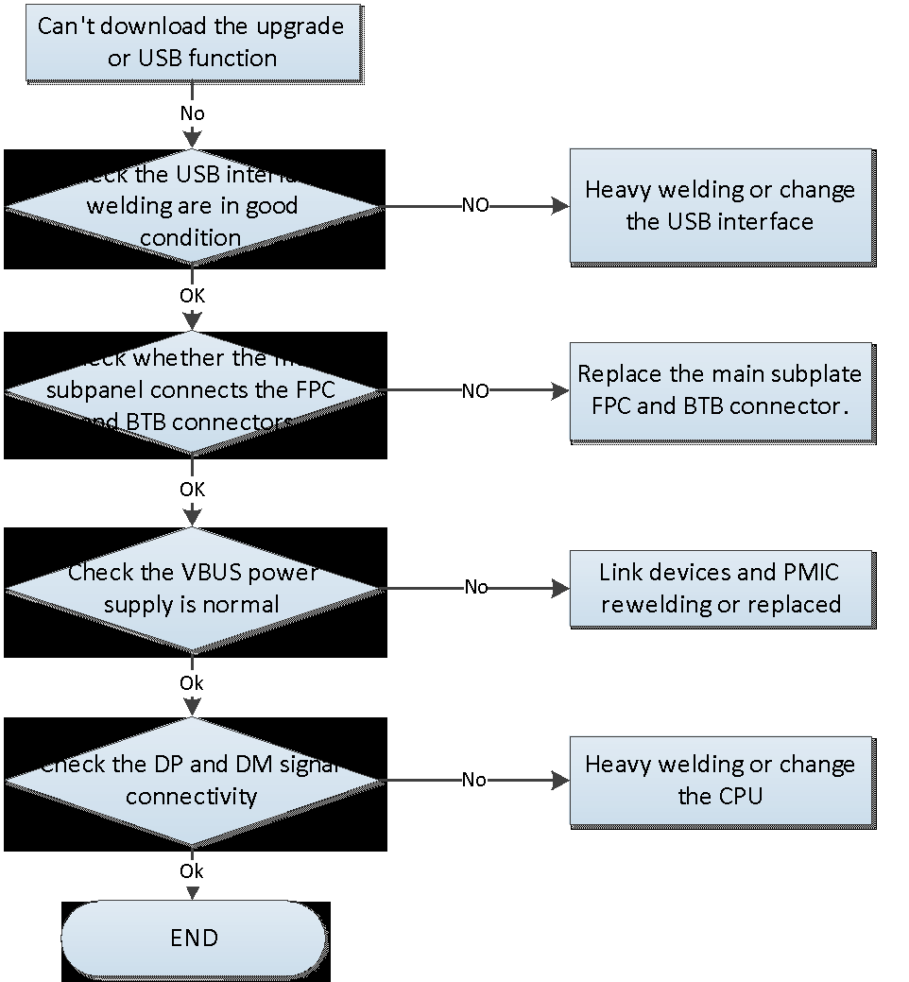

3.9 MIC fault
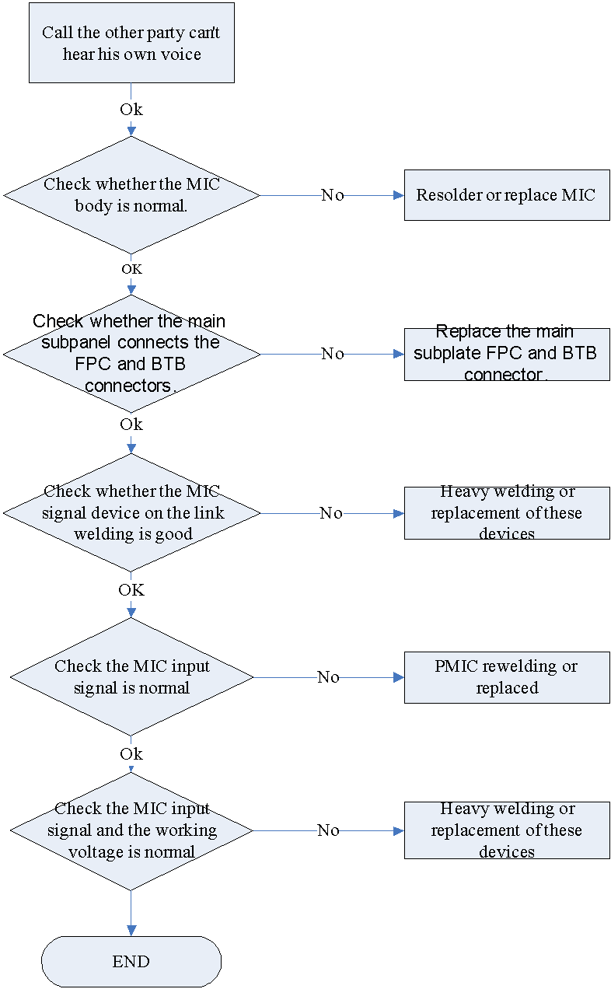
更换CPU

3.10 Camera malfunction
3.10.1 The main camera malfunction
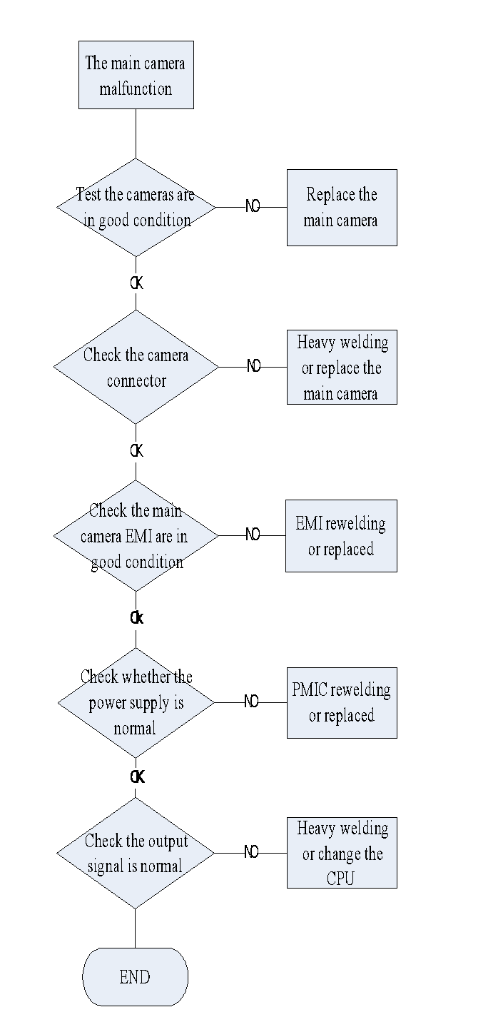

3.10.2 Before the camera malfunction

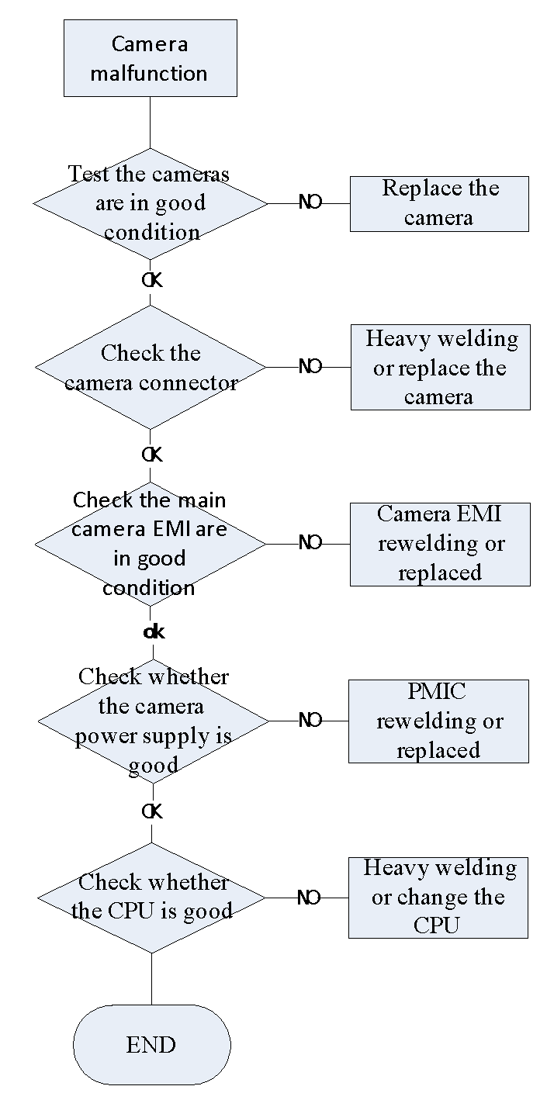

3.11 Vibration fault
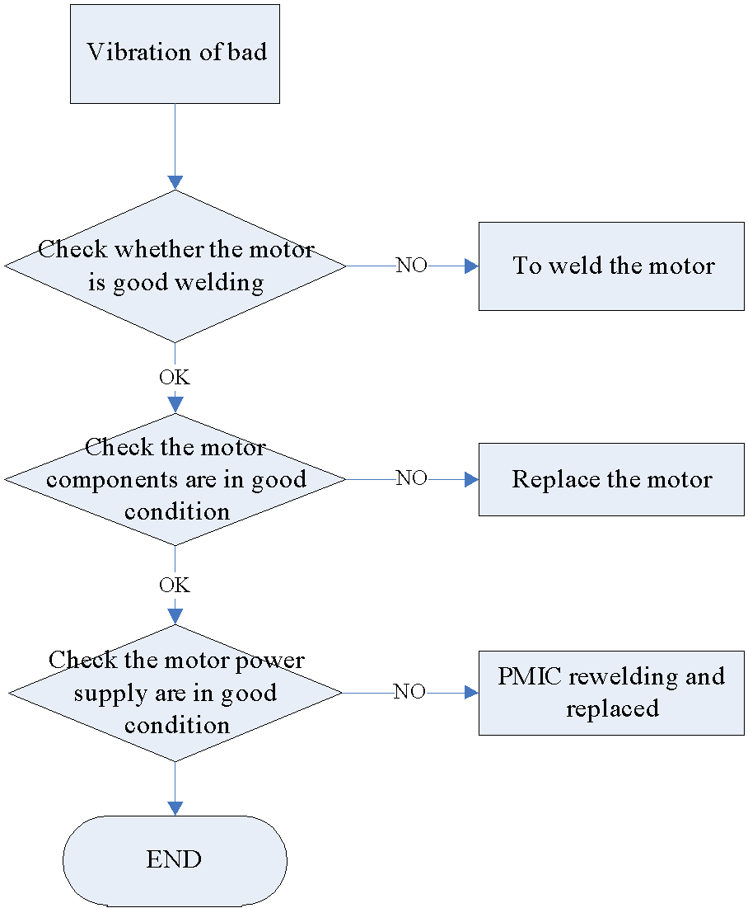

3.12 SIM card not to identify
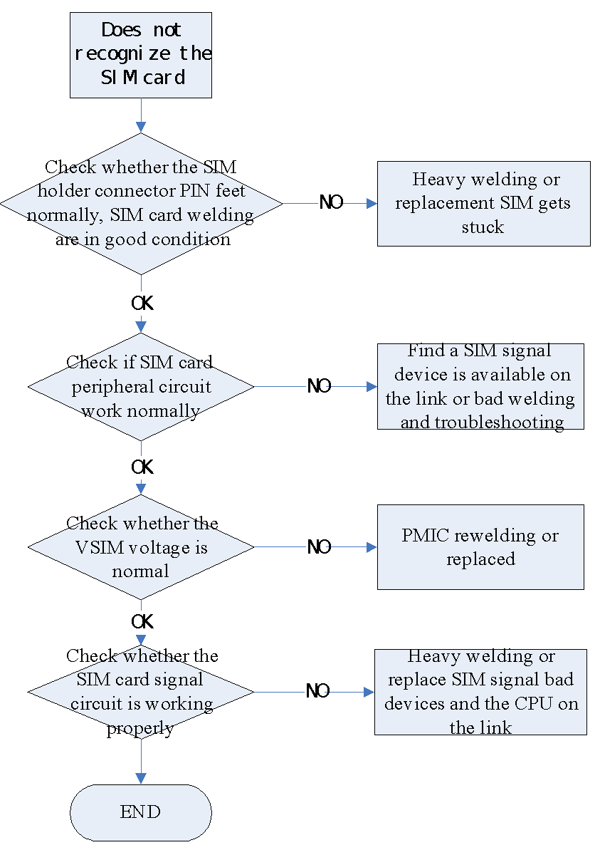

3.13 SD card can't identify
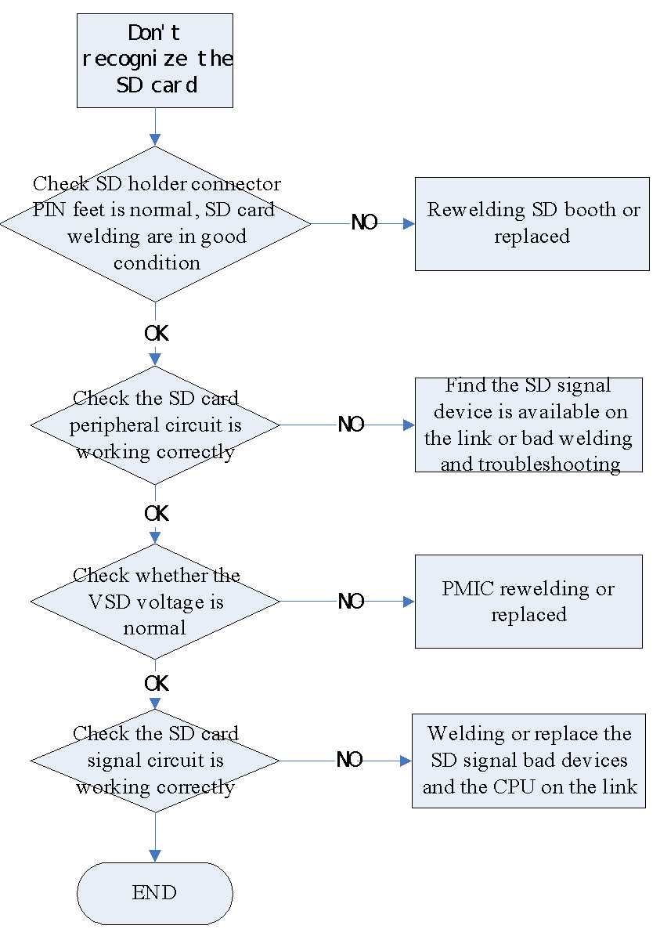

3.14 FM fault
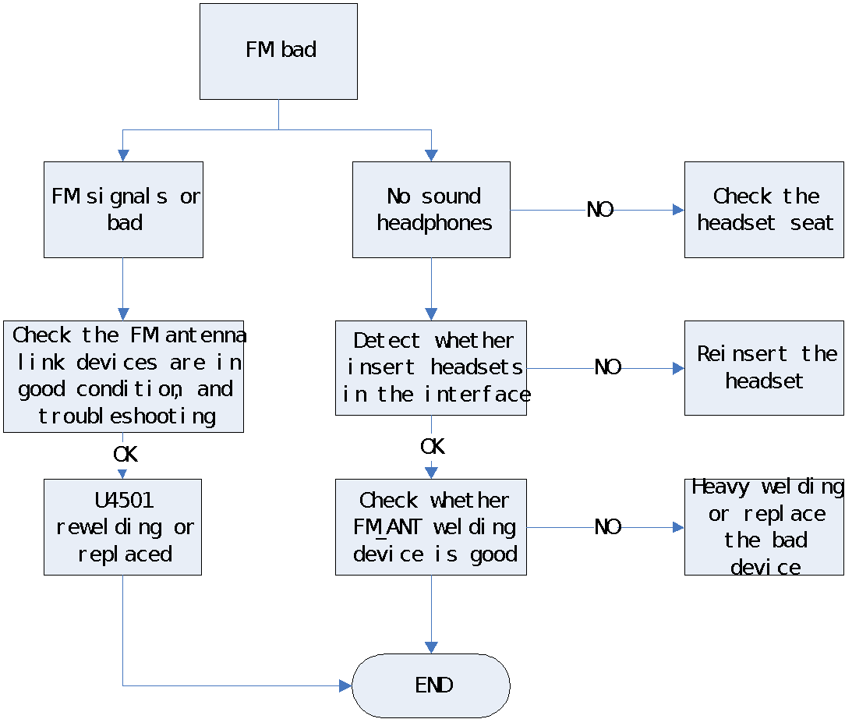

3.15 Bluetooth/WLAN fault
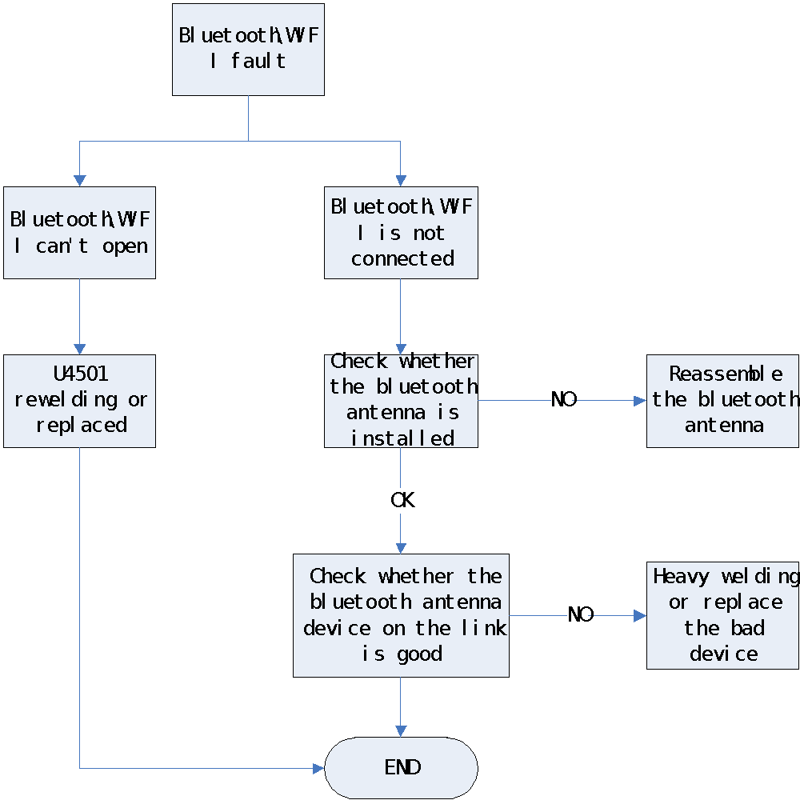

3.16 Fingerprint fault
