Revision History
Date | Rev. | Responsible | Change Description
08/29/14 | 1 | Jorge Santos | Document creation
Note 1: The actual released date of the document resides within the deco system.
Note 2: Only the last 5 revisions are required to be shown above.

Approvals
Name | Position
Michael Gressick | Quality and Sustaining Engineering
Daniel Silva | Global Service Operations
Jill Weck | Call Center

- Purpose

The purpose of this document is to provide guidelines to define the attributes of liquid damage in terms of Motorola Mobility’s limited warranty liabilities.

- Scope

This document is to be used as an aid to identify and disposition non-warranted liquid damage returns within all Motorola regions (NA, LATAN, EMEA, and ASIA)

- Responsibilities

- Quality and sustaining – Document creation and maintenance
- Service operations – Ensure guidelines and policy compliance
- Service center – Follow guidelines and document liquid damage
- Call center – Inform consumers regarding policy when unit return un-repaired

- Definitions

- CSB - Customer Service Bulletin
- FSB - Field Service Bulletin
- MRSC – Motorola Mobility Repair Service Center
- PBA - Printed Board Assembly
- PCB - Printed Circuit Board
- RUR - Return Un-Repaired
- LDI – Liquid Damage Indicator

- Criteria

A device will be declared liquid damage ONLY IF there is signs of corrosion. Triggered LDIs without any sign of corrosion are not sufficient to declare a unit liquid damage and send back as RUR.

- Tools, Equipment, and Material

- Camera and PC to take corresponding liquid damage evidence
- Arrows to point corrosion area on the picture

- Procedure

  - Liquid Damage Inspection and Disposition

As part of the standard procedure at MRSC, there must be a visual inspection for corrosion externally and internally when applicable.

 | External Inspection | Internal Inspection
Inspection | 1. Inspect externally looking for corrosion at the followings:  - USB, headset jack, HDMI, SIM port, SD memory port, and any other applicable port  - Housings, buttons, rear housing, display, and any other applicable part of the housing  - Battery, battery connectors, battery contacts, battery doors and any other part associated to the battery  2. Inspect external LDIs, if any is triggered and there is not EXTERNAL corrosion, the device must be opened to ensure there is INTERNAL corrosion. | 1. Inspect internally looking for corrosion at the followings:  - PCB, Shields, ICs, Internal Connectors, Antennas, external ports PCB connections, and all PCB related components  - Internal housing, buttons, back of display, and all internal housing associated parts  - Battery, battery connectors, battery contacts, battery doors and any other part associated to the battery  2. Inspect internal LDIs, if any is triggered and there is not INTERNAL and EXTERNAL corrosion, the device is not a liquid damage.
Disposition | 3. A device is declared as liquid damage from external inspection only if external corrosion is observed. In case there is an external LDI triggered and no external corrosion, the device must be opened to inspect internally for corrosion. An external LDI triggered ONLY is not sufficient evidence to declare a unit liquid damage, thus it must be repaired and the LDIs replaced. | 3. A device is declared as liquid damage from internal inspection only if internal corrosion is observed. If any internal LDI is triggered and there is not INTERNAL or EXTERNAL corrosion, the device is not a liquid damage and it must be repaired and the LDIs replaced
  - Corrosion and LDI Location Examples

- EXTERNAL Corrosion Examples

Housing and keypad corrosion USB Corrosion

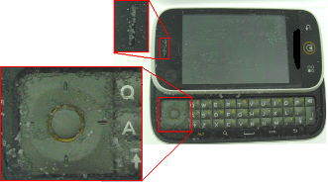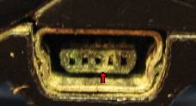

- INTERNAL Corrosion

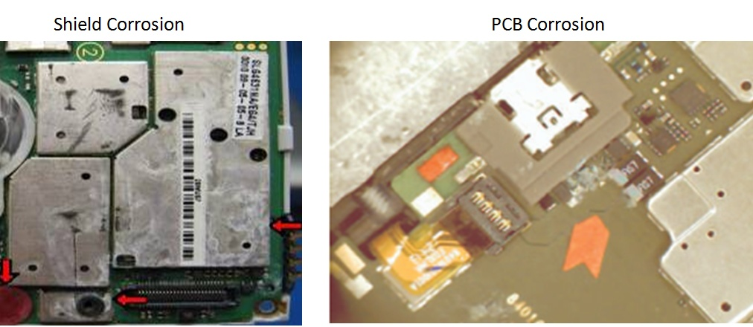

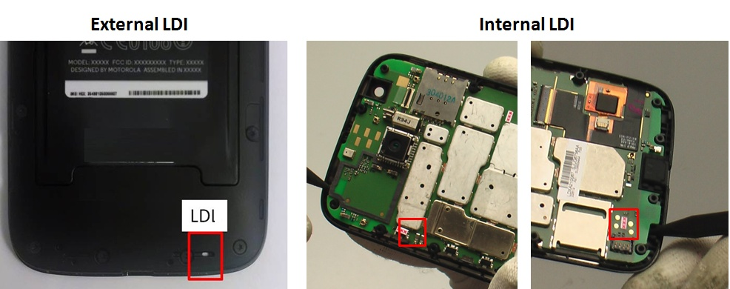
- LDIs Location Examples

  - Documentation of Liquid Damage

MRSC must document and store records of devices declared as liquid damage. The format below contains all the information required for documenting a liquid damage. It must have, corrosion picture, arrow pointing the corrosion location, “Return Un-repaired” title, model, problem found, location of the corrosion, service center code, date, and signature of supervisor that ensure the liquid damage is valid.

- Environmental, Health, and Safety

Follow all applicable EHS standards that apply to this procedure.

