


EMEA – Nexus6 reboot issue displaying “optimizing apps”

Problem

This process document will give instruction of Nexus6 flashing process when customer devices returned for repair with a reboot issue by optimizing apps displayed in the phone.

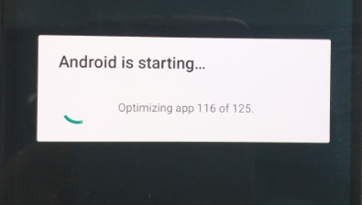

Solution

MASC have to perform an additional Motoservice step under “enhanced flash” option by using the recipe board swap to fix power up issue !

- When phone is powered up and reboot issue is seen, power down the phone by pressing the volume down button for min. 4 seconds.
- Press accordingly the volume down button and connect the phone with factory cable to USB port. The phone should be start up in fastboot mode.

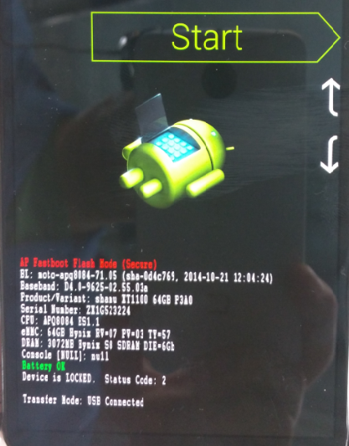

- If the phone is connected in fastboot mode select under “enhanced flash” option in MotoService following carrier:

- Carrier: Google Play Store Global: Europe
- Model: XT1100/SM3974AY2F1
- Recipe: BoardSwap
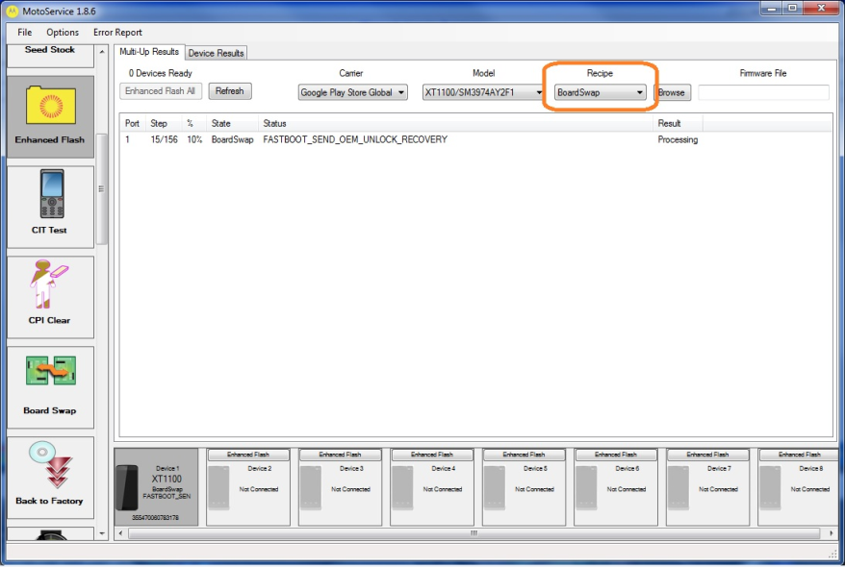

- Start the flashing process and scan the serial number of the device.
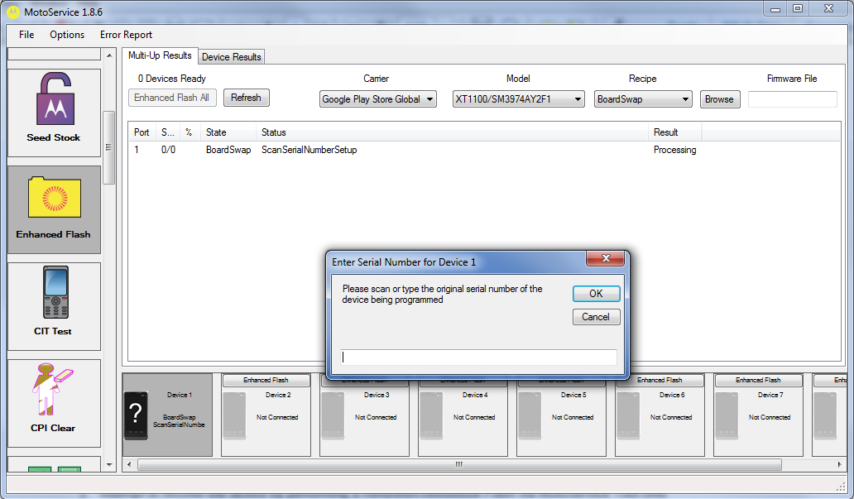

- Unlock the bootloader when it will be displayed in phone
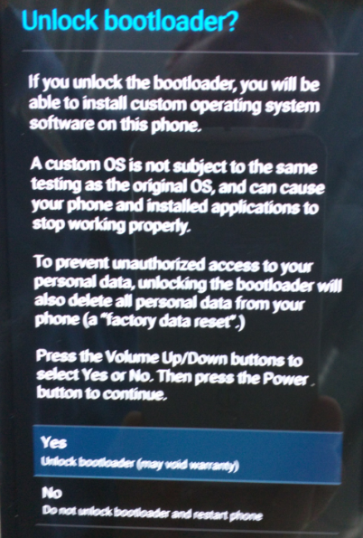

- The phone will power up to the welcome screen and fail at Motoservice process step 37 with issue “CONNECT_FTM_SOCKET_RESTORE_KK”.
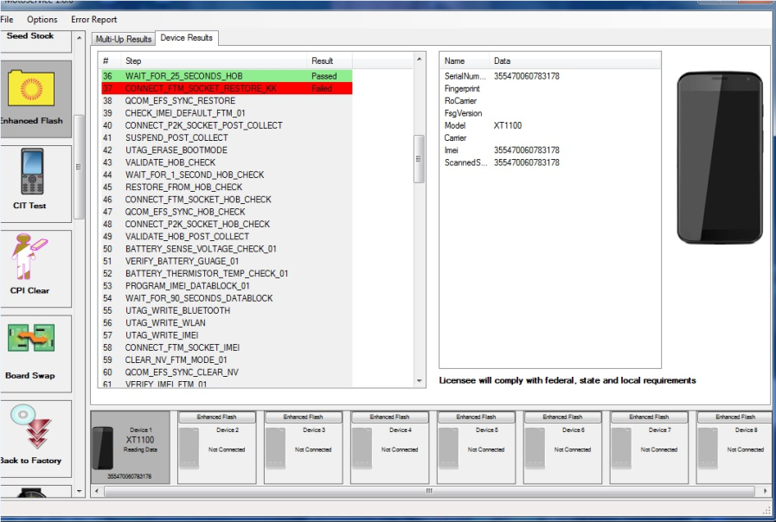

- Connect the phone in fastboot mode and run the kill switch option in MotoService
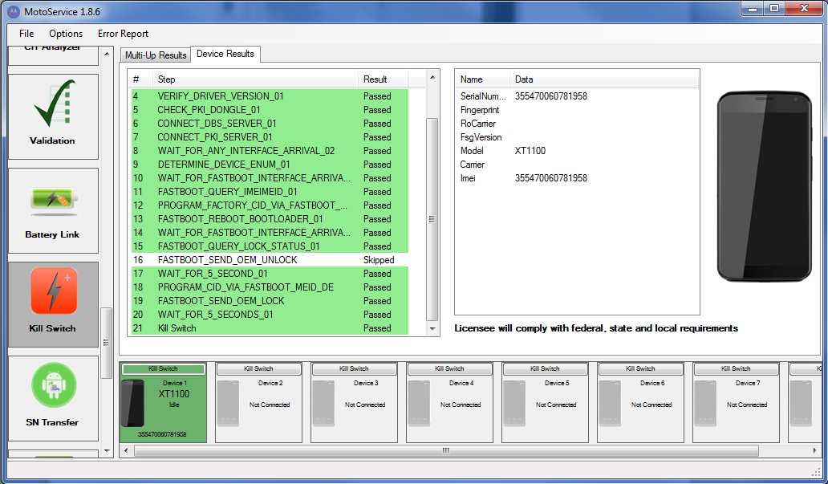

- Reconnect the phone and enable the developer option as described in the SRI 2015-11
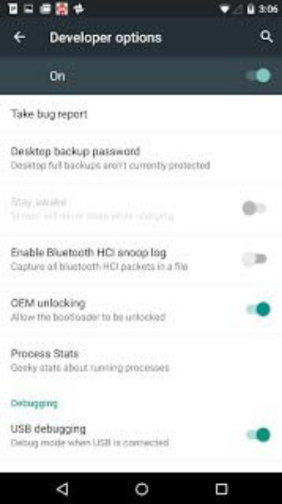

- Run the “Reflash” option in Motoservice and unlock the bootloader when it will be displayed in phone.
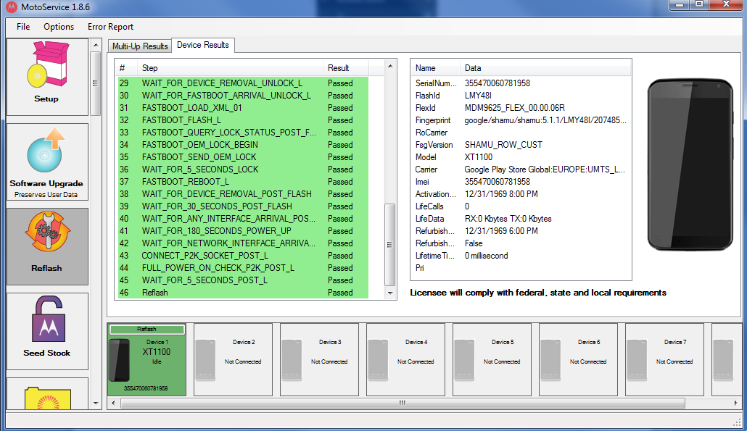

- Power off the device and connect to the factory usb cable to start the CIT process.

- Perform RF live call test to check audio loop.

With kind regards
B2X Service support team


