HOW TO Load the “application SW”

What is needed

- PST flash and test commands
- Applicative file that has to be downloaded (.shx).

Initial setup
- Connect the PC and the phone via the USB port.
- It is recommended to disconnect the parallel cable (if connected)

For Mortables:-
Power on the mortable.
Start PST and you should see the phone enumerating (Figure 3).

For Phones:-
Start PST and by holding down the “*” and the “#” keys, press the power on key.
you should see the phone enumerating (Figure 3).
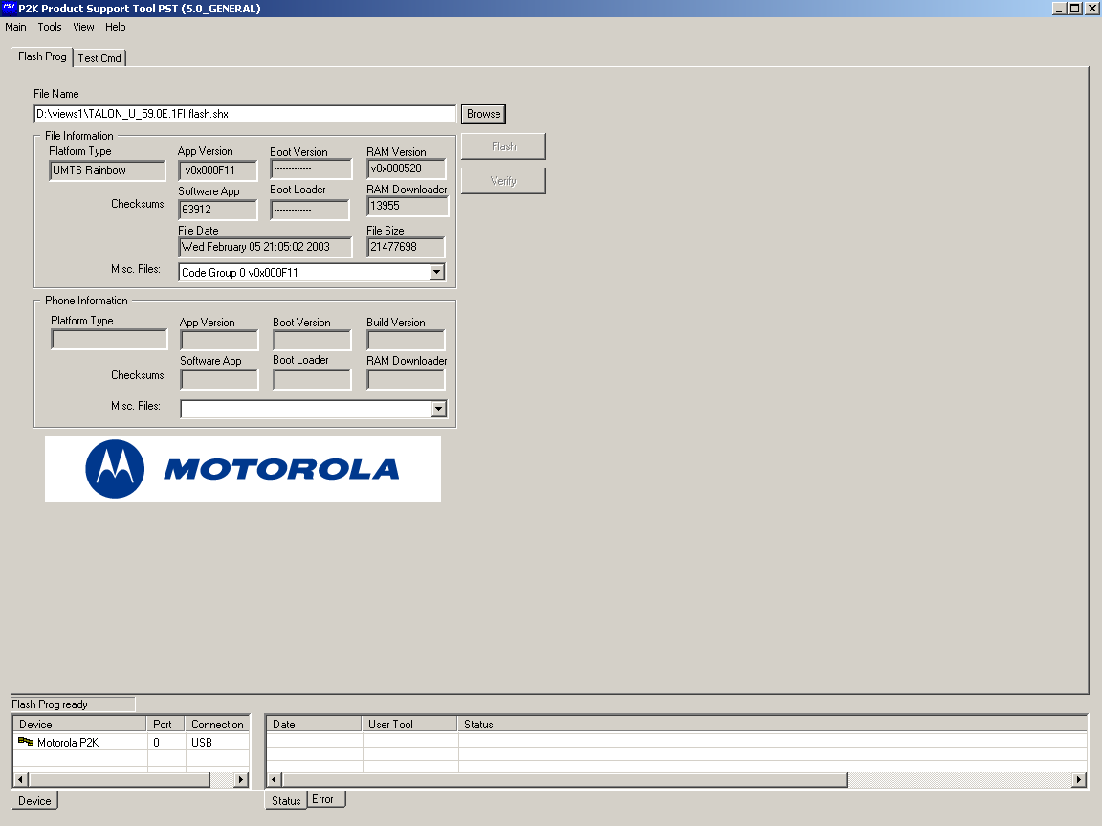
Figure 1

Download of the applicative software
Browse the File Name window to find the file to be downloaded.
In the Device window select (click with the mouse) Motorola P2K device.
Click on the Flash button.

At the end of the download procedure power-cycle the phone.

HOW TO “flex” the phone

What is needed:
- Serial cable
- RadioComm
- Flex file to be downloaded (*.hs)

Initial setup
- Connect the PC and the board via the serial port.
- Disconnect the parallel cable (if connected)
- Switch on the card.

From RadioComm (Figure 4) perform the following actions:

- click on the AT-MODE button and check that the action has been performed properly in the dialog box with PST label.
- click on the SUSPEND button and check that the action has been performed properly in the PST window.
- select the second label (GSM2 if GSM phone or 3G2 if UMTS phone).

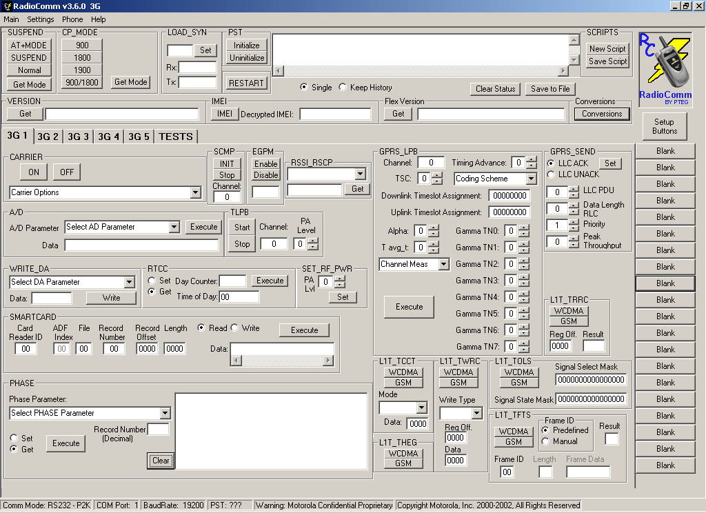
I
II
III
Figure 2

Download the flex file
In the flex field (Figure 5) select the flex filename that has to be downloaded.

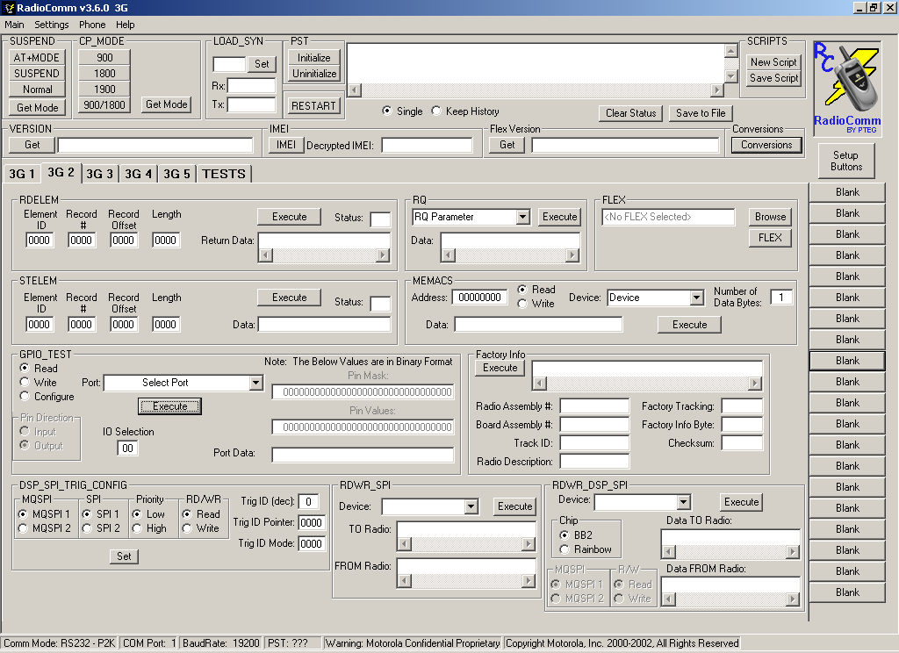
Figure 3

When the download is finished, power cycle the phone.

The phone is now ready to be used.

